UNITED STATES
SECURITIES AND EXCHANGE COMMISSION
Washington, D.C. 20549
___________________________________
FORM 8-K
___________________________________
CURRENT REPORT
Pursuant to Section 13 or 15(d)
of the Securities Exchange Act of 1934

Date of Report (date of earliest event reported): May 4, 2026
___________________________________
Central Bancompany, Inc.
(Exact name of registrant as specified in its charter)
___________________________________

Missouri  (State or other jurisdiction of  incorporation or organization) |  |  | 001-42965  (Commission File Number) |  |  | 43-0959114  (I.R.S. Employer Identification Number)
238 Madison Street
Jefferson City, MO 65101
(Address of principal executive offices and zip code)
(573) 634-1111
(Registrant's telephone number, including area code)
___________________________________
Check the appropriate box below if the Form 8-K filing is intended to simultaneously satisfy the filing obligation of the registrant under any of the following provisions:

☐ |  |  | Written communications pursuant to Rule 425 under the Securities Act (17 CFR 230.425)
☐ |  |  | Soliciting material pursuant to Rule 14a-12 under the Exchange Act (17 CFR 240.14a-12)
☐ |  |  | Pre-commencement communications pursuant to Rule 14d-2(b) under the Exchange Act (17 CFR 240.14d-2(b))
☐ |  |  | Pre-commencement communications pursuant to Rule 13e-4(c) under the Exchange Act (17 CFR 240.13e-4(c))
Securities registered pursuant to Section 12(b) of the Act:
Title of each class |  |  | Trading Symbol |  |  | Name of each exchange on which registered
Class A common stock, par value $0.01 per share |  |  | CBC |  |  | The Nasdaq Stock Market LLC
Indicate by check mark whether the registrant is an emerging growth company as defined in Rule 405 of the Securities Act of 1933 (17 CFR 230.405) or Rule 12b-2 of the Securities Exchange Act of 1934 (17 CFR 240.12b-2).
Emerging growth company ☒
If an emerging growth company, indicate by check mark if the registrant has elected not to use the extended transition period for complying with any new or revised financial accounting standards provided pursuant to Section 13(a) of the Exchange Act. ☐

Item 5.07 - Submission of Matters to a Vote of Security Holders; Appointment of Certain Officers; Compensatory Arrangements of Certain Officers
The Board of Directors of Central Bancompany, Inc. (the “Company”) held its 2026 Annual Meeting of Stockholders on May 4, 2026. Three items of business were considered by the Company's stockholders at the meeting:
•The election of four (4) Directors for the Class I Directors for a term of three (3) years;
•Ratification of the appointment of KPMG, LLP to serve as the Company's independent registered public accounting firm for the fiscal year ending December 31, 2026; and
•Adoption of the Central Bancompany, Inc. 2026 Employee Stock Purchase Plan Proposal.
The results of the meeting were as follows:
Proposal No. 1 - Election of Directors - Stockholders elected four nominees named in the Proxy Statement.
Name |  |  | Votes For |  |  | Votes Against |  |  | Abstentions |  |  | Broker Non-Votes
Michael Farmer, Jr. |  |  | 170,152,467 |  |  | 4 |  |  | 96 |  |  | —
E. Stanley Kroenke |  |  | 169,483,861 |  |  | 5,105 |  |  | 663,601 |  |  | —
Charles E. Kruse |  |  | 170,152,471 |  |  | — |  |  | 96 |  |  | —
Bradley N. Sprong |  |  | 170,152,471 |  |  | — |  |  | 96 |  |  | —
Proposal No. 2 - Stockholder Ratification of Independent Registered Public Accounting Firm - Stockholders ratified the appointment of KPMG, LLP as independent registered public accounting firm for the fiscal year ending December 31, 2026.
Votes For |  |  | Votes Against |  |  | Abstentions
170,152,546 |  |  | 21 |  |  | 2
Proposal No. 3 - Central Bancompany, Inc. 2026 Employee Stock Purchase Plan - Stockholders adopted the 2026 Employee Stock Purchase Plan.
Votes For |  |  | Votes Against |  |  | Abstentions |  |  | Broker Non-Votes
170,152,565 |  |  | 2 |  |  | — |  |  | —

Item 8.01 - Other Events
Second Quarter 2026 Shareholder Dividend
On May 4, 2026, the Board of Directors of the Company declared a dividend of $0.12 per common share payable on June 1, 2026 to stockholders of record as of the close of business on May 22, 2026.
A copy of the Company's press release announcing this dividend is attached as Exhibit 99.1 hereto and incorporated herein by reference.

Item 9.01 - Financial Statements and Exhibits
(d) Exhibits
Exhibit No. |  |  | Description
99.1 |  |  | Press release of the registrant dated May 5, 2026, announcing dividend declaration.
104 |  |  | The XBRL tags on the cover page of this Form 8-K are embedded within the Inline XBRL document.

SIGNATURE
Pursuant to the requirements of the Securities Exchange Act of 1934, as amended, the Registrant has duly caused this report to be signed on its behalf by the undersigned hereunto duly authorized.

 |  |  |  |  |  | CENTRAL BANCOMPANY, INC.
Date: |  |  | May 5, 2026 |  |  | By: |  |  | /s/ James K. Ciroli
 |  |  |  |  |  |  |  |  | Name: James K. Ciroli
 |  |  |  |  |  |  |  |  | Title: Executive Vice President and Chief Financial Officer
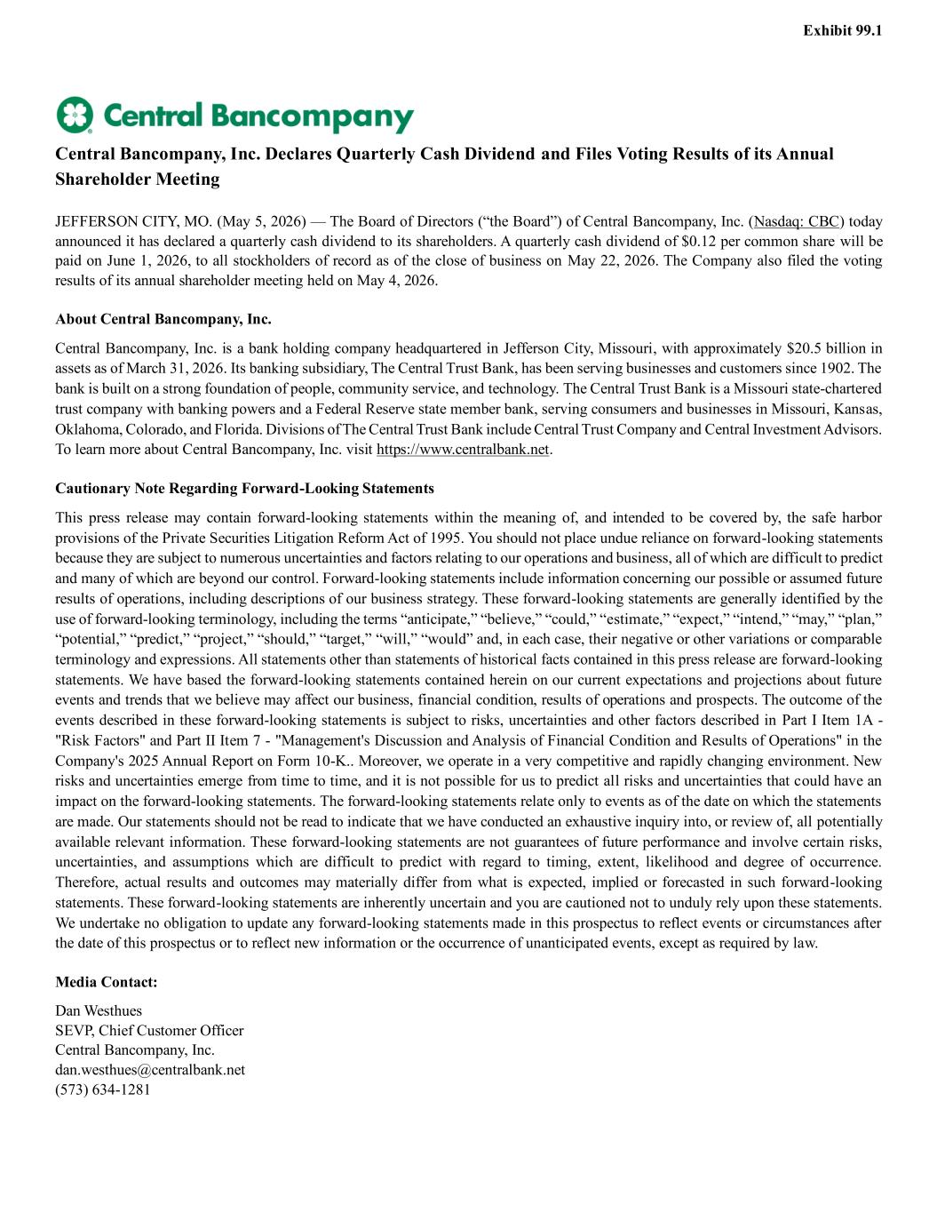

Exhibit 99.1 Central Bancompany, Inc. Declares Quarterly Cash Dividend and Files Voting Results of its Annual Shareholder Meeting JEFFERSON CITY, MO. (May 5, 2026) — The Board of Directors (“the Board”) of Central Bancompany, Inc. (Nasdaq: CBC) today announced it has declared a quarterly cash dividend to its shareholders. A quarterly cash dividend of $0.12 per common share will be paid on June 1, 2026, to all stockholders of record as of the close of business on May 22, 2026. The Company also filed the voting results of its annual shareholder meeting held on May 4, 2026. About Central Bancompany, Inc. Central Bancompany, Inc. is a bank holding company headquartered in Jefferson City, Missouri, with approximately $20.5 billion in assets as of March 31, 2026. Its banking subsidiary, The Central Trust Bank, has been serving businesses and customers since 1902. The bank is built on a strong foundation of people, community service, and technology. The Central Trust Bank is a Missouri state-chartered trust company with banking powers and a Federal Reserve state member bank, serving consumers and businesses in Missouri, Kansas, Oklahoma, Colorado, and Florida. Divisions of The Central Trust Bank include Central Trust Company and Central Investment Advisors. To learn more about Central Bancompany, Inc. visit https://www.centralbank.net. Cautionary Note Regarding Forward-Looking Statements This press release may contain forward-looking statements within the meaning of, and intended to be covered by, the safe harbor provisions of the Private Securities Litigation Reform Act of 1995. You should not place undue reliance on forward-looking statements because they are subject to numerous uncertainties and factors relating to our operations and business, all of which are difficult to predict and many of which are beyond our control. Forward-looking statements include information concerning our possible or assumed future results of operations, including descriptions of our business strategy. These forward-looking statements are generally identified by the use of forward-looking terminology, including the terms “anticipate,” “believe,” “could,” “estimate,” “expect,” “intend,” “may,” “plan,” “potential,” “predict,” “project,” “should,” “target,” “will,” “would” and, in each case, their negative or other variations or comparable terminology and expressions. All statements other than statements of historical facts contained in this press release are forward-looking statements. We have based the forward-looking statements contained herein on our current expectations and projections about future events and trends that we believe may affect our business, financial condition, results of operations and prospects. The outcome of the events described in these forward-looking statements is subject to risks, uncertainties and other factors described in Part I Item 1A - "Risk Factors" and Part II Item 7 - "Management's Discussion and Analysis of Financial Condition and Results of Operations" in the Company's 2025 Annual Report on Form 10-K.. Moreover, we operate in a very competitive and rapidly changing environment. New risks and uncertainties emerge from time to time, and it is not possible for us to predict all risks and uncertainties that could have an impact on the forward-looking statements. The forward-looking statements relate only to events as of the date on which the statements are made. Our statements should not be read to indicate that we have conducted an exhaustive inquiry into, or review of, all potentially available relevant information. These forward-looking statements are not guarantees of future performance and involve certain risks, uncertainties, and assumptions which are difficult to predict with regard to timing, extent, likelihood and degree of occurrence. Therefore, actual results and outcomes may materially differ from what is expected, implied or forecasted in such forward-looking statements. These forward-looking statements are inherently uncertain and you are cautioned not to unduly rely upon these statements. We undertake no obligation to update any forward-looking statements made in this prospectus to reflect events or circumstances after the date of this prospectus or to reflect new information or the occurrence of unanticipated events, except as required by law. Media Contact: Dan Westhues SEVP, Chief Customer Officer Central Bancompany, Inc. dan.westhues@centralbank.net (573) 634-1281


Investor Relations Contact: Charlie Martin Corporate Development Officer Central Bancompany, Inc. charlie.martin@centralbank.net (314) 686-7007

