UNITED STATES
SECURITIES AND EXCHANGE COMMISSION
Washington, D.C. 20549
___________________________________
FORM 8-K
___________________________________
CURRENT REPORT
Pursuant to Section 13 or 15(d)
of the Securities Exchange Act of 1934

Date of Report (date of earliest event reported): August 4, 2026
___________________________________
Central Bancompany, Inc.
(Exact name of registrant as specified in its charter)
___________________________________

Missouri  (State or other jurisdiction of  incorporation or organization) |  |  | 001-42965  (Commission File Number) |  |  | 43-0959114  (I.R.S. Employer Identification Number)
238 Madison Street
Jefferson City, MO 65101
(Address of principal executive offices and zip code)
(573) 634-1111
(Registrant's telephone number, including area code)
___________________________________
Check the appropriate box below if the Form 8-K filing is intended to simultaneously satisfy the filing obligation of the registrant under any of the following provisions:

☐ |  |  | Written communications pursuant to Rule 425 under the Securities Act (17 CFR 230.425)
☐ |  |  | Soliciting material pursuant to Rule 14a-12 under the Exchange Act (17 CFR 240.14a-12)
☐ |  |  | Pre-commencement communications pursuant to Rule 14d-2(b) under the Exchange Act (17 CFR 240.14d-2(b))
☐ |  |  | Pre-commencement communications pursuant to Rule 13e-4(c) under the Exchange Act (17 CFR 240.13e-4(c))
Securities registered pursuant to Section 12(b) of the Act:
Title of each class |  |  | Trading Symbol |  |  | Name of each exchange on which registered
Class A common stock, par value $0.01 per share |  |  | CBC |  |  | The Nasdaq Stock Market LLC
Indicate by check mark whether the registrant is an emerging growth company as defined in Rule 405 of the Securities Act of 1933 (17 CFR 230.405) or Rule 12b-2 of the Securities Exchange Act of 1934 (17 CFR 240.12b-2).
Emerging growth company ☒
If an emerging growth company, indicate by check mark if the registrant has elected not to use the extended transition period for complying with any new or revised financial accounting standards provided pursuant to Section 13(a) of the Exchange Act. ☐

Item 2.02 - Results of Operations and Financial Condition
On August 04, 2026, Central Bancompany, Inc. (“the Company”), issued a press release announcing the financial results for the Company for the quarter ended June 30, 2026. A copy of the press release is attached as Exhibit 99.1 and the information is hereby incorporated by reference herein. The Company does not incorporate by reference information presented at any website referenced in the press release.

Item 7.01 - Regulation FD Disclosure
The Company is furnishing a copy of materials that will be used in the Company's shareholder conference call at 9:00 a.m. CT on August 04, 2026. A copy of the materials is attached as Exhibit 99.2 and will be available on the Company’s investor relations website https://investor.centralbank.net. The call can be accessed via this same website or by using the following link: https://edge.media-server.com/mmc/p/fgiw74rw. A recorded replay of the conference call will be available on the website after the call’s completion. The materials are dated August 04, 2026, and the Company disclaims any obligation to correct or update any of the materials in the future.
The information contained in Item 2.02 and 7.01 of this Current Report on Form 8-K, including Exhibits 99.1 and 99.2 hereto, is being furnished and shall not be deemed to be “filed” with the Securities and Exchange Commission (“SEC”) for the purposes of Section 18 of the Securities Exchange Act of 1934, as amended (the “Exchange Act”), or otherwise subject to the liabilities of that section and is not incorporated by reference into any filing of the Company under the Securities Act of 1933, as amended (the “Securities Act”), or the Exchange Act, whether made before or after the date hereof, except as shall be expressly set forth by specific reference to this Current Report on Form 8-K in such a filing.

Item 8.01 - Other Events
Third Quarter 2026 Shareholder Dividend

On August 3, 2026, the Board of Directors of the Company declared a cash dividend of $0.12 per common share payable on September 1, 2026 to stockholders of record as of the close of business on August 21, 2026. A copy of the Company's press release announcing this dividend is attached as Exhibit 99.1 hereto and incorporated herein by reference.
Approval of New Stock Repurchase Plan
On August 3, 2026, the Board of Directors of the Company approved a new stock repurchase program authorizing the repurchase of up to $100 million of the Company's Class A common stock (the "Second Repurchase Plan"). In connection with the approval of the Second Repurchase Plan, the Board of Directors rescinded the Company's previously authorized stock repurchase program (the "2026 Repurchase Plan"), effective immediately.

The Second Repurchase Plan does not obligate the Company to repurchase any specified number of shares of its Class A common stock. Repurchases under the Second Repurchase Plan may be made from time to time as market conditions and other factors warrant. Shares may be repurchased in open market purchases, privately negotiated transactions, block trades, accelerated share repurchase transactions, or pursuant to one or more trading plans established in accordance with Rule 10b5-1 under the Securities Exchange Act of 1934, as amended.

The amount, timing, and manner of any repurchases will be determined by the Company in its sole discretion and will depend on a variety of factors, including market conditions, share price, liquidity requirements, applicable legal requirements, and other considerations. The Second Repurchase Plan may be modified, suspended, or terminated at any time without prior notice. No assurance can be given that the Company will repurchase any particular amount of its Class A common stock, or any shares at all, under the Second Repurchase Plan.

A copy of the Company's press release announcing the approval of the Second Repurchase Plan is attached hereto as Exhibit 99.1 and incorporated herein by reference.

Item 9.01 - Financial Statements and Exhibits
(d) Exhibits
Exhibit No. |  |  | Description
99.1 |  |  | Press release of Central Bancompany, Inc. dated August 4, 2026, containing information for the quarter ended June 30, 2026 and dividend declaration
99.2 |  |  | Quarterly Investor Relations Presentation for the quarter ended June 30, 2026
104 |  |  | The XBRL tags on the cover page of this Form 8-K are embedded within the Inline XBRL document.

SIGNATURE
Pursuant to the requirements of the Securities Exchange Act of 1934, as amended, the Registrant has duly caused this report to be signed on its behalf by the undersigned hereunto duly authorized.

 |  |  |  |  |  | CENTRAL BANCOMPANY, INC.
Date: |  |  | August 04, 2026 |  |  | By: |  |  | /s/ James K. Ciroli
 |  |  |  |  |  |  |  |  | Name: James K. Ciroli
Title: Chief Financial Officer
(Principal Financial Officer and Authorized Officer)
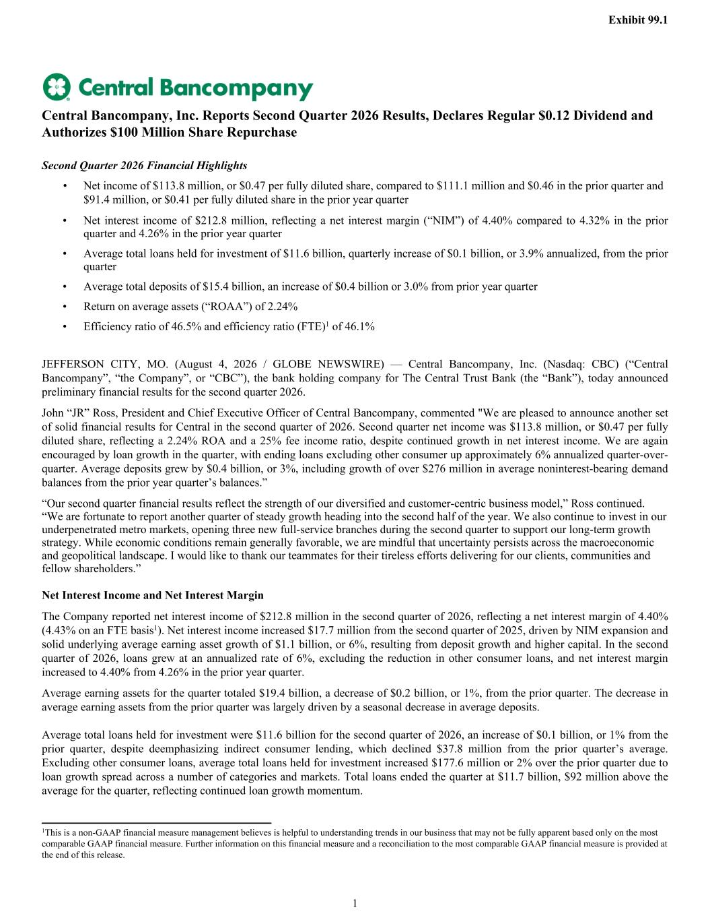

Central Bancompany, Inc. Reports Second Quarter 2026 Results, Declares Regular $0.12 Dividend and Authorizes $100 Million Share Repurchase Second Quarter 2026 Financial Highlights • Net income of $113.8 million, or $0.47 per fully diluted share, compared to $111.1 million and $0.46 in the prior quarter and $91.4 million, or $0.41 per fully diluted share in the prior year quarter • Net interest income of $212.8 million, reflecting a net interest margin (“NIM”) of 4.40% compared to 4.32% in the prior quarter and 4.26% in the prior year quarter • Average total loans held for investment of $11.6 billion, quarterly increase of $0.1 billion, or 3.9% annualized, from the prior quarter • Average total deposits of $15.4 billion, an increase of $0.4 billion or 3.0% from prior year quarter • Return on average assets (“ROAA”) of 2.24% • Efficiency ratio of 46.5% and efficiency ratio (FTE)1 of 46.1% JEFFERSON CITY, MO. (August 4, 2026 / GLOBE NEWSWIRE) — Central Bancompany, Inc. (Nasdaq: CBC) (“Central Bancompany”, “the Company”, or “CBC”), the bank holding company for The Central Trust Bank (the “Bank”), today announced preliminary financial results for the second quarter 2026. John “JR” Ross, President and Chief Executive Officer of Central Bancompany, commented "We are pleased to announce another set of solid financial results for Central in the second quarter of 2026. Second quarter net income was $113.8 million, or $0.47 per fully diluted share, reflecting a 2.24% ROA and a 25% fee income ratio, despite continued growth in net interest income. We are again encouraged by loan growth in the quarter, with ending loans excluding other consumer up approximately 6% annualized quarter-over- quarter. Average deposits grew by $0.4 billion, or 3%, including growth of over $276 million in average noninterest-bearing demand balances from the prior year quarter’s balances.” “Our second quarter financial results reflect the strength of our diversified and customer-centric business model,” Ross continued. “We are fortunate to report another quarter of steady growth heading into the second half of the year. We also continue to invest in our underpenetrated metro markets, opening three new full-service branches during the second quarter to support our long-term growth strategy. While economic conditions remain generally favorable, we are mindful that uncertainty persists across the macroeconomic and geopolitical landscape. I would like to thank our teammates for their tireless efforts delivering for our clients, communities and fellow shareholders.” Net Interest Income and Net Interest Margin The Company reported net interest income of $212.8 million in the second quarter of 2026, reflecting a net interest margin of 4.40% (4.43% on an FTE basis1). Net interest income increased $17.7 million from the second quarter of 2025, driven by NIM expansion and solid underlying average earning asset growth of $1.1 billion, or 6%, resulting from deposit growth and higher capital. In the second quarter of 2026, loans grew at an annualized rate of 6%, excluding the reduction in other consumer loans, and net interest margin increased to 4.40% from 4.26% in the prior year quarter. Average earning assets for the quarter totaled $19.4 billion, a decrease of $0.2 billion, or 1%, from the prior quarter. The decrease in average earning assets from the prior quarter was largely driven by a seasonal decrease in average deposits. Average total loans held for investment were $11.6 billion for the second quarter of 2026, an increase of $0.1 billion, or 1% from the prior quarter, despite deemphasizing indirect consumer lending, which declined $37.8 million from the prior quarter’s average. Excluding other consumer loans, average total loans held for investment increased $177.6 million or 2% over the prior quarter due to loan growth spread across a number of categories and markets. Total loans ended the quarter at $11.7 billion, $92 million above the average for the quarter, reflecting continued loan growth momentum. Exhibit 99.1 1 1This is a non-GAAP financial measure management believes is helpful to understanding trends in our business that may not be fully apparent based only on the most comparable GAAP financial measure. Further information on this financial measure and a reconciliation to the most comparable GAAP financial measure is provided at the end of this release.

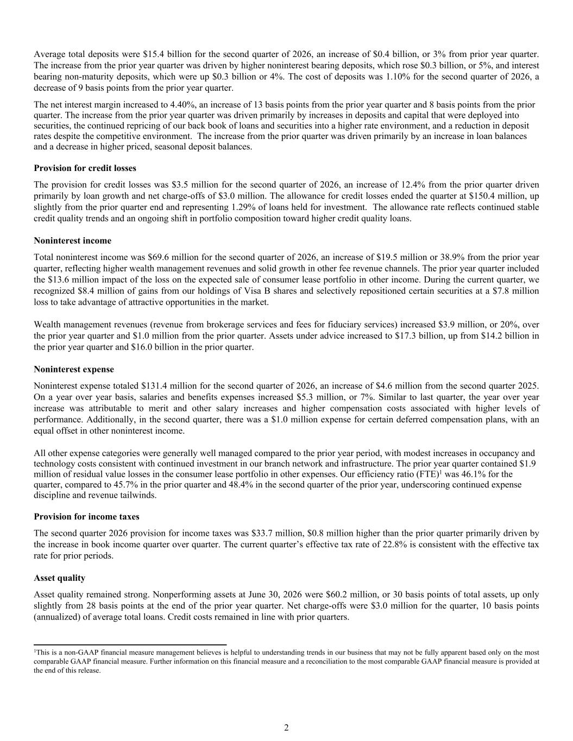
Average total deposits were $15.4 billion for the second quarter of 2026, an increase of $0.4 billion, or 3% from prior year quarter. The increase from the prior year quarter was driven by higher noninterest bearing deposits, which rose $0.3 billion, or 5%, and interest bearing non-maturity deposits, which were up $0.3 billion or 4%. The cost of deposits was 1.10% for the second quarter of 2026, a decrease of 9 basis points from the prior year quarter. The net interest margin increased to 4.40%, an increase of 13 basis points from the prior year quarter and 8 basis points from the prior quarter. The increase from the prior year quarter was driven primarily by increases in deposits and capital that were deployed into securities, the continued repricing of our back book of loans and securities into a higher rate environment, and a reduction in deposit rates despite the competitive environment. The increase from the prior quarter was driven primarily by an increase in loan balances and a decrease in higher priced, seasonal deposit balances. Provision for credit losses The provision for credit losses was $3.5 million for the second quarter of 2026, an increase of 12.4% from the prior quarter driven primarily by loan growth and net charge-offs of $3.0 million. The allowance for credit losses ended the quarter at $150.4 million, up slightly from the prior quarter end and representing 1.29% of loans held for investment. The allowance rate reflects continued stable credit quality trends and an ongoing shift in portfolio composition toward higher credit quality loans. Noninterest income Total noninterest income was $69.6 million for the second quarter of 2026, an increase of $19.5 million or 38.9% from the prior year quarter, reflecting higher wealth management revenues and solid growth in other fee revenue channels. The prior year quarter included the $13.6 million impact of the loss on the expected sale of consumer lease portfolio in other income. During the current quarter, we recognized $8.4 million of gains from our holdings of Visa B shares and selectively repositioned certain securities at a $7.8 million loss to take advantage of attractive opportunities in the market. Wealth management revenues (revenue from brokerage services and fees for fiduciary services) increased $3.9 million, or 20%, over the prior year quarter and $1.0 million from the prior quarter. Assets under advice increased to $17.3 billion, up from $14.2 billion in the prior year quarter and $16.0 billion in the prior quarter. Noninterest expense Noninterest expense totaled $131.4 million for the second quarter of 2026, an increase of $4.6 million from the second quarter 2025. On a year over year basis, salaries and benefits expenses increased $5.3 million, or 7%. Similar to last quarter, the year over year increase was attributable to merit and other salary increases and higher compensation costs associated with higher levels of performance. Additionally, in the second quarter, there was a $1.0 million expense for certain deferred compensation plans, with an equal offset in other noninterest income. All other expense categories were generally well managed compared to the prior year period, with modest increases in occupancy and technology costs consistent with continued investment in our branch network and infrastructure. The prior year quarter contained $1.9 million of residual value losses in the consumer lease portfolio in other expenses. Our efficiency ratio (FTE)1 was 46.1% for the quarter, compared to 45.7% in the prior quarter and 48.4% in the second quarter of the prior year, underscoring continued expense discipline and revenue tailwinds. Provision for income taxes The second quarter 2026 provision for income taxes was $33.7 million, $0.8 million higher than the prior quarter primarily driven by the increase in book income quarter over quarter. The current quarter’s effective tax rate of 22.8% is consistent with the effective tax rate for prior periods. Asset quality Asset quality remained strong. Nonperforming assets at June 30, 2026 were $60.2 million, or 30 basis points of total assets, up only slightly from 28 basis points at the end of the prior year quarter. Net charge-offs were $3.0 million for the quarter, 10 basis points (annualized) of average total loans. Credit costs remained in line with prior quarters. 1This is a non-GAAP financial measure management believes is helpful to understanding trends in our business that may not be fully apparent based only on the most comparable GAAP financial measure. Further information on this financial measure and a reconciliation to the most comparable GAAP financial measure is provided at the end of this release. 2

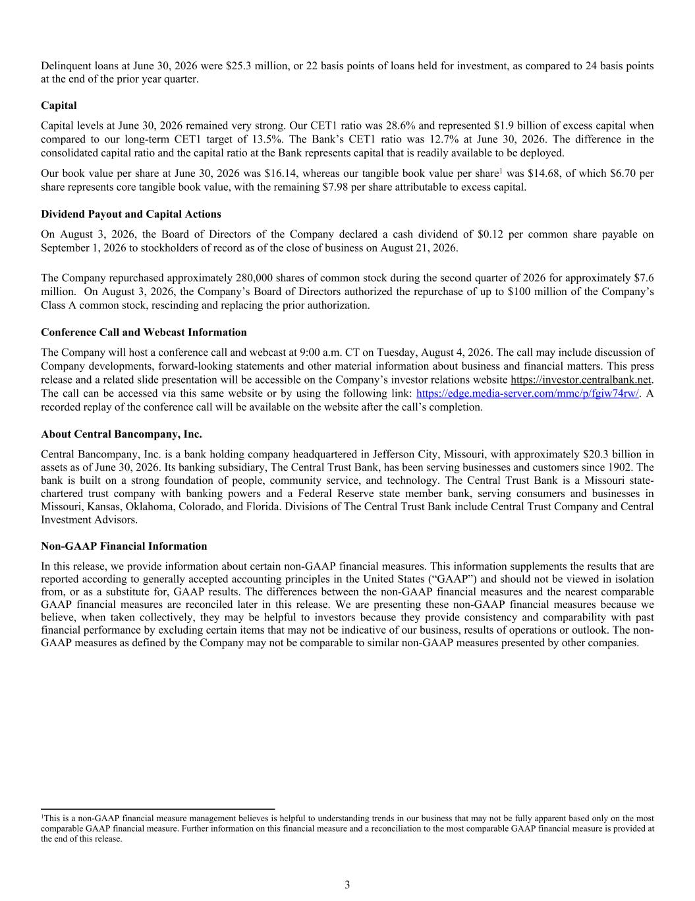
Delinquent loans at June 30, 2026 were $25.3 million, or 22 basis points of loans held for investment, as compared to 24 basis points at the end of the prior year quarter. Capital Capital levels at June 30, 2026 remained very strong. Our CET1 ratio was 28.6% and represented $1.9 billion of excess capital when compared to our long-term CET1 target of 13.5%. The Bank’s CET1 ratio was 12.7% at June 30, 2026. The difference in the consolidated capital ratio and the capital ratio at the Bank represents capital that is readily available to be deployed. Our book value per share at June 30, 2026 was $16.14, whereas our tangible book value per share1 was $14.68, of which $6.70 per share represents core tangible book value, with the remaining $7.98 per share attributable to excess capital. Dividend Payout and Capital Actions On August 3, 2026, the Board of Directors of the Company declared a cash dividend of $0.12 per common share payable on September 1, 2026 to stockholders of record as of the close of business on August 21, 2026. The Company repurchased approximately 280,000 shares of common stock during the second quarter of 2026 for approximately $7.6 million. On August 3, 2026, the Company’s Board of Directors authorized the repurchase of up to $100 million of the Company’s Class A common stock, rescinding and replacing the prior authorization. Conference Call and Webcast Information The Company will host a conference call and webcast at 9:00 a.m. CT on Tuesday, August 4, 2026. The call may include discussion of Company developments, forward-looking statements and other material information about business and financial matters. This press release and a related slide presentation will be accessible on the Company’s investor relations website https://investor.centralbank.net. The call can be accessed via this same website or by using the following link: https://edge.media-server.com/mmc/p/fgiw74rw/. A recorded replay of the conference call will be available on the website after the call’s completion. About Central Bancompany, Inc. Central Bancompany, Inc. is a bank holding company headquartered in Jefferson City, Missouri, with approximately $20.3 billion in assets as of June 30, 2026. Its banking subsidiary, The Central Trust Bank, has been serving businesses and customers since 1902. The bank is built on a strong foundation of people, community service, and technology. The Central Trust Bank is a Missouri state- chartered trust company with banking powers and a Federal Reserve state member bank, serving consumers and businesses in Missouri, Kansas, Oklahoma, Colorado, and Florida. Divisions of The Central Trust Bank include Central Trust Company and Central Investment Advisors. Non-GAAP Financial Information In this release, we provide information about certain non-GAAP financial measures. This information supplements the results that are reported according to generally accepted accounting principles in the United States (“GAAP”) and should not be viewed in isolation from, or as a substitute for, GAAP results. The differences between the non-GAAP financial measures and the nearest comparable GAAP financial measures are reconciled later in this release. We are presenting these non-GAAP financial measures because we believe, when taken collectively, they may be helpful to investors because they provide consistency and comparability with past financial performance by excluding certain items that may not be indicative of our business, results of operations or outlook. The non- GAAP measures as defined by the Company may not be comparable to similar non-GAAP measures presented by other companies. 1This is a non-GAAP financial measure management believes is helpful to understanding trends in our business that may not be fully apparent based only on the most comparable GAAP financial measure. Further information on this financial measure and a reconciliation to the most comparable GAAP financial measure is provided at the end of this release. 3

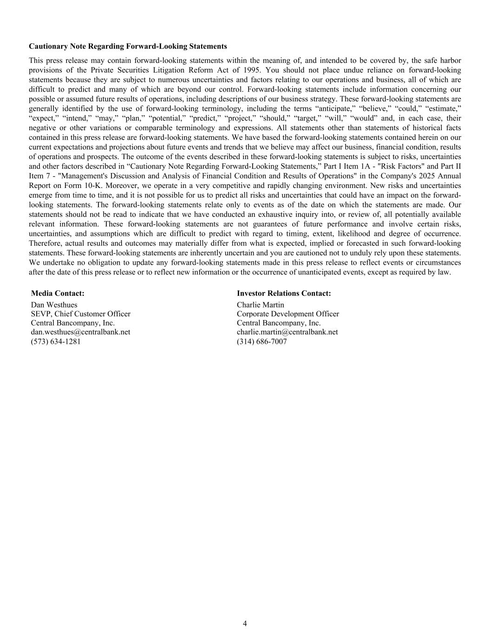
Cautionary Note Regarding Forward-Looking Statements This press release may contain forward-looking statements within the meaning of, and intended to be covered by, the safe harbor provisions of the Private Securities Litigation Reform Act of 1995. You should not place undue reliance on forward-looking statements because they are subject to numerous uncertainties and factors relating to our operations and business, all of which are difficult to predict and many of which are beyond our control. Forward-looking statements include information concerning our possible or assumed future results of operations, including descriptions of our business strategy. These forward-looking statements are generally identified by the use of forward-looking terminology, including the terms “anticipate,” “believe,” “could,” “estimate,” “expect,” “intend,” “may,” “plan,” “potential,” “predict,” “project,” “should,” “target,” “will,” “would” and, in each case, their negative or other variations or comparable terminology and expressions. All statements other than statements of historical facts contained in this press release are forward-looking statements. We have based the forward-looking statements contained herein on our current expectations and projections about future events and trends that we believe may affect our business, financial condition, results of operations and prospects. The outcome of the events described in these forward-looking statements is subject to risks, uncertainties and other factors described in “Cautionary Note Regarding Forward-Looking Statements,” Part I Item 1A - "Risk Factors" and Part II Item 7 - "Management's Discussion and Analysis of Financial Condition and Results of Operations" in the Company's 2025 Annual Report on Form 10-K. Moreover, we operate in a very competitive and rapidly changing environment. New risks and uncertainties emerge from time to time, and it is not possible for us to predict all risks and uncertainties that could have an impact on the forward- looking statements. The forward-looking statements relate only to events as of the date on which the statements are made. Our statements should not be read to indicate that we have conducted an exhaustive inquiry into, or review of, all potentially available relevant information. These forward-looking statements are not guarantees of future performance and involve certain risks, uncertainties, and assumptions which are difficult to predict with regard to timing, extent, likelihood and degree of occurrence. Therefore, actual results and outcomes may materially differ from what is expected, implied or forecasted in such forward-looking statements. These forward-looking statements are inherently uncertain and you are cautioned not to unduly rely upon these statements. We undertake no obligation to update any forward-looking statements made in this press release to reflect events or circumstances after the date of this press release or to reflect new information or the occurrence of unanticipated events, except as required by law. Media Contact: Investor Relations Contact: Dan Westhues Charlie Martin SEVP, Chief Customer Officer Corporate Development Officer Central Bancompany, Inc. Central Bancompany, Inc. dan.westhues@centralbank.net charlie.martin@centralbank.net (573) 634-1281 (314) 686-7007 4

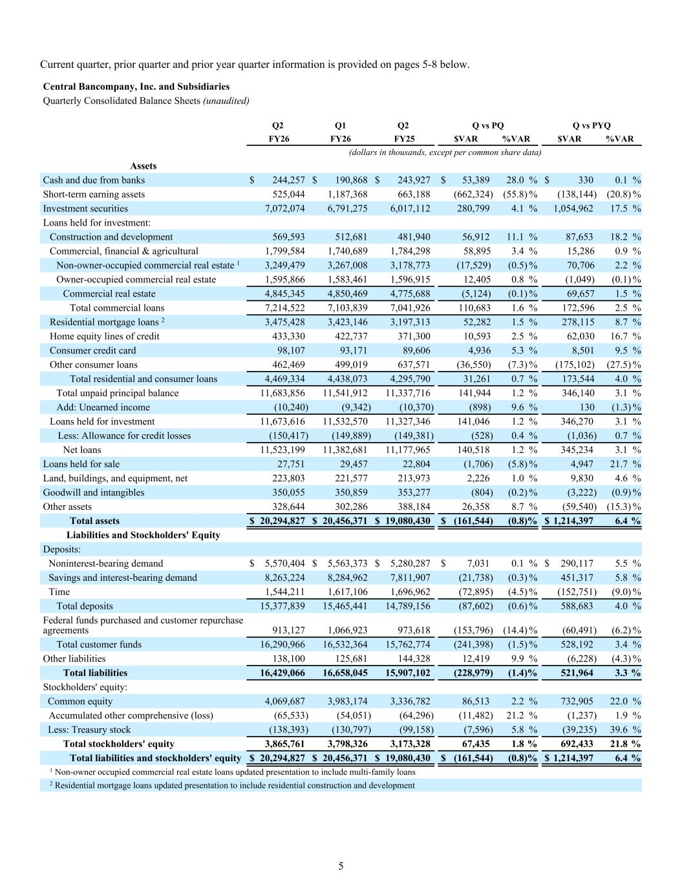
Current quarter, prior quarter and prior year quarter information is provided on pages 5-8 below. Central Bancompany, Inc. and Subsidiaries Quarterly Consolidated Balance Sheets (unaudited) Q2 Q1 Q2 Q vs PQ Q vs PYQ FY26 FY26 FY25 $VAR %VAR $VAR %VAR (dollars in thousands, except per common share data) Assets Cash and due from banks $ 244,257 $ 190,868 $ 243,927 $ 53,389 28.0 % $ 330 0.1 % Short-term earning assets 525,044 1,187,368 663,188 (662,324) (55.8) % (138,144) (20.8) % Investment securities 7,072,074 6,791,275 6,017,112 280,799 4.1 % 1,054,962 17.5 % Loans held for investment: Construction and development 569,593 512,681 481,940 56,912 11.1 % 87,653 18.2 % Commercial, financial & agricultural 1,799,584 1,740,689 1,784,298 58,895 3.4 % 15,286 0.9 % Non-owner-occupied commercial real estate 1 3,249,479 3,267,008 3,178,773 (17,529) (0.5) % 70,706 2.2 % Owner-occupied commercial real estate 1,595,866 1,583,461 1,596,915 12,405 0.8 % (1,049) (0.1) % Commercial real estate 4,845,345 4,850,469 4,775,688 (5,124) (0.1) % 69,657 1.5 % Total commercial loans 7,214,522 7,103,839 7,041,926 110,683 1.6 % 172,596 2.5 % Residential mortgage loans 2 3,475,428 3,423,146 3,197,313 52,282 1.5 % 278,115 8.7 % Home equity lines of credit 433,330 422,737 371,300 10,593 2.5 % 62,030 16.7 % Consumer credit card 98,107 93,171 89,606 4,936 5.3 % 8,501 9.5 % Other consumer loans 462,469 499,019 637,571 (36,550) (7.3) % (175,102) (27.5) % Total residential and consumer loans 4,469,334 4,438,073 4,295,790 31,261 0.7 % 173,544 4.0 % Total unpaid principal balance 11,683,856 11,541,912 11,337,716 141,944 1.2 % 346,140 3.1 % Add: Unearned income (10,240) (9,342) (10,370) (898) 9.6 % 130 (1.3) % Loans held for investment 11,673,616 11,532,570 11,327,346 141,046 1.2 % 346,270 3.1 % Less: Allowance for credit losses (150,417) (149,889) (149,381) (528) 0.4 % (1,036) 0.7 % Net loans 11,523,199 11,382,681 11,177,965 140,518 1.2 % 345,234 3.1 % Loans held for sale 27,751 29,457 22,804 (1,706) (5.8) % 4,947 21.7 % Land, buildings, and equipment, net 223,803 221,577 213,973 2,226 1.0 % 9,830 4.6 % Goodwill and intangibles 350,055 350,859 353,277 (804) (0.2) % (3,222) (0.9) % Other assets 328,644 302,286 388,184 26,358 8.7 % (59,540) (15.3) % Total assets $ 20,294,827 $ 20,456,371 $ 19,080,430 $ (161,544) (0.8) % $ 1,214,397 6.4 % Liabilities and Stockholders' Equity Deposits: Noninterest-bearing demand $ 5,570,404 $ 5,563,373 $ 5,280,287 $ 7,031 0.1 % $ 290,117 5.5 % Savings and interest-bearing demand 8,263,224 8,284,962 7,811,907 (21,738) (0.3) % 451,317 5.8 % Time 1,544,211 1,617,106 1,696,962 (72,895) (4.5) % (152,751) (9.0) % Total deposits 15,377,839 15,465,441 14,789,156 (87,602) (0.6) % 588,683 4.0 % Federal funds purchased and customer repurchase agreements 913,127 1,066,923 973,618 (153,796) (14.4) % (60,491) (6.2) % Total customer funds 16,290,966 16,532,364 15,762,774 (241,398) (1.5) % 528,192 3.4 % Other liabilities 138,100 125,681 144,328 12,419 9.9 % (6,228) (4.3) % Total liabilities 16,429,066 16,658,045 15,907,102 (228,979) (1.4) % 521,964 3.3 % Stockholders' equity: Common equity 4,069,687 3,983,174 3,336,782 86,513 2.2 % 732,905 22.0 % Accumulated other comprehensive (loss) (65,533) (54,051) (64,296) (11,482) 21.2 % (1,237) 1.9 % Less: Treasury stock (138,393) (130,797) (99,158) (7,596) 5.8 % (39,235) 39.6 % Total stockholders' equity 3,865,761 3,798,326 3,173,328 67,435 1.8 % 692,433 21.8 % Total liabilities and stockholders' equity $ 20,294,827 $ 20,456,371 $ 19,080,430 $ (161,544) (0.8) % $ 1,214,397 6.4 % 1 Non-owner occupied commercial real estate loans updated presentation to include multi-family loans 2 Residential mortgage loans updated presentation to include residential construction and development 5

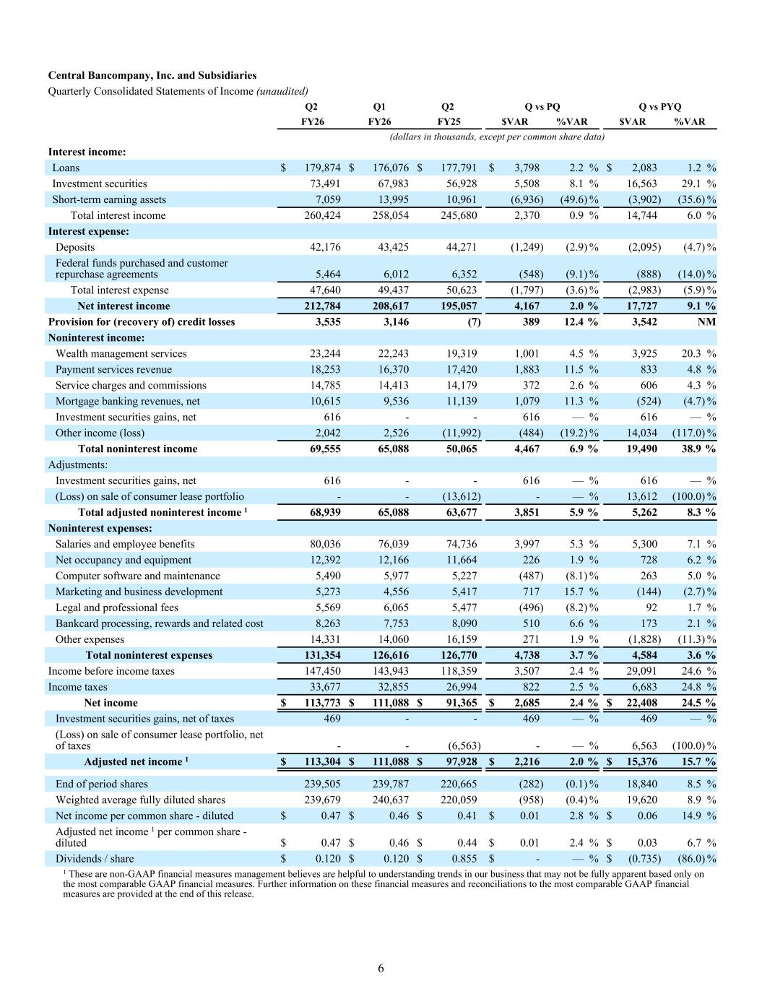
Central Bancompany, Inc. and Subsidiaries Quarterly Consolidated Statements of Income (unaudited) Q2 Q1 Q2 Q vs PQ Q vs PYQ FY26 FY26 FY25 $VAR %VAR $VAR %VAR (dollars in thousands, except per common share data) Interest income: Loans $ 179,874 $ 176,076 $ 177,791 $ 3,798 2.2 % $ 2,083 1.2 % Investment securities 73,491 67,983 56,928 5,508 8.1 % 16,563 29.1 % Short-term earning assets 7,059 13,995 10,961 (6,936) (49.6) % (3,902) (35.6) % Total interest income 260,424 258,054 245,680 2,370 0.9 % 14,744 6.0 % Interest expense: Deposits 42,176 43,425 44,271 (1,249) (2.9) % (2,095) (4.7) % Federal funds purchased and customer repurchase agreements 5,464 6,012 6,352 (548) (9.1) % (888) (14.0) % Total interest expense 47,640 49,437 50,623 (1,797) (3.6) % (2,983) (5.9) % Net interest income 212,784 208,617 195,057 4,167 2.0 % 17,727 9.1 % Provision for (recovery of) credit losses 3,535 3,146 (7) 389 12.4 % 3,542 NM Noninterest income: Wealth management services 23,244 22,243 19,319 1,001 4.5 % 3,925 20.3 % Payment services revenue 18,253 16,370 17,420 1,883 11.5 % 833 4.8 % Service charges and commissions 14,785 14,413 14,179 372 2.6 % 606 4.3 % Mortgage banking revenues, net 10,615 9,536 11,139 1,079 11.3 % (524) (4.7) % Investment securities gains, net 616 - - 616 — % 616 — % Other income (loss) 2,042 2,526 (11,992) (484) (19.2) % 14,034 (117.0) % Total noninterest income 69,555 65,088 50,065 4,467 6.9 % 19,490 38.9 % Adjustments: Investment securities gains, net 616 - - 616 — % 616 — % (Loss) on sale of consumer lease portfolio - - (13,612) - — % 13,612 (100.0) % Total adjusted noninterest income 1 68,939 65,088 63,677 3,851 5.9 % 5,262 8.3 % Noninterest expenses: Salaries and employee benefits 80,036 76,039 74,736 3,997 5.3 % 5,300 7.1 % Net occupancy and equipment 12,392 12,166 11,664 226 1.9 % 728 6.2 % Computer software and maintenance 5,490 5,977 5,227 (487) (8.1) % 263 5.0 % Marketing and business development 5,273 4,556 5,417 717 15.7 % (144) (2.7) % Legal and professional fees 5,569 6,065 5,477 (496) (8.2) % 92 1.7 % Bankcard processing, rewards and related cost 8,263 7,753 8,090 510 6.6 % 173 2.1 % Other expenses 14,331 14,060 16,159 271 1.9 % (1,828) (11.3) % Total noninterest expenses 131,354 126,616 126,770 4,738 3.7 % 4,584 3.6 % Income before income taxes 147,450 143,943 118,359 3,507 2.4 % 29,091 24.6 % Income taxes 33,677 32,855 26,994 822 2.5 % 6,683 24.8 % Net income $ 113,773 $ 111,088 $ 91,365 $ 2,685 2.4 % $ 22,408 24.5 % Investment securities gains, net of taxes 469 - - 469 — % 469 — % (Loss) on sale of consumer lease portfolio, net of taxes - - (6,563) - — % 6,563 (100.0) % Adjusted net income 1 $ 113,304 $ 111,088 $ 97,928 $ 2,216 2.0 % $ 15,376 15.7 % End of period shares 239,505 239,787 220,665 (282) (0.1) % 18,840 8.5 % Weighted average fully diluted shares 239,679 240,637 220,059 (958) (0.4) % 19,620 8.9 % Net income per common share - diluted $ 0.47 $ 0.46 $ 0.41 $ 0.01 2.8 % $ 0.06 14.9 % Adjusted net income 1 per common share - diluted $ 0.47 $ 0.46 $ 0.44 $ 0.01 2.4 % $ 0.03 6.7 % Dividends / share $ 0.120 $ 0.120 $ 0.855 $ - — % $ (0.735) (86.0) % 1 These are non-GAAP financial measures management believes are helpful to understanding trends in our business that may not be fully apparent based only on the most comparable GAAP financial measures. Further information on these financial measures and reconciliations to the most comparable GAAP financial measures are provided at the end of this release. 6

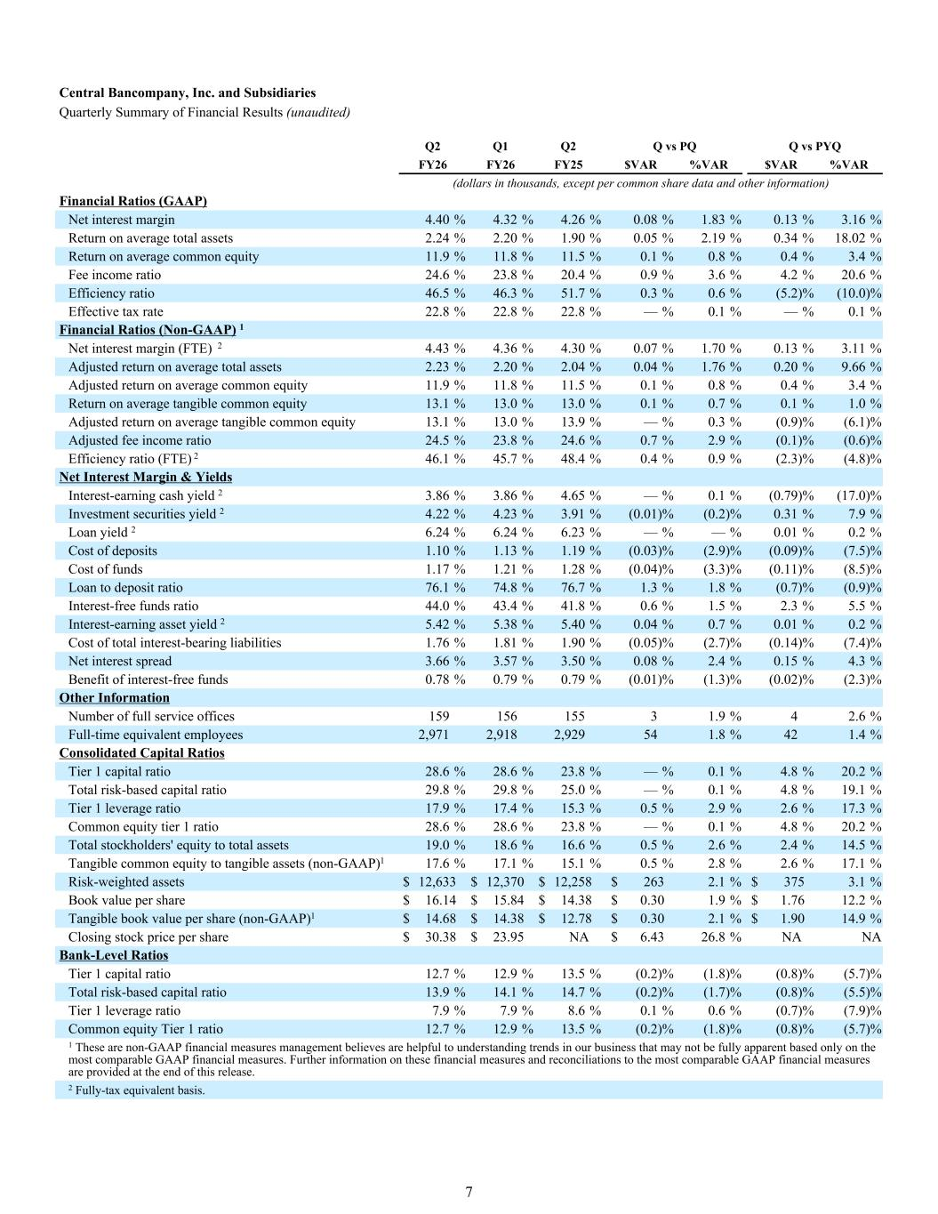
(dollars in thousands, except per common share data and other information) Financial Ratios (GAAP) Net interest margin 4.40 % 4.32 % 4.26 % 0.08 % 1.83 % 0.13 % 3.16 % Return on average total assets 2.24 % 2.20 % 1.90 % 0.05 % 2.19 % 0.34 % 18.02 % Return on average common equity 11.9 % 11.8 % 11.5 % 0.1 % 0.8 % 0.4 % 3.4 % Fee income ratio 24.6 % 23.8 % 20.4 % 0.9 % 3.6 % 4.2 % 20.6 % Efficiency ratio 46.5 % 46.3 % 51.7 % 0.3 % 0.6 % (5.2) % (10.0) % Effective tax rate 22.8 % 22.8 % 22.8 % — % 0.1 % — % 0.1 % Financial Ratios (Non-GAAP) 1 Net interest margin (FTE) 2 4.43 % 4.36 % 4.30 % 0.07 % 1.70 % 0.13 % 3.11 % Adjusted return on average total assets 2.23 % 2.20 % 2.04 % 0.04 % 1.76 % 0.20 % 9.66 % Adjusted return on average common equity 11.9 % 11.8 % 11.5 % 0.1 % 0.8 % 0.4 % 3.4 % Return on average tangible common equity 13.1 % 13.0 % 13.0 % 0.1 % 0.7 % 0.1 % 1.0 % Adjusted return on average tangible common equity 13.1 % 13.0 % 13.9 % — % 0.3 % (0.9) % (6.1) % Adjusted fee income ratio 24.5 % 23.8 % 24.6 % 0.7 % 2.9 % (0.1) % (0.6) % Efficiency ratio (FTE) 2 46.1 % 45.7 % 48.4 % 0.4 % 0.9 % (2.3) % (4.8) % Net Interest Margin & Yields Interest-earning cash yield 2 3.86 % 3.86 % 4.65 % — % 0.1 % (0.79) % (17.0) % Investment securities yield 2 4.22 % 4.23 % 3.91 % (0.01) % (0.2) % 0.31 % 7.9 % Loan yield 2 6.24 % 6.24 % 6.23 % — % — % 0.01 % 0.2 % Cost of deposits 1.10 % 1.13 % 1.19 % (0.03) % (2.9) % (0.09) % (7.5) % Cost of funds 1.17 % 1.21 % 1.28 % (0.04) % (3.3) % (0.11) % (8.5) % Loan to deposit ratio 76.1 % 74.8 % 76.7 % 1.3 % 1.8 % (0.7) % (0.9) % Interest-free funds ratio 44.0 % 43.4 % 41.8 % 0.6 % 1.5 % 2.3 % 5.5 % Interest-earning asset yield 2 5.42 % 5.38 % 5.40 % 0.04 % 0.7 % 0.01 % 0.2 % Cost of total interest-bearing liabilities 1.76 % 1.81 % 1.90 % (0.05) % (2.7) % (0.14) % (7.4) % Net interest spread 3.66 % 3.57 % 3.50 % 0.08 % 2.4 % 0.15 % 4.3 % Benefit of interest-free funds 0.78 % 0.79 % 0.79 % (0.01) % (1.3) % (0.02) % (2.3) % Other Information Number of full service offices 159 156 155 3 1.9 % 4 2.6 % Full-time equivalent employees 2,971 2,918 2,929 54 1.8 % 42 1.4 % Consolidated Capital Ratios Tier 1 capital ratio 28.6 % 28.6 % 23.8 % — % 0.1 % 4.8 % 20.2 % Total risk-based capital ratio 29.8 % 29.8 % 25.0 % — % 0.1 % 4.8 % 19.1 % Tier 1 leverage ratio 17.9 % 17.4 % 15.3 % 0.5 % 2.9 % 2.6 % 17.3 % Common equity tier 1 ratio 28.6 % 28.6 % 23.8 % — % 0.1 % 4.8 % 20.2 % Total stockholders' equity to total assets 19.0 % 18.6 % 16.6 % 0.5 % 2.6 % 2.4 % 14.5 % Tangible common equity to tangible assets (non-GAAP)1 17.6 % 17.1 % 15.1 % 0.5 % 2.8 % 2.6 % 17.1 % Risk-weighted assets $ 12,633 $ 12,370 $ 12,258 $ 263 2.1 % $ 375 3.1 % Book value per share $ 16.14 $ 15.84 $ 14.38 $ 0.30 1.9 % $ 1.76 12.2 % Tangible book value per share (non-GAAP)1 $ 14.68 $ 14.38 $ 12.78 $ 0.30 2.1 % $ 1.90 14.9 % Closing stock price per share $ 30.38 $ 23.95 NA $ 6.43 26.8 % NA NA Bank-Level Ratios Tier 1 capital ratio 12.7 % 12.9 % 13.5 % (0.2) % (1.8) % (0.8) % (5.7) % Total risk-based capital ratio 13.9 % 14.1 % 14.7 % (0.2) % (1.7) % (0.8) % (5.5) % Tier 1 leverage ratio 7.9 % 7.9 % 8.6 % 0.1 % 0.6 % (0.7) % (7.9) % Common equity Tier 1 ratio 12.7 % 12.9 % 13.5 % (0.2) % (1.8) % (0.8) % (5.7) % 1 These are non-GAAP financial measures management believes are helpful to understanding trends in our business that may not be fully apparent based only on the most comparable GAAP financial measures. Further information on these financial measures and reconciliations to the most comparable GAAP financial measures are provided at the end of this release. 2 Fully-tax equivalent basis. Central Bancompany, Inc. and Subsidiaries Quarterly Summary of Financial Results (unaudited) Q2 Q1 Q2 Q vs PQ Q vs PYQ FY26 FY26 FY25 $VAR %VAR $VAR %VAR 7

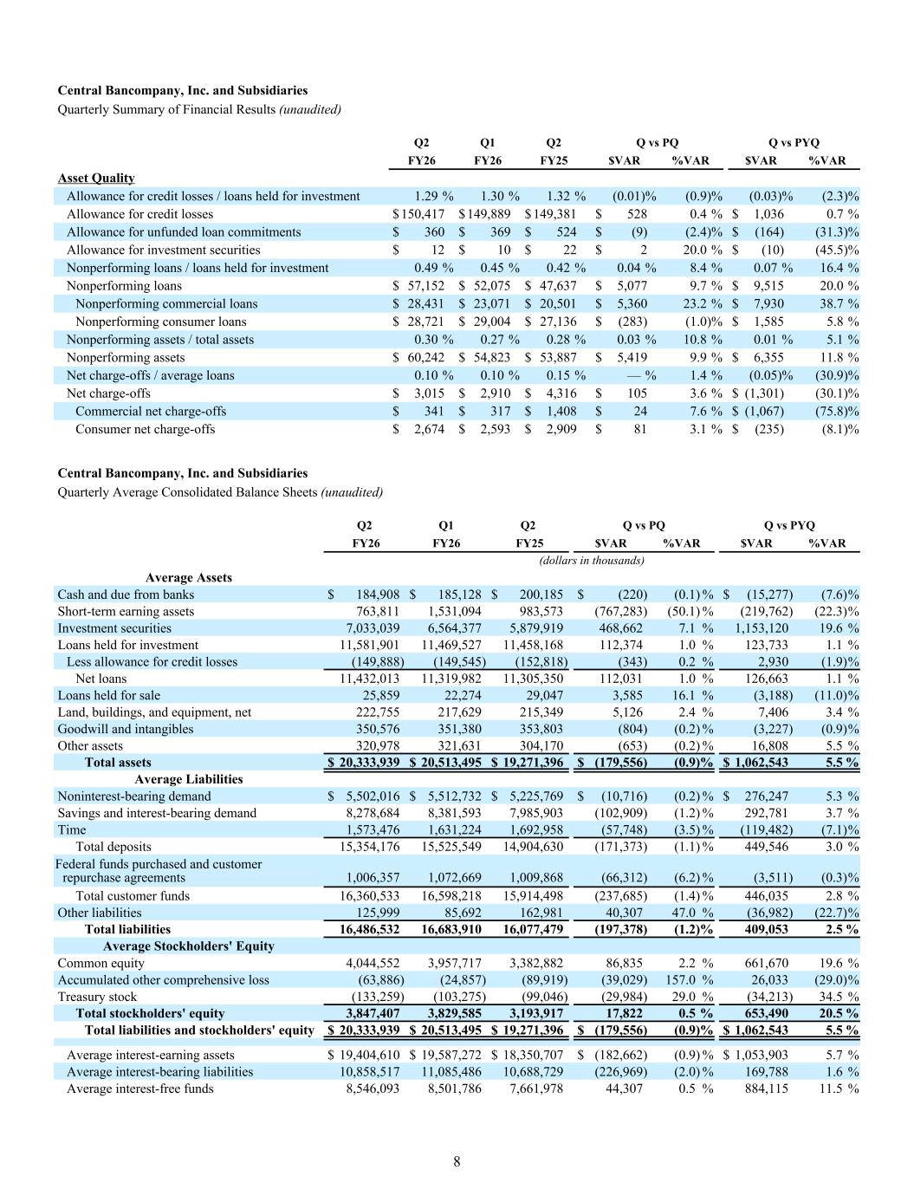
Asset Quality Allowance for credit losses / loans held for investment 1.29 % 1.30 % 1.32 % (0.01) % (0.9) % (0.03) % (2.3) % Allowance for credit losses $ 150,417 $ 149,889 $ 149,381 $ 528 0.4 % $ 1,036 0.7 % Allowance for unfunded loan commitments $ 360 $ 369 $ 524 $ (9) (2.4) % $ (164) (31.3) % Allowance for investment securities $ 12 $ 10 $ 22 $ 2 20.0 % $ (10) (45.5) % Nonperforming loans / loans held for investment 0.49 % 0.45 % 0.42 % 0.04 % 8.4 % 0.07 % 16.4 % Nonperforming loans $ 57,152 $ 52,075 $ 47,637 $ 5,077 9.7 % $ 9,515 20.0 % Nonperforming commercial loans $ 28,431 $ 23,071 $ 20,501 $ 5,360 23.2 % $ 7,930 38.7 % Nonperforming consumer loans $ 28,721 $ 29,004 $ 27,136 $ (283) (1.0) % $ 1,585 5.8 % Nonperforming assets / total assets 0.30 % 0.27 % 0.28 % 0.03 % 10.8 % 0.01 % 5.1 % Nonperforming assets $ 60,242 $ 54,823 $ 53,887 $ 5,419 9.9 % $ 6,355 11.8 % Net charge-offs / average loans 0.10 % 0.10 % 0.15 % — % 1.4 % (0.05) % (30.9) % Net charge-offs $ 3,015 $ 2,910 $ 4,316 $ 105 3.6 % $ (1,301) (30.1) % Commercial net charge-offs $ 341 $ 317 $ 1,408 $ 24 7.6 % $ (1,067) (75.8) % Consumer net charge-offs $ 2,674 $ 2,593 $ 2,909 $ 81 3.1 % $ (235) (8.1) % Central Bancompany, Inc. and Subsidiaries Quarterly Summary of Financial Results (unaudited) Q2 Q1 Q2 Q vs PQ Q vs PYQ FY26 FY26 FY25 $VAR %VAR $VAR %VAR Central Bancompany, Inc. and Subsidiaries Quarterly Average Consolidated Balance Sheets (unaudited) Q2 Q1 Q2 Q vs PQ Q vs PYQ FY26 FY26 FY25 $VAR %VAR $VAR %VAR (dollars in thousands) Average Assets Cash and due from banks $ 184,908 $ 185,128 $ 200,185 $ (220) (0.1) % $ (15,277) (7.6) % Short-term earning assets 763,811 1,531,094 983,573 (767,283) (50.1) % (219,762) (22.3) % Investment securities 7,033,039 6,564,377 5,879,919 468,662 7.1 % 1,153,120 19.6 % Loans held for investment 11,581,901 11,469,527 11,458,168 112,374 1.0 % 123,733 1.1 % Less allowance for credit losses (149,888) (149,545) (152,818) (343) 0.2 % 2,930 (1.9) % Net loans 11,432,013 11,319,982 11,305,350 112,031 1.0 % 126,663 1.1 % Loans held for sale 25,859 22,274 29,047 3,585 16.1 % (3,188) (11.0) % Land, buildings, and equipment, net 222,755 217,629 215,349 5,126 2.4 % 7,406 3.4 % Goodwill and intangibles 350,576 351,380 353,803 (804) (0.2) % (3,227) (0.9) % Other assets 320,978 321,631 304,170 (653) (0.2) % 16,808 5.5 % Total assets $ 20,333,939 $ 20,513,495 $ 19,271,396 $ (179,556) (0.9) % $ 1,062,543 5.5 % Average Liabilities Noninterest-bearing demand $ 5,502,016 $ 5,512,732 $ 5,225,769 $ (10,716) (0.2) % $ 276,247 5.3 % Savings and interest-bearing demand 8,278,684 8,381,593 7,985,903 (102,909) (1.2) % 292,781 3.7 % Time 1,573,476 1,631,224 1,692,958 (57,748) (3.5) % (119,482) (7.1) % Total deposits 15,354,176 15,525,549 14,904,630 (171,373) (1.1) % 449,546 3.0 % Federal funds purchased and customer repurchase agreements 1,006,357 1,072,669 1,009,868 (66,312) (6.2) % (3,511) (0.3) % Total customer funds 16,360,533 16,598,218 15,914,498 (237,685) (1.4) % 446,035 2.8 % Other liabilities 125,999 85,692 162,981 40,307 47.0 % (36,982) (22.7) % Total liabilities 16,486,532 16,683,910 16,077,479 (197,378) (1.2) % 409,053 2.5 % Average Stockholders' Equity Common equity 4,044,552 3,957,717 3,382,882 86,835 2.2 % 661,670 19.6 % Accumulated other comprehensive loss (63,886) (24,857) (89,919) (39,029) 157.0 % 26,033 (29.0) % Treasury stock (133,259) (103,275) (99,046) (29,984) 29.0 % (34,213) 34.5 % Total stockholders' equity 3,847,407 3,829,585 3,193,917 17,822 0.5 % 653,490 20.5 % Total liabilities and stockholders' equity $ 20,333,939 $ 20,513,495 $ 19,271,396 $ (179,556) (0.9) % $ 1,062,543 5.5 % Average interest-earning assets $ 19,404,610 $ 19,587,272 $ 18,350,707 $ (182,662) (0.9) % $ 1,053,903 5.7 % Average interest-bearing liabilities 10,858,517 11,085,486 10,688,729 (226,969) (2.0) % 169,788 1.6 % Average interest-free funds 8,546,093 8,501,786 7,661,978 44,307 0.5 % 884,115 11.5 % 8

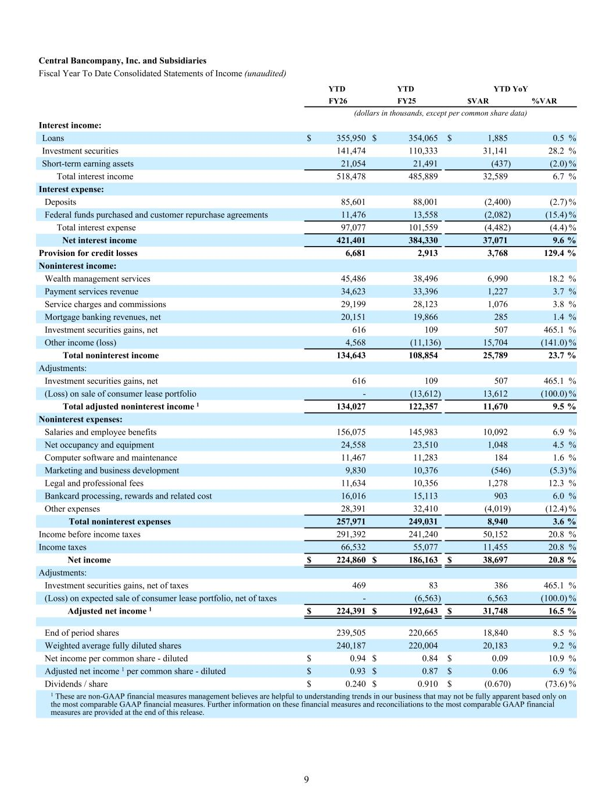
Central Bancompany, Inc. and Subsidiaries Fiscal Year To Date Consolidated Statements of Income (unaudited) YTD YTD YTD YoY FY26 FY25 $VAR %VAR (dollars in thousands, except per common share data) Interest income: Loans $ 355,950 $ 354,065 $ 1,885 0.5 % Investment securities 141,474 110,333 31,141 28.2 % Short-term earning assets 21,054 21,491 (437) (2.0) % Total interest income 518,478 485,889 32,589 6.7 % Interest expense: Deposits 85,601 88,001 (2,400) (2.7) % Federal funds purchased and customer repurchase agreements 11,476 13,558 (2,082) (15.4) % Total interest expense 97,077 101,559 (4,482) (4.4) % Net interest income 421,401 384,330 37,071 9.6 % Provision for credit losses 6,681 2,913 3,768 129.4 % Noninterest income: Wealth management services 45,486 38,496 6,990 18.2 % Payment services revenue 34,623 33,396 1,227 3.7 % Service charges and commissions 29,199 28,123 1,076 3.8 % Mortgage banking revenues, net 20,151 19,866 285 1.4 % Investment securities gains, net 616 109 507 465.1 % Other income (loss) 4,568 (11,136) 15,704 (141.0) % Total noninterest income 134,643 108,854 25,789 23.7 % Adjustments: Investment securities gains, net 616 109 507 465.1 % (Loss) on sale of consumer lease portfolio - (13,612) 13,612 (100.0) % Total adjusted noninterest income 1 134,027 122,357 11,670 9.5 % Noninterest expenses: Salaries and employee benefits 156,075 145,983 10,092 6.9 % Net occupancy and equipment 24,558 23,510 1,048 4.5 % Computer software and maintenance 11,467 11,283 184 1.6 % Marketing and business development 9,830 10,376 (546) (5.3) % Legal and professional fees 11,634 10,356 1,278 12.3 % Bankcard processing, rewards and related cost 16,016 15,113 903 6.0 % Other expenses 28,391 32,410 (4,019) (12.4) % Total noninterest expenses 257,971 249,031 8,940 3.6 % Income before income taxes 291,392 241,240 50,152 20.8 % Income taxes 66,532 55,077 11,455 20.8 % Net income $ 224,860 $ 186,163 $ 38,697 20.8 % Adjustments: Investment securities gains, net of taxes 469 83 386 465.1 % (Loss) on expected sale of consumer lease portfolio, net of taxes - (6,563) 6,563 (100.0) % Adjusted net income 1 $ 224,391 $ 192,643 $ 31,748 16.5 % End of period shares 239,505 220,665 18,840 8.5 % Weighted average fully diluted shares 240,187 220,004 20,183 9.2 % Net income per common share - diluted $ 0.94 $ 0.84 $ 0.09 10.9 % Adjusted net income 1 per common share - diluted $ 0.93 $ 0.87 $ 0.06 6.9 % Dividends / share $ 0.240 $ 0.910 $ (0.670) (73.6) % 1 These are non-GAAP financial measures management believes are helpful to understanding trends in our business that may not be fully apparent based only on the most comparable GAAP financial measures. Further information on these financial measures and reconciliations to the most comparable GAAP financial measures are provided at the end of this release. 9

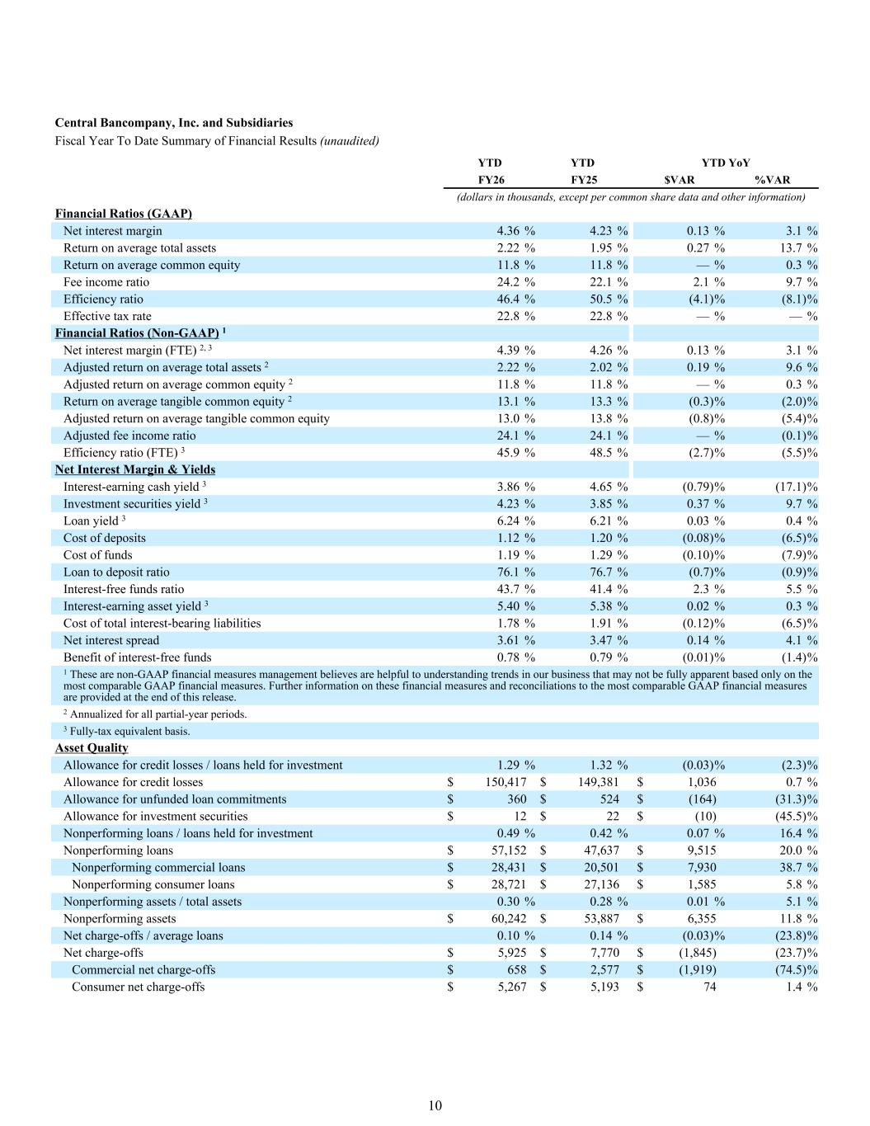
Financial Ratios (GAAP) Net interest margin 4.36 % 4.23 % 0.13 % 3.1 % Return on average total assets 2.22 % 1.95 % 0.27 % 13.7 % Return on average common equity 11.8 % 11.8 % — % 0.3 % Fee income ratio 24.2 % 22.1 % 2.1 % 9.7 % Efficiency ratio 46.4 % 50.5 % (4.1) % (8.1) % Effective tax rate 22.8 % 22.8 % — % — % Financial Ratios (Non-GAAP) 1 Net interest margin (FTE) 2, 3 4.39 % 4.26 % 0.13 % 3.1 % Adjusted return on average total assets 2 2.22 % 2.02 % 0.19 % 9.6 % Adjusted return on average common equity 2 11.8 % 11.8 % — % 0.3 % Return on average tangible common equity 2 13.1 % 13.3 % (0.3) % (2.0) % Adjusted return on average tangible common equity 13.0 % 13.8 % (0.8) % (5.4) % Adjusted fee income ratio 24.1 % 24.1 % — % (0.1) % Efficiency ratio (FTE) 3 45.9 % 48.5 % (2.7) % (5.5) % Net Interest Margin & Yields Interest-earning cash yield 3 3.86 % 4.65 % (0.79) % (17.1) % Investment securities yield 3 4.23 % 3.85 % 0.37 % 9.7 % Loan yield 3 6.24 % 6.21 % 0.03 % 0.4 % Cost of deposits 1.12 % 1.20 % (0.08) % (6.5) % Cost of funds 1.19 % 1.29 % (0.10) % (7.9) % Loan to deposit ratio 76.1 % 76.7 % (0.7) % (0.9) % Interest-free funds ratio 43.7 % 41.4 % 2.3 % 5.5 % Interest-earning asset yield 3 5.40 % 5.38 % 0.02 % 0.3 % Cost of total interest-bearing liabilities 1.78 % 1.91 % (0.12) % (6.5) % Net interest spread 3.61 % 3.47 % 0.14 % 4.1 % Benefit of interest-free funds 0.78 % 0.79 % (0.01) % (1.4) % 1 These are non-GAAP financial measures management believes are helpful to understanding trends in our business that may not be fully apparent based only on the most comparable GAAP financial measures. Further information on these financial measures and reconciliations to the most comparable GAAP financial measures are provided at the end of this release. 2 Annualized for all partial-year periods. 3 Fully-tax equivalent basis. Asset Quality Allowance for credit losses / loans held for investment 1.29 % 1.32 % (0.03) % (2.3) % Allowance for credit losses $ 150,417 $ 149,381 $ 1,036 0.7 % Allowance for unfunded loan commitments $ 360 $ 524 $ (164) (31.3) % Allowance for investment securities $ 12 $ 22 $ (10) (45.5) % Nonperforming loans / loans held for investment 0.49 % 0.42 % 0.07 % 16.4 % Nonperforming loans $ 57,152 $ 47,637 $ 9,515 20.0 % Nonperforming commercial loans $ 28,431 $ 20,501 $ 7,930 38.7 % Nonperforming consumer loans $ 28,721 $ 27,136 $ 1,585 5.8 % Nonperforming assets / total assets 0.30 % 0.28 % 0.01 % 5.1 % Nonperforming assets $ 60,242 $ 53,887 $ 6,355 11.8 % Net charge-offs / average loans 0.10 % 0.14 % (0.03) % (23.8) % Net charge-offs $ 5,925 $ 7,770 $ (1,845) (23.7) % Commercial net charge-offs $ 658 $ 2,577 $ (1,919) (74.5) % Consumer net charge-offs $ 5,267 $ 5,193 $ 74 1.4 % Central Bancompany, Inc. and Subsidiaries Fiscal Year To Date Summary of Financial Results (unaudited) YTD YTD YTD YoY FY26 FY25 $VAR %VAR (dollars in thousands, except per common share data and other information) 10

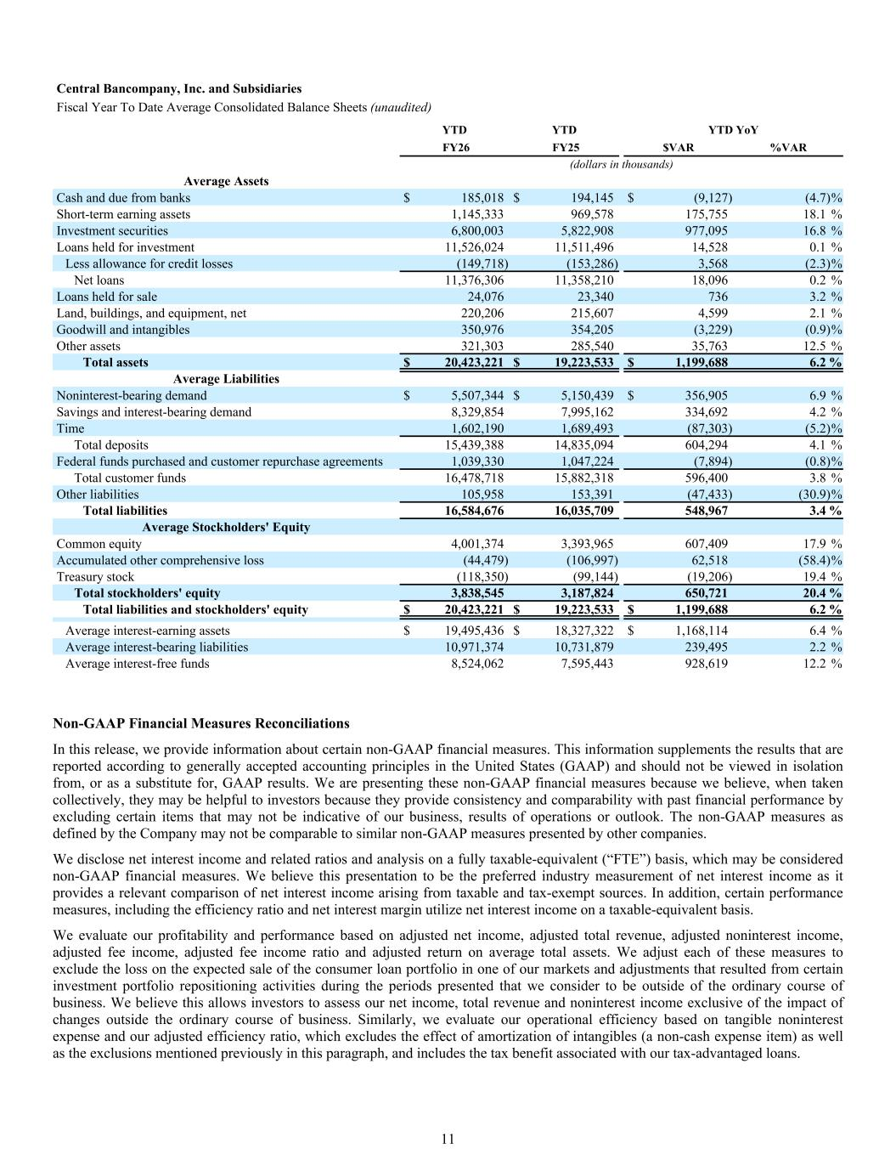
Central Bancompany, Inc. and Subsidiaries Fiscal Year To Date Average Consolidated Balance Sheets (unaudited) YTD YTD YTD YoY FY26 FY25 $VAR %VAR (dollars in thousands) Average Assets Cash and due from banks $ 185,018 $ 194,145 $ (9,127) (4.7) % Short-term earning assets 1,145,333 969,578 175,755 18.1 % Investment securities 6,800,003 5,822,908 977,095 16.8 % Loans held for investment 11,526,024 11,511,496 14,528 0.1 % Less allowance for credit losses (149,718) (153,286) 3,568 (2.3) % Net loans 11,376,306 11,358,210 18,096 0.2 % Loans held for sale 24,076 23,340 736 3.2 % Land, buildings, and equipment, net 220,206 215,607 4,599 2.1 % Goodwill and intangibles 350,976 354,205 (3,229) (0.9) % Other assets 321,303 285,540 35,763 12.5 % Total assets $ 20,423,221 $ 19,223,533 $ 1,199,688 6.2 % Average Liabilities Noninterest-bearing demand $ 5,507,344 $ 5,150,439 $ 356,905 6.9 % Savings and interest-bearing demand 8,329,854 7,995,162 334,692 4.2 % Time 1,602,190 1,689,493 (87,303) (5.2) % Total deposits 15,439,388 14,835,094 604,294 4.1 % Federal funds purchased and customer repurchase agreements 1,039,330 1,047,224 (7,894) (0.8) % Total customer funds 16,478,718 15,882,318 596,400 3.8 % Other liabilities 105,958 153,391 (47,433) (30.9) % Total liabilities 16,584,676 16,035,709 548,967 3.4 % Average Stockholders' Equity Common equity 4,001,374 3,393,965 607,409 17.9 % Accumulated other comprehensive loss (44,479) (106,997) 62,518 (58.4) % Treasury stock (118,350) (99,144) (19,206) 19.4 % Total stockholders' equity 3,838,545 3,187,824 650,721 20.4 % Total liabilities and stockholders' equity $ 20,423,221 $ 19,223,533 $ 1,199,688 6.2 % Average interest-earning assets $ 19,495,436 $ 18,327,322 $ 1,168,114 6.4 % Average interest-bearing liabilities 10,971,374 10,731,879 239,495 2.2 % Average interest-free funds 8,524,062 7,595,443 928,619 12.2 % Non-GAAP Financial Measures Reconciliations In this release, we provide information about certain non-GAAP financial measures. This information supplements the results that are reported according to generally accepted accounting principles in the United States (GAAP) and should not be viewed in isolation from, or as a substitute for, GAAP results. We are presenting these non-GAAP financial measures because we believe, when taken collectively, they may be helpful to investors because they provide consistency and comparability with past financial performance by excluding certain items that may not be indicative of our business, results of operations or outlook. The non-GAAP measures as defined by the Company may not be comparable to similar non-GAAP measures presented by other companies. We disclose net interest income and related ratios and analysis on a fully taxable-equivalent (“FTE”) basis, which may be considered non-GAAP financial measures. We believe this presentation to be the preferred industry measurement of net interest income as it provides a relevant comparison of net interest income arising from taxable and tax-exempt sources. In addition, certain performance measures, including the efficiency ratio and net interest margin utilize net interest income on a taxable-equivalent basis. We evaluate our profitability and performance based on adjusted net income, adjusted total revenue, adjusted noninterest income, adjusted fee income, adjusted fee income ratio and adjusted return on average total assets. We adjust each of these measures to exclude the loss on the expected sale of the consumer loan portfolio in one of our markets and adjustments that resulted from certain investment portfolio repositioning activities during the periods presented that we consider to be outside of the ordinary course of business. We believe this allows investors to assess our net income, total revenue and noninterest income exclusive of the impact of changes outside the ordinary course of business. Similarly, we evaluate our operational efficiency based on tangible noninterest expense and our adjusted efficiency ratio, which excludes the effect of amortization of intangibles (a non-cash expense item) as well as the exclusions mentioned previously in this paragraph, and includes the tax benefit associated with our tax-advantaged loans. 11

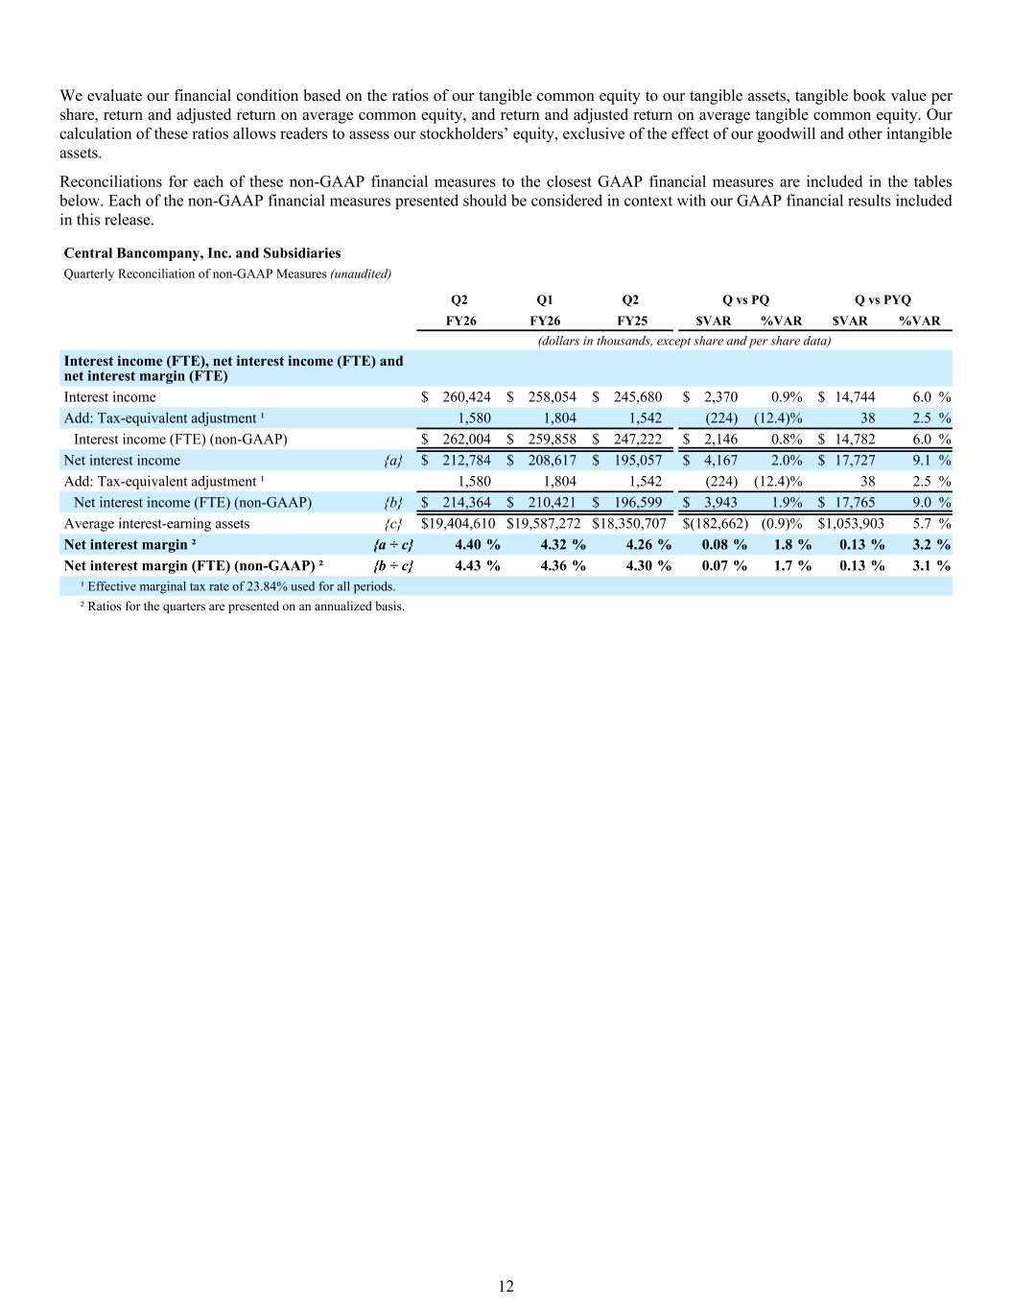
We evaluate our financial condition based on the ratios of our tangible common equity to our tangible assets, tangible book value per share, return and adjusted return on average common equity, and return and adjusted return on average tangible common equity. Our calculation of these ratios allows readers to assess our stockholders’ equity, exclusive of the effect of our goodwill and other intangible assets. Reconciliations for each of these non-GAAP financial measures to the closest GAAP financial measures are included in the tables below. Each of the non-GAAP financial measures presented should be considered in context with our GAAP financial results included in this release. Interest income (FTE), net interest income (FTE) and net interest margin (FTE) Interest income $ 260,424 $ 258,054 $ 245,680 $ 2,370 0.9 % $ 14,744 6.0 % Add: Tax-equivalent adjustment ¹ 1,580 1,804 1,542 (224) (12.4) % 38 2.5 % Interest income (FTE) (non-GAAP) $ 262,004 $ 259,858 $ 247,222 $ 2,146 0.8 % $ 14,782 6.0 % Net interest income {a} $ 212,784 $ 208,617 $ 195,057 $ 4,167 2.0 % $ 17,727 9.1 % Add: Tax-equivalent adjustment ¹ 1,580 1,804 1,542 (224) (12.4) % 38 2.5 % Net interest income (FTE) (non-GAAP) {b} $ 214,364 $ 210,421 $ 196,599 $ 3,943 1.9 % $ 17,765 9.0 % Average interest-earning assets {c} $ 19,404,610 $ 19,587,272 $ 18,350,707 $ (182,662) (0.9) % $ 1,053,903 5.7 % Net interest margin ² {a ÷ c} 4.40 % 4.32 % 4.26 % 0.08 % 1.8 % 0.13 % 3.2 % Net interest margin (FTE) (non-GAAP) ² {b ÷ c} 4.43 % 4.36 % 4.30 % 0.07 % 1.7 % 0.13 % 3.1 % ¹ Effective marginal tax rate of 23.84% used for all periods. ² Ratios for the quarters are presented on an annualized basis. Central Bancompany, Inc. and Subsidiaries Quarterly Reconciliation of non-GAAP Measures (unaudited) Q2 Q1 Q2 Q vs PQ Q vs PYQ FY26 FY26 FY25 $VAR %VAR $VAR %VAR (dollars in thousands, except share and per share data) 12

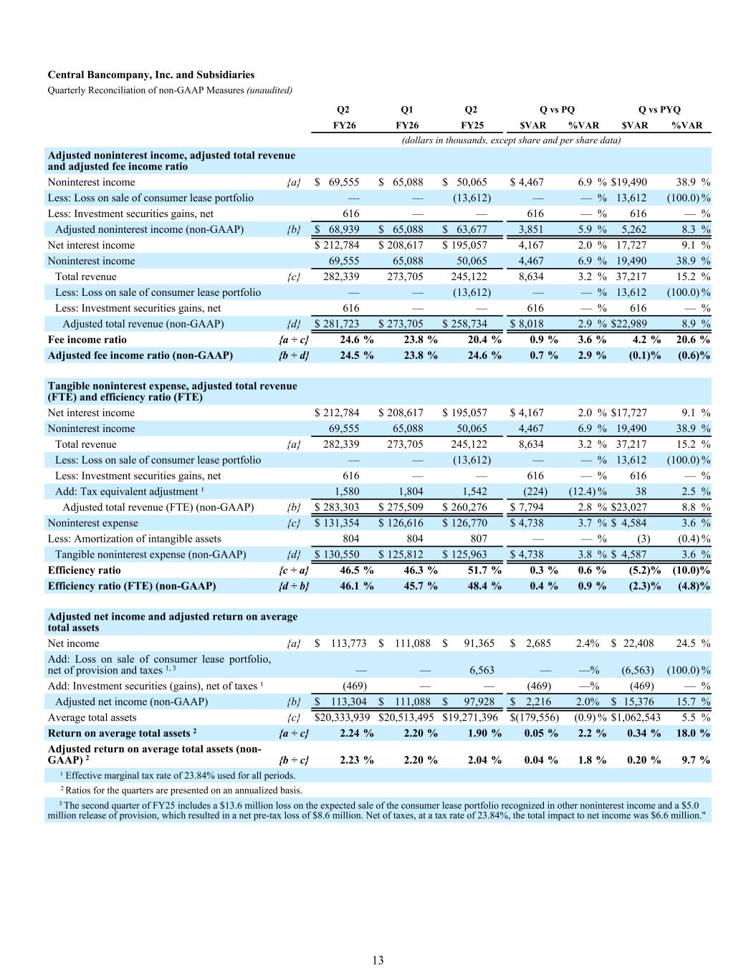
Adjusted noninterest income, adjusted total revenue and adjusted fee income ratio Noninterest income {a} $ 69,555 $ 65,088 $ 50,065 $ 4,467 6.9 % $ 19,490 38.9 % Less: Loss on sale of consumer lease portfolio — — (13,612) — — % 13,612 (100.0) % Less: Investment securities gains, net 616 — — 616 — % 616 — % Adjusted noninterest income (non-GAAP) {b} $ 68,939 $ 65,088 $ 63,677 3,851 5.9 % 5,262 8.3 % Net interest income $ 212,784 $ 208,617 $ 195,057 4,167 2.0 % 17,727 9.1 % Noninterest income 69,555 65,088 50,065 4,467 6.9 % 19,490 38.9 % Total revenue {c} 282,339 273,705 245,122 8,634 3.2 % 37,217 15.2 % Less: Loss on sale of consumer lease portfolio — — (13,612) — — % 13,612 (100.0) % Less: Investment securities gains, net 616 — — 616 — % 616 — % Adjusted total revenue (non-GAAP) {d} $ 281,723 $ 273,705 $ 258,734 $ 8,018 2.9 % $ 22,989 8.9 % Fee income ratio {a ÷ c} 24.6 % 23.8 % 20.4 % 0.9 % 3.6 % 4.2 % 20.6 % Adjusted fee income ratio (non-GAAP) {b ÷ d} 24.5 % 23.8 % 24.6 % 0.7 % 2.9 % (0.1) % (0.6) % Tangible noninterest expense, adjusted total revenue (FTE) and efficiency ratio (FTE) Net interest income $ 212,784 $ 208,617 $ 195,057 $ 4,167 2.0 % $ 17,727 9.1 % Noninterest income 69,555 65,088 50,065 4,467 6.9 % 19,490 38.9 % Total revenue {a} 282,339 273,705 245,122 8,634 3.2 % 37,217 15.2 % Less: Loss on sale of consumer lease portfolio — — (13,612) — — % 13,612 (100.0) % Less: Investment securities gains, net 616 — — 616 — % 616 — % Add: Tax equivalent adjustment ¹ 1,580 1,804 1,542 (224) (12.4) % 38 2.5 % Adjusted total revenue (FTE) (non-GAAP) {b} $ 283,303 $ 275,509 $ 260,276 $ 7,794 2.8 % $ 23,027 8.8 % Noninterest expense {c} $ 131,354 $ 126,616 $ 126,770 $ 4,738 3.7 % $ 4,584 3.6 % Less: Amortization of intangible assets 804 804 807 — — % (3) (0.4) % Tangible noninterest expense (non-GAAP) {d} $ 130,550 $ 125,812 $ 125,963 $ 4,738 3.8 % $ 4,587 3.6 % Efficiency ratio {c ÷ a} 46.5 % 46.3 % 51.7 % 0.3 % 0.6 % (5.2) % (10.0) % Efficiency ratio (FTE) (non-GAAP) {d ÷ b} 46.1 % 45.7 % 48.4 % 0.4 % 0.9 % (2.3) % (4.8) % Adjusted net income and adjusted return on average total assets Net income {a} $ 113,773 $ 111,088 $ 91,365 $ 2,685 2.4 % $ 22,408 24.5 % Add: Loss on sale of consumer lease portfolio, net of provision and taxes 1, 3 — — 6,563 — — % (6,563) (100.0) % Add: Investment securities (gains), net of taxes ¹ (469) — — (469) — % (469) — % Adjusted net income (non-GAAP) {b} $ 113,304 $ 111,088 $ 97,928 $ 2,216 2.0 % $ 15,376 15.7 % Average total assets {c} $ 20,333,939 $ 20,513,495 $ 19,271,396 $ (179,556) (0.9) % $ 1,062,543 5.5 % Return on average total assets 2 {a ÷ c} 2.24 % 2.20 % 1.90 % 0.05 % 2.2 % 0.34 % 18.0 % Adjusted return on average total assets (non- GAAP) 2 {b ÷ c} 2.23 % 2.20 % 2.04 % 0.04 % 1.8 % 0.20 % 9.7 % ¹ Effective marginal tax rate of 23.84% used for all periods. 2 Ratios for the quarters are presented on an annualized basis. 3 The second quarter of FY25 includes a $13.6 million loss on the expected sale of the consumer lease portfolio recognized in other noninterest income and a $5.0 million release of provision, which resulted in a net pre-tax loss of $8.6 million. Net of taxes, at a tax rate of 23.84%, the total impact to net income was $6.6 million." Central Bancompany, Inc. and Subsidiaries Quarterly Reconciliation of non-GAAP Measures (unaudited) Q2 Q1 Q2 Q vs PQ Q vs PYQ FY26 FY26 FY25 $VAR %VAR $VAR %VAR (dollars in thousands, except share and per share data) 13

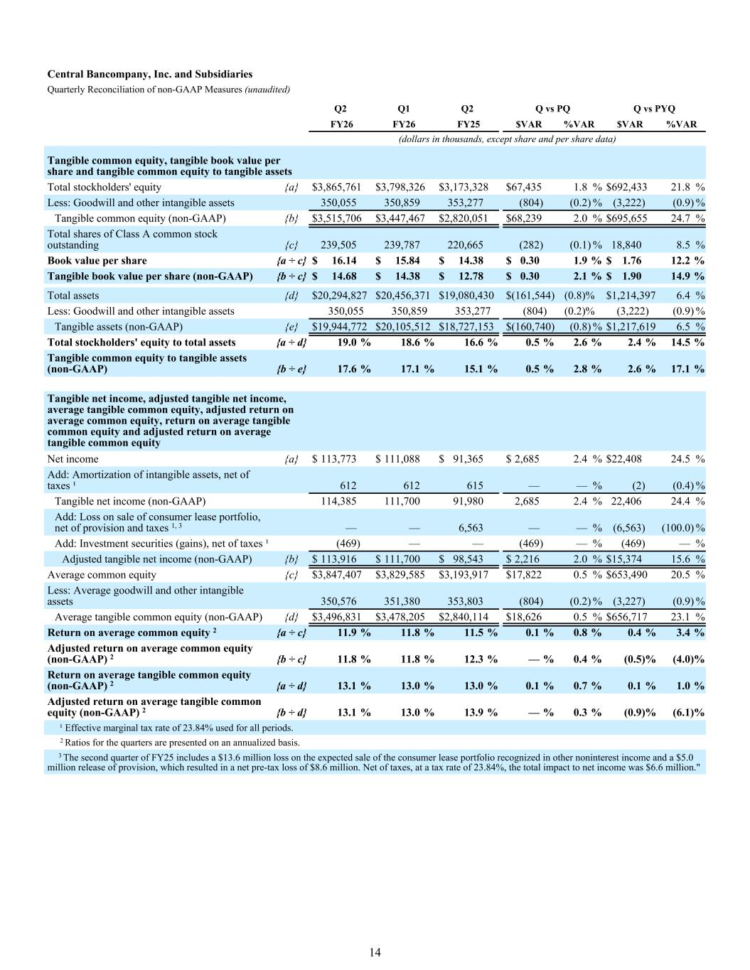
Tangible common equity, tangible book value per share and tangible common equity to tangible assets Total stockholders' equity {a} $ 3,865,761 $ 3,798,326 $ 3,173,328 $ 67,435 1.8 % $ 692,433 21.8 % Less: Goodwill and other intangible assets 350,055 350,859 353,277 (804) (0.2) % (3,222) (0.9) % Tangible common equity (non-GAAP) {b} $ 3,515,706 $ 3,447,467 $ 2,820,051 $ 68,239 2.0 % $ 695,655 24.7 % Total shares of Class A common stock outstanding {c} 239,505 239,787 220,665 (282) (0.1) % 18,840 8.5 % Book value per share {a ÷ c} $ 16.14 $ 15.84 $ 14.38 $ 0.30 1.9 % $ 1.76 12.2 % Tangible book value per share (non-GAAP) {b ÷ c} $ 14.68 $ 14.38 $ 12.78 $ 0.30 2.1 % $ 1.90 14.9 % Total assets {d} $ 20,294,827 $ 20,456,371 $ 19,080,430 $ (161,544) (0.8) % $ 1,214,397 6.4 % Less: Goodwill and other intangible assets 350,055 350,859 353,277 (804) (0.2) % (3,222) (0.9) % Tangible assets (non-GAAP) {e} $ 19,944,772 $ 20,105,512 $ 18,727,153 $ (160,740) (0.8) % $ 1,217,619 6.5 % Total stockholders' equity to total assets {a ÷ d} 19.0 % 18.6 % 16.6 % 0.5 % 2.6 % 2.4 % 14.5 % Tangible common equity to tangible assets (non-GAAP) {b ÷ e} 17.6 % 17.1 % 15.1 % 0.5 % 2.8 % 2.6 % 17.1 % Tangible net income, adjusted tangible net income, average tangible common equity, adjusted return on average common equity, return on average tangible common equity and adjusted return on average tangible common equity Net income {a} $ 113,773 $ 111,088 $ 91,365 $ 2,685 2.4 % $ 22,408 24.5 % Add: Amortization of intangible assets, net of taxes ¹ 612 612 615 — — % (2) (0.4) % Tangible net income (non-GAAP) 114,385 111,700 91,980 2,685 2.4 % 22,406 24.4 % Add: Loss on sale of consumer lease portfolio, net of provision and taxes 1, 3 — — 6,563 — — % (6,563) (100.0) % Add: Investment securities (gains), net of taxes ¹ (469) — — (469) — % (469) — % Adjusted tangible net income (non-GAAP) {b} $ 113,916 $ 111,700 $ 98,543 $ 2,216 2.0 % $ 15,374 15.6 % Average common equity {c} $ 3,847,407 $ 3,829,585 $ 3,193,917 $ 17,822 0.5 % $ 653,490 20.5 % Less: Average goodwill and other intangible assets 350,576 351,380 353,803 (804) (0.2) % (3,227) (0.9) % Average tangible common equity (non-GAAP) {d} $ 3,496,831 $ 3,478,205 $ 2,840,114 $ 18,626 0.5 % $ 656,717 23.1 % Return on average common equity 2 {a ÷ c} 11.9 % 11.8 % 11.5 % 0.1 % 0.8 % 0.4 % 3.4 % Adjusted return on average common equity (non-GAAP) 2 {b ÷ c} 11.8 % 11.8 % 12.3 % — % 0.4 % (0.5) % (4.0) % Return on average tangible common equity (non-GAAP) 2 {a ÷ d} 13.1 % 13.0 % 13.0 % 0.1 % 0.7 % 0.1 % 1.0 % Adjusted return on average tangible common equity (non-GAAP) 2 {b ÷ d} 13.1 % 13.0 % 13.9 % — % 0.3 % (0.9) % (6.1) % ¹ Effective marginal tax rate of 23.84% used for all periods. 2 Ratios for the quarters are presented on an annualized basis. 3 The second quarter of FY25 includes a $13.6 million loss on the expected sale of the consumer lease portfolio recognized in other noninterest income and a $5.0 million release of provision, which resulted in a net pre-tax loss of $8.6 million. Net of taxes, at a tax rate of 23.84%, the total impact to net income was $6.6 million." Central Bancompany, Inc. and Subsidiaries Quarterly Reconciliation of non-GAAP Measures (unaudited) Q2 Q1 Q2 Q vs PQ Q vs PYQ FY26 FY26 FY25 $VAR %VAR $VAR %VAR (dollars in thousands, except share and per share data) 14

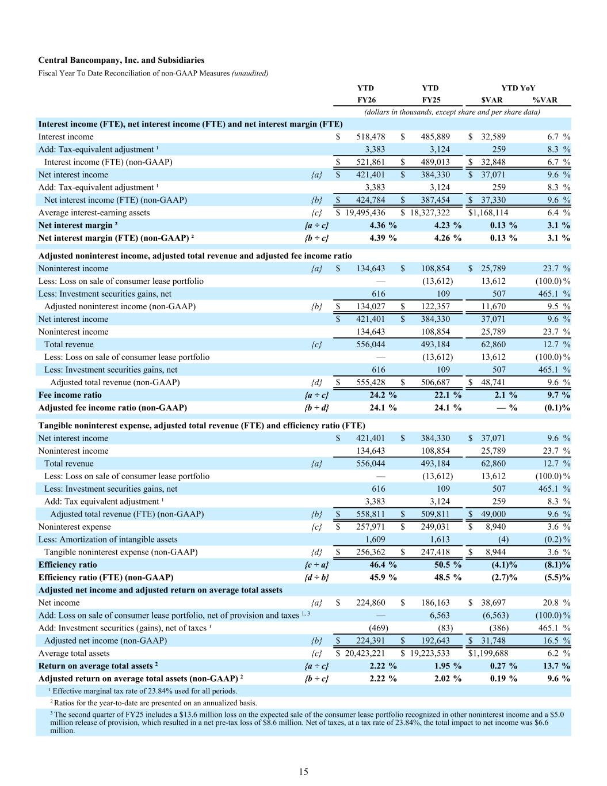
Interest income (FTE), net interest income (FTE) and net interest margin (FTE) Interest income $ 518,478 $ 485,889 $ 32,589 6.7 % Add: Tax-equivalent adjustment ¹ 3,383 3,124 259 8.3 % Interest income (FTE) (non-GAAP) $ 521,861 $ 489,013 $ 32,848 6.7 % Net interest income {a} $ 421,401 $ 384,330 $ 37,071 9.6 % Add: Tax-equivalent adjustment ¹ 3,383 3,124 259 8.3 % Net interest income (FTE) (non-GAAP) {b} $ 424,784 $ 387,454 $ 37,330 9.6 % Average interest-earning assets {c} $ 19,495,436 $ 18,327,322 $ 1,168,114 6.4 % Net interest margin ² {a ÷ c} 4.36 % 4.23 % 0.13 % 3.1 % Net interest margin (FTE) (non-GAAP) ² {b ÷ c} 4.39 % 4.26 % 0.13 % 3.1 % Adjusted noninterest income, adjusted total revenue and adjusted fee income ratio Noninterest income {a} $ 134,643 $ 108,854 $ 25,789 23.7 % Less: Loss on sale of consumer lease portfolio — (13,612) 13,612 (100.0) % Less: Investment securities gains, net 616 109 507 465.1 % Adjusted noninterest income (non-GAAP) {b} $ 134,027 $ 122,357 11,670 9.5 % Net interest income $ 421,401 $ 384,330 37,071 9.6 % Noninterest income 134,643 108,854 25,789 23.7 % Total revenue {c} 556,044 493,184 62,860 12.7 % Less: Loss on sale of consumer lease portfolio — (13,612) 13,612 (100.0) % Less: Investment securities gains, net 616 109 507 465.1 % Adjusted total revenue (non-GAAP) {d} $ 555,428 $ 506,687 $ 48,741 9.6 % Fee income ratio {a ÷ c} 24.2 % 22.1 % 2.1 % 9.7 % Adjusted fee income ratio (non-GAAP) {b ÷ d} 24.1 % 24.1 % — % (0.1) % Tangible noninterest expense, adjusted total revenue (FTE) and efficiency ratio (FTE) Net interest income $ 421,401 $ 384,330 $ 37,071 9.6 % Noninterest income 134,643 108,854 25,789 23.7 % Total revenue {a} 556,044 493,184 62,860 12.7 % Less: Loss on sale of consumer lease portfolio — (13,612) 13,612 (100.0) % Less: Investment securities gains, net 616 109 507 465.1 % Add: Tax equivalent adjustment ¹ 3,383 3,124 259 8.3 % Adjusted total revenue (FTE) (non-GAAP) {b} $ 558,811 $ 509,811 $ 49,000 9.6 % Noninterest expense {c} $ 257,971 $ 249,031 $ 8,940 3.6 % Less: Amortization of intangible assets 1,609 1,613 (4) (0.2) % Tangible noninterest expense (non-GAAP) {d} $ 256,362 $ 247,418 $ 8,944 3.6 % Efficiency ratio {c ÷ a} 46.4 % 50.5 % (4.1) % (8.1) % Efficiency ratio (FTE) (non-GAAP) {d ÷ b} 45.9 % 48.5 % (2.7) % (5.5) % Adjusted net income and adjusted return on average total assets Net income {a} $ 224,860 $ 186,163 $ 38,697 20.8 % Add: Loss on sale of consumer lease portfolio, net of provision and taxes 1, 3 — 6,563 (6,563) (100.0) % Add: Investment securities (gains), net of taxes ¹ (469) (83) (386) 465.1 % Adjusted net income (non-GAAP) {b} $ 224,391 $ 192,643 $ 31,748 16.5 % Average total assets {c} $ 20,423,221 $ 19,223,533 $ 1,199,688 6.2 % Return on average total assets 2 {a ÷ c} 2.22 % 1.95 % 0.27 % 13.7 % Adjusted return on average total assets (non-GAAP) 2 {b ÷ c} 2.22 % 2.02 % 0.19 % 9.6 % ¹ Effective marginal tax rate of 23.84% used for all periods. 2 Ratios for the year-to-date are presented on an annualized basis. 3 The second quarter of FY25 includes a $13.6 million loss on the expected sale of the consumer lease portfolio recognized in other noninterest income and a $5.0 million release of provision, which resulted in a net pre-tax loss of $8.6 million. Net of taxes, at a tax rate of 23.84%, the total impact to net income was $6.6 million. Central Bancompany, Inc. and Subsidiaries Fiscal Year To Date Reconciliation of non-GAAP Measures (unaudited) YTD YTD YTD YoY FY26 FY25 $VAR %VAR (dollars in thousands, except share and per share data) 15

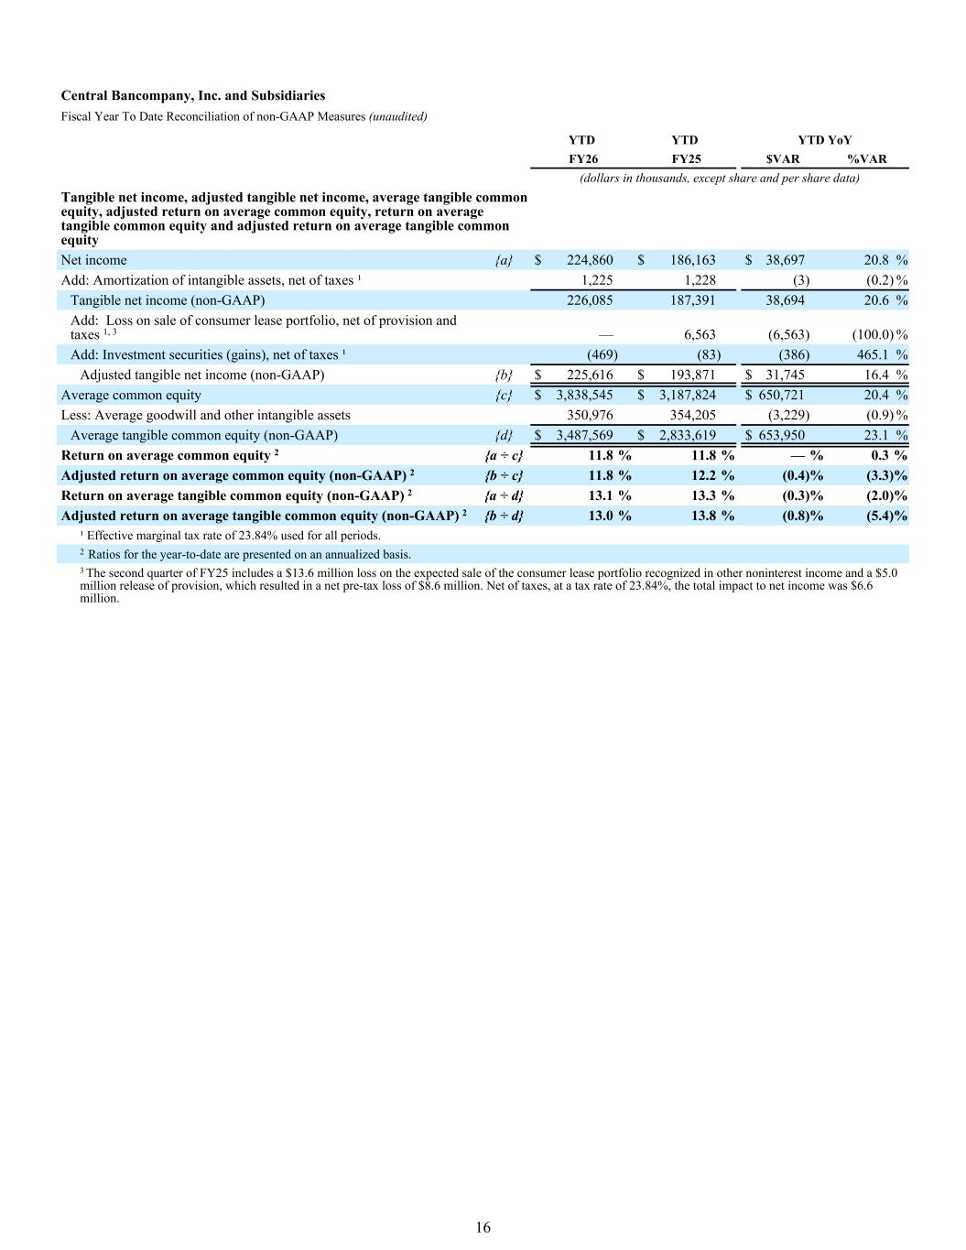
Tangible net income, adjusted tangible net income, average tangible common equity, adjusted return on average common equity, return on average tangible common equity and adjusted return on average tangible common equity Net income {a} $ 224,860 $ 186,163 $ 38,697 20.8 % Add: Amortization of intangible assets, net of taxes ¹ 1,225 1,228 (3) (0.2) % Tangible net income (non-GAAP) 226,085 187,391 38,694 20.6 % Add: Loss on sale of consumer lease portfolio, net of provision and taxes 1, 3 — 6,563 (6,563) (100.0) % Add: Investment securities (gains), net of taxes ¹ (469) (83) (386) 465.1 % Adjusted tangible net income (non-GAAP) {b} $ 225,616 $ 193,871 $ 31,745 16.4 % Average common equity {c} $ 3,838,545 $ 3,187,824 $ 650,721 20.4 % Less: Average goodwill and other intangible assets 350,976 354,205 (3,229) (0.9) % Average tangible common equity (non-GAAP) {d} $ 3,487,569 $ 2,833,619 $ 653,950 23.1 % Return on average common equity 2 {a ÷ c} 11.8 % 11.8 % — % 0.3 % Adjusted return on average common equity (non-GAAP) 2 {b ÷ c} 11.8 % 12.2 % (0.4) % (3.3) % Return on average tangible common equity (non-GAAP) 2 {a ÷ d} 13.1 % 13.3 % (0.3) % (2.0) % Adjusted return on average tangible common equity (non-GAAP) 2 {b ÷ d} 13.0 % 13.8 % (0.8) % (5.4) % ¹ Effective marginal tax rate of 23.84% used for all periods. 2 Ratios for the year-to-date are presented on an annualized basis. 3 The second quarter of FY25 includes a $13.6 million loss on the expected sale of the consumer lease portfolio recognized in other noninterest income and a $5.0 million release of provision, which resulted in a net pre-tax loss of $8.6 million. Net of taxes, at a tax rate of 23.84%, the total impact to net income was $6.6 million. Central Bancompany, Inc. and Subsidiaries Fiscal Year To Date Reconciliation of non-GAAP Measures (unaudited) YTD YTD YTD YoY FY26 FY25 $VAR %VAR (dollars in thousands, except share and per share data) 16

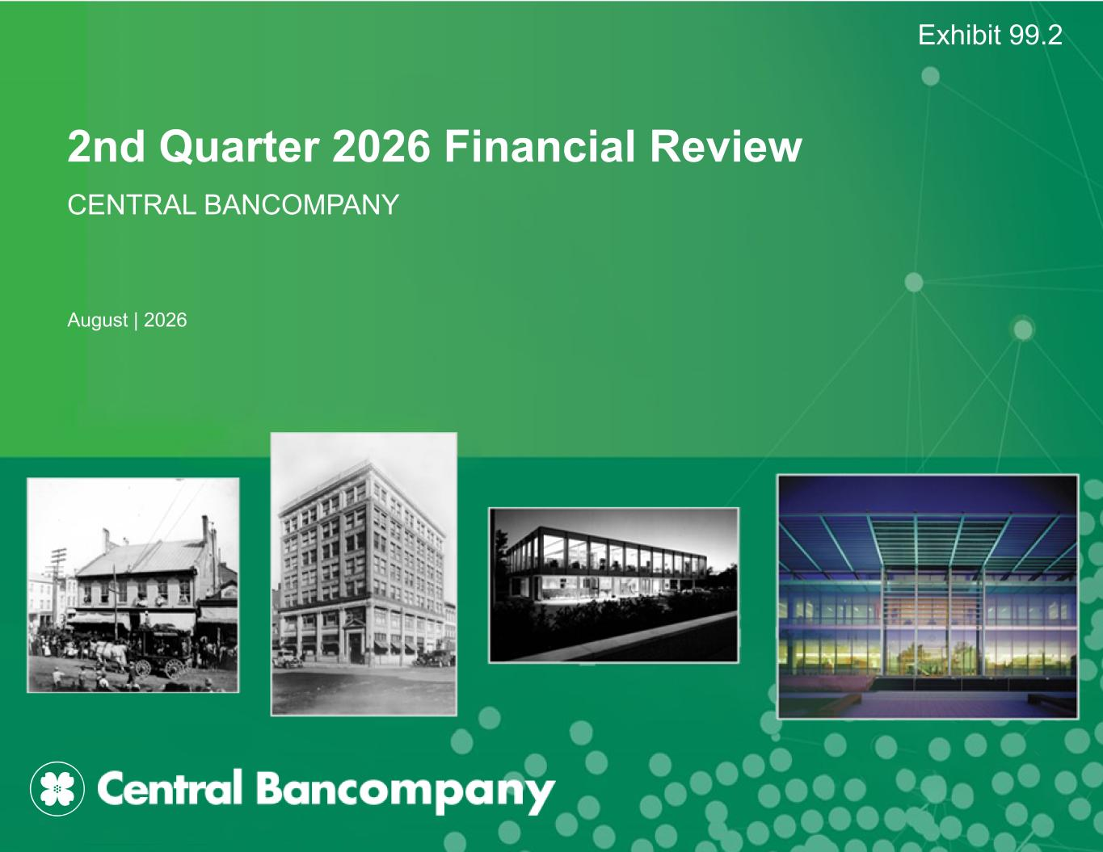
2nd Quarter 2026 Financial Review CENTRAL BANCOMPANY August | 2026 Exhibit 99.2

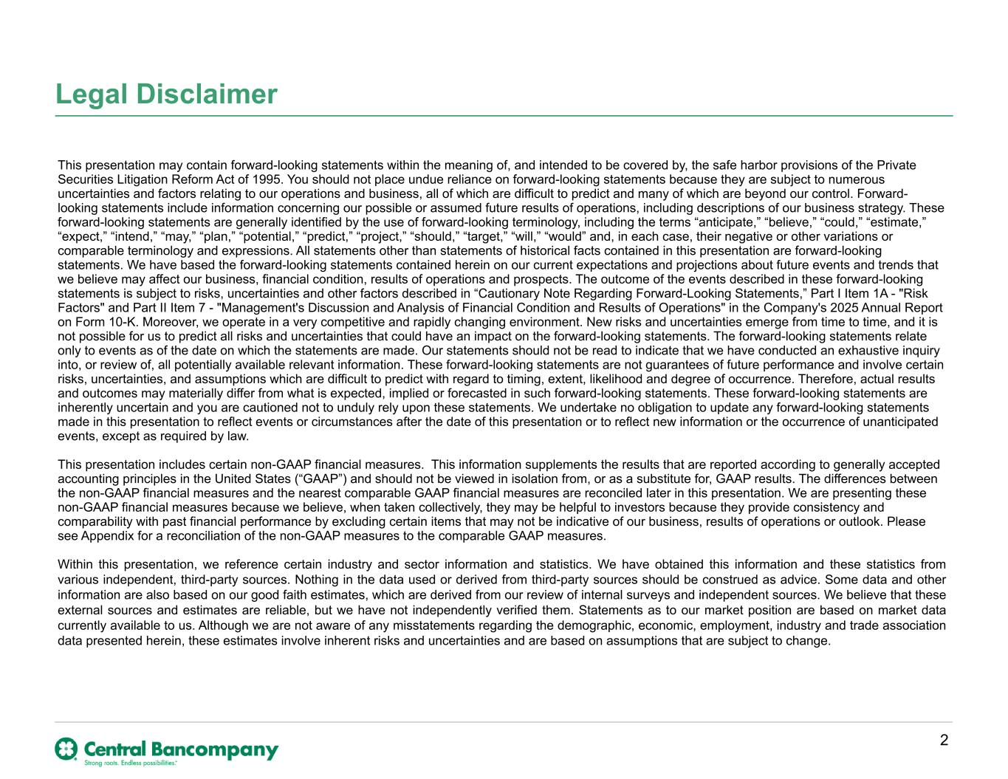
Legal Disclaimer This presentation may contain forward-looking statements within the meaning of, and intended to be covered by, the safe harbor provisions of the Private Securities Litigation Reform Act of 1995. You should not place undue reliance on forward-looking statements because they are subject to numerous uncertainties and factors relating to our operations and business, all of which are difficult to predict and many of which are beyond our control. Forward- looking statements include information concerning our possible or assumed future results of operations, including descriptions of our business strategy. These forward-looking statements are generally identified by the use of forward-looking terminology, including the terms “anticipate,” “believe,” “could,” “estimate,” “expect,” “intend,” “may,” “plan,” “potential,” “predict,” “project,” “should,” “target,” “will,” “would” and, in each case, their negative or other variations or comparable terminology and expressions. All statements other than statements of historical facts contained in this presentation are forward-looking statements. We have based the forward-looking statements contained herein on our current expectations and projections about future events and trends that we believe may affect our business, financial condition, results of operations and prospects. The outcome of the events described in these forward-looking statements is subject to risks, uncertainties and other factors described in “Cautionary Note Regarding Forward-Looking Statements,” Part I Item 1A - "Risk Factors" and Part II Item 7 - "Management's Discussion and Analysis of Financial Condition and Results of Operations" in the Company's 2025 Annual Report on Form 10-K. Moreover, we operate in a very competitive and rapidly changing environment. New risks and uncertainties emerge from time to time, and it is not possible for us to predict all risks and uncertainties that could have an impact on the forward-looking statements. The forward-looking statements relate only to events as of the date on which the statements are made. Our statements should not be read to indicate that we have conducted an exhaustive inquiry into, or review of, all potentially available relevant information. These forward-looking statements are not guarantees of future performance and involve certain risks, uncertainties, and assumptions which are difficult to predict with regard to timing, extent, likelihood and degree of occurrence. Therefore, actual results and outcomes may materially differ from what is expected, implied or forecasted in such forward-looking statements. These forward-looking statements are inherently uncertain and you are cautioned not to unduly rely upon these statements. We undertake no obligation to update any forward-looking statements made in this presentation to reflect events or circumstances after the date of this presentation or to reflect new information or the occurrence of unanticipated events, except as required by law. This presentation includes certain non-GAAP financial measures. This information supplements the results that are reported according to generally accepted accounting principles in the United States (“GAAP”) and should not be viewed in isolation from, or as a substitute for, GAAP results. The differences between the non-GAAP financial measures and the nearest comparable GAAP financial measures are reconciled later in this presentation. We are presenting these non-GAAP financial measures because we believe, when taken collectively, they may be helpful to investors because they provide consistency and comparability with past financial performance by excluding certain items that may not be indicative of our business, results of operations or outlook. Please see Appendix for a reconciliation of the non-GAAP measures to the comparable GAAP measures. Within this presentation, we reference certain industry and sector information and statistics. We have obtained this information and these statistics from various independent, third-party sources. Nothing in the data used or derived from third-party sources should be construed as advice. Some data and other information are also based on our good faith estimates, which are derived from our review of internal surveys and independent sources. We believe that these external sources and estimates are reliable, but we have not independently verified them. Statements as to our market position are based on market data currently available to us. Although we are not aware of any misstatements regarding the demographic, economic, employment, industry and trade association data presented herein, these estimates involve inherent risks and uncertainties and are based on assumptions that are subject to change. 2

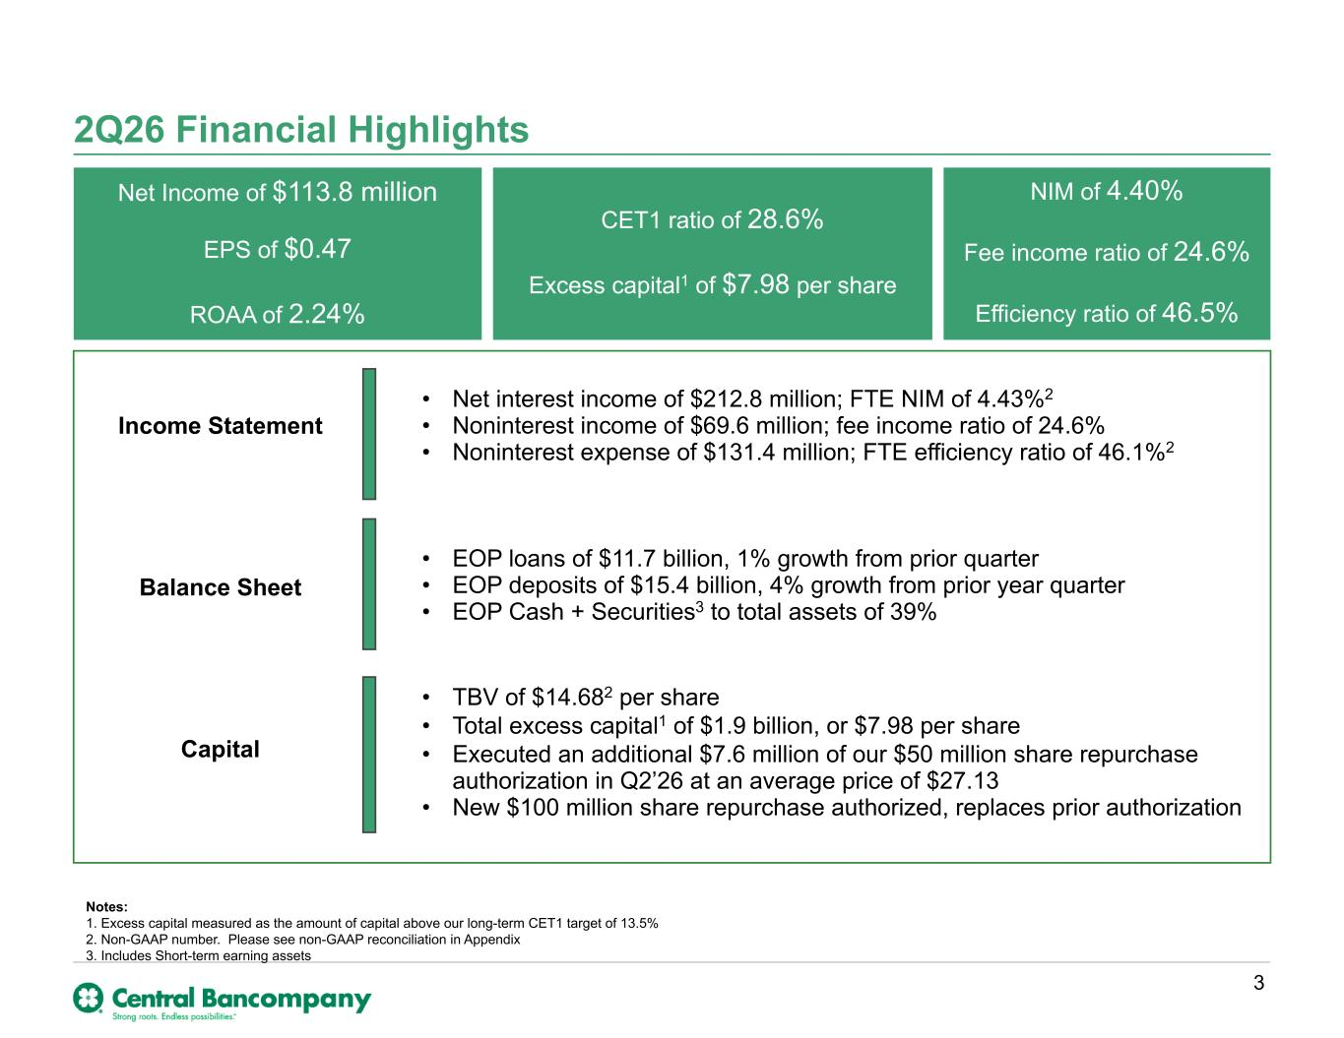
2Q26 Financial Highlights Net Income of $113.8 million EPS of $0.47 ROAA of 2.24% CET1 ratio of 28.6% Excess capital1 of $7.98 per share NIM of 4.40% Fee income ratio of 24.6% Efficiency ratio of 46.5% Income Statement Balance Sheet Capital 3 Notes: 1. Excess capital measured as the amount of capital above our long-term CET1 target of 13.5% 2. Non-GAAP number. Please see non-GAAP reconciliation in Appendix 3. Includes Short-term earning assets • Net interest income of $212.8 million; FTE NIM of 4.43%2 • Noninterest income of $69.6 million; fee income ratio of 24.6% • Noninterest expense of $131.4 million; FTE efficiency ratio of 46.1%2 • EOP loans of $11.7 billion, 1% growth from prior quarter • EOP deposits of $15.4 billion, 4% growth from prior year quarter • EOP Cash + Securities3 to total assets of 39% • TBV of $14.682 per share • Total excess capital1 of $1.9 billion, or $7.98 per share • Executed an additional $7.6 million of our $50 million share repurchase authorization in Q2’26 at an average price of $27.13 • New $100 million share repurchase authorized, replaces prior authorization

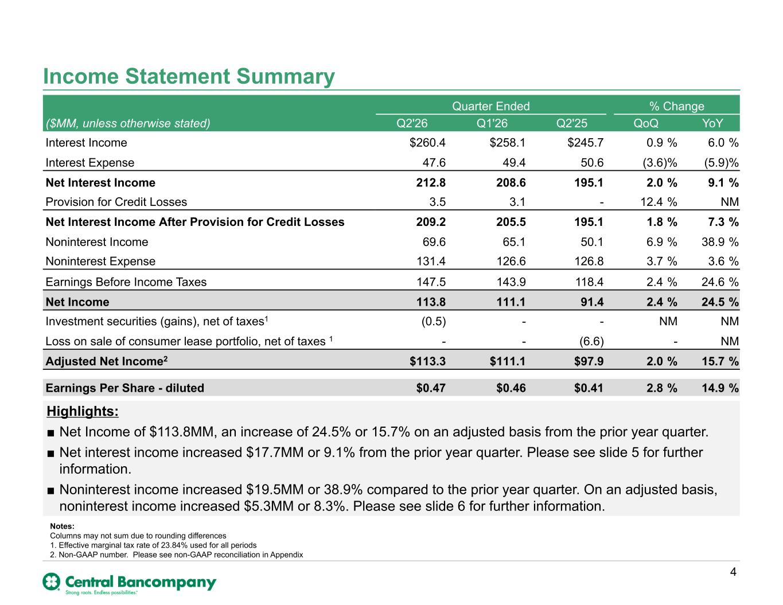
Highlights: ■ Net Income of $113.8MM, an increase of 24.5% or 15.7% on an adjusted basis from the prior year quarter. ■ Net interest income increased $17.7MM or 9.1% from the prior year quarter. Please see slide 5 for further information. ■ Noninterest income increased $19.5MM or 38.9% compared to the prior year quarter. On an adjusted basis, noninterest income increased $5.3MM or 8.3%. Please see slide 6 for further information. Quarter Ended % Change ($MM, unless otherwise stated) Q2'26 Q1'26 Q2'25 QoQ YoY Interest Income $260.4 $258.1 $245.7 0.9 % 6.0 % Interest Expense 47.6 49.4 50.6 (3.6) % (5.9) % Net Interest Income 212.8 208.6 195.1 2.0 % 9.1 % Provision for Credit Losses 3.5 3.1 - 12.4 % NM Net Interest Income After Provision for Credit Losses 209.2 205.5 195.1 1.8 % 7.3 % Noninterest Income 69.6 65.1 50.1 6.9 % 38.9 % Noninterest Expense 131.4 126.6 126.8 3.7 % 3.6 % Earnings Before Income Taxes 147.5 143.9 118.4 2.4 % 24.6 % Net Income 113.8 111.1 91.4 2.4 % 24.5 % Investment securities (gains), net of taxes1 (0.5) - - NM NM Loss on sale of consumer lease portfolio, net of taxes 1 - - (6.6) - NM Adjusted Net Income2 $113.3 $111.1 $97.9 2.0 % 15.7 % Earnings Per Share - diluted $0.47 $0.46 $0.41 2.8 % 14.9 % 4 Notes: Columns may not sum due to rounding differences 1. Effective marginal tax rate of 23.84% used for all periods 2. Non-GAAP number. Please see non-GAAP reconciliation in Appendix Income Statement Summary

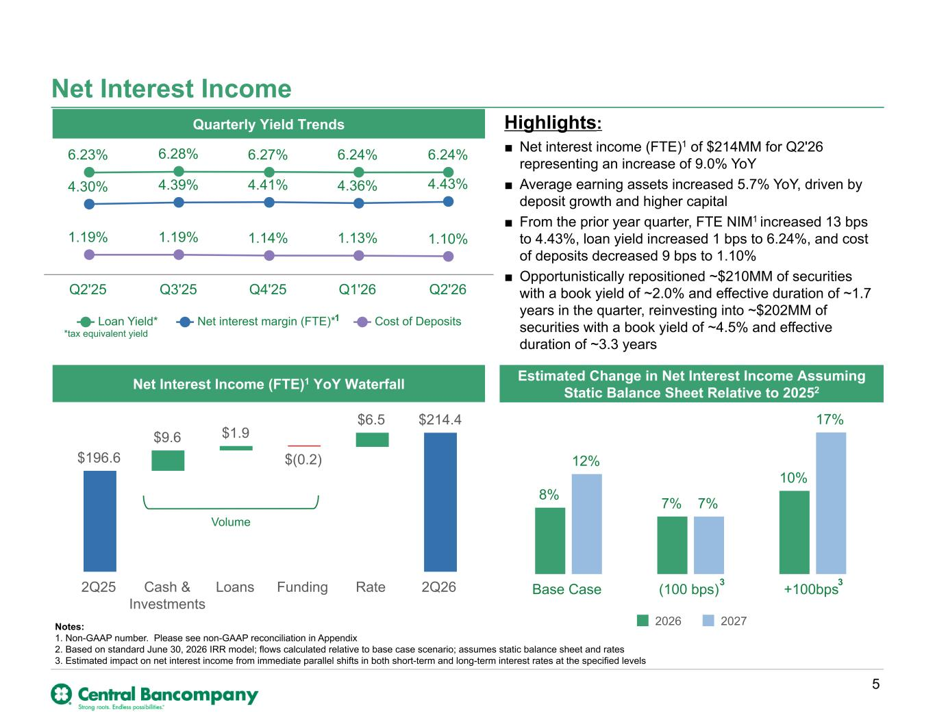
Highlights: ■ Net interest income (FTE)1 of $214MM for Q2'26 representing an increase of 9.0% YoY ■ Average earning assets increased 5.7% YoY, driven by deposit growth and higher capital ■ From the prior year quarter, FTE NIM1 increased 13 bps to 4.43%, loan yield increased 1 bps to 6.24%, and cost of deposits decreased 9 bps to 1.10% ■ Opportunistically repositioned ~$210MM of securities with a book yield of ~2.0% and effective duration of ~1.7 years in the quarter, reinvesting into ~$202MM of securities with a book yield of ~4.5% and effective duration of ~3.3 years Net Interest Income *tax equivalent yield 6.23% 6.28% 6.27% 6.24% 6.24% 4.30% 4.39% 4.41% 4.36% 4.43% 1.19% 1.19% 1.14% 1.13% 1.10% Loan Yield* Net interest margin (FTE)* Cost of Deposits Q2'25 Q3'25 Q4'25 Q1'26 Q2'26 Volume 5 8% 7% 10% 12% 7% 17% 2026 2027 Base Case (100 bps) +100bps Quarterly Yield Trends Net Interest Income (FTE)1 YoY Waterfall Estimated Change in Net Interest Income Assuming Static Balance Sheet Relative to 20252 3 3 $196.6 $9.6 $1.9 $(0.2) $6.5 $214.4 2Q25 Cash & Investments Loans Funding Rate 2Q26 Notes: 1. Non-GAAP number. Please see non-GAAP reconciliation in Appendix 2. Based on standard June 30, 2026 IRR model; flows calculated relative to base case scenario; assumes static balance sheet and rates 3. Estimated impact on net interest income from immediate parallel shifts in both short-term and long-term interest rates at the specified levels 1

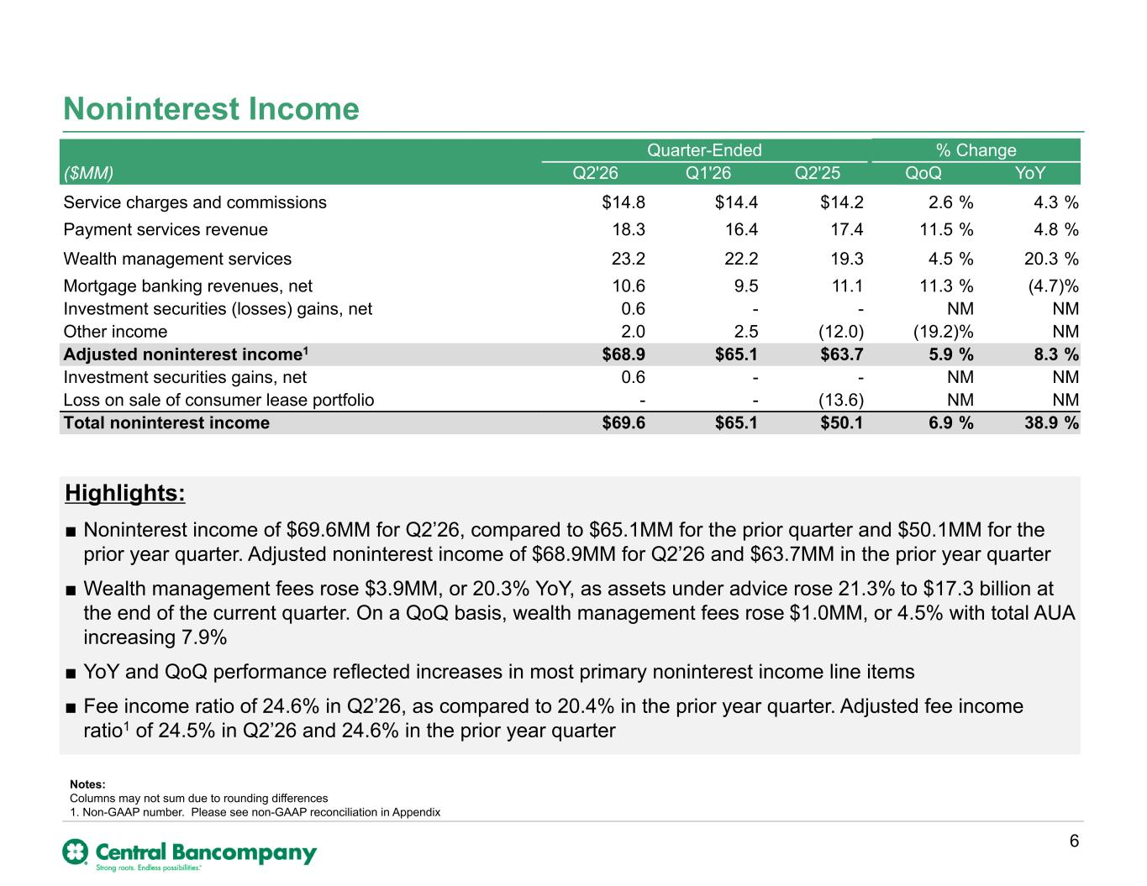
Highlights: ■ Noninterest income of $69.6MM for Q2’26, compared to $65.1MM for the prior quarter and $50.1MM for the prior year quarter. Adjusted noninterest income of $68.9MM for Q2’26 and $63.7MM in the prior year quarter ■ Wealth management fees rose $3.9MM, or 20.3% YoY, as assets under advice rose 21.3% to $17.3 billion at the end of the current quarter. On a QoQ basis, wealth management fees rose $1.0MM, or 4.5% with total AUA increasing 7.9% ■ YoY and QoQ performance reflected increases in most primary noninterest income line items ■ Fee income ratio of 24.6% in Q2’26, as compared to 20.4% in the prior year quarter. Adjusted fee income ratio1 of 24.5% in Q2’26 and 24.6% in the prior year quarter Noninterest Income Quarter-Ended % Change ($MM) Q2'26 Q1'26 Q2'25 QoQ YoY Service charges and commissions $14.8 $14.4 $14.2 2.6 % 4.3 % Payment services revenue 18.3 16.4 17.4 11.5 % 4.8 % Wealth management services 23.2 22.2 19.3 4.5 % 20.3 % Mortgage banking revenues, net 10.6 9.5 11.1 11.3 % (4.7) % Investment securities (losses) gains, net 0.6 - - NM NM Other income 2.0 2.5 (12.0) (19.2) % NM Adjusted noninterest income1 $68.9 $65.1 $63.7 5.9 % 8.3 % Investment securities gains, net 0.6 - - NM NM Loss on sale of consumer lease portfolio - - (13.6) NM NM Total noninterest income $69.6 $65.1 $50.1 6.9 % 38.9 % 6 Notes: Columns may not sum due to rounding differences 1. Non-GAAP number. Please see non-GAAP reconciliation in Appendix

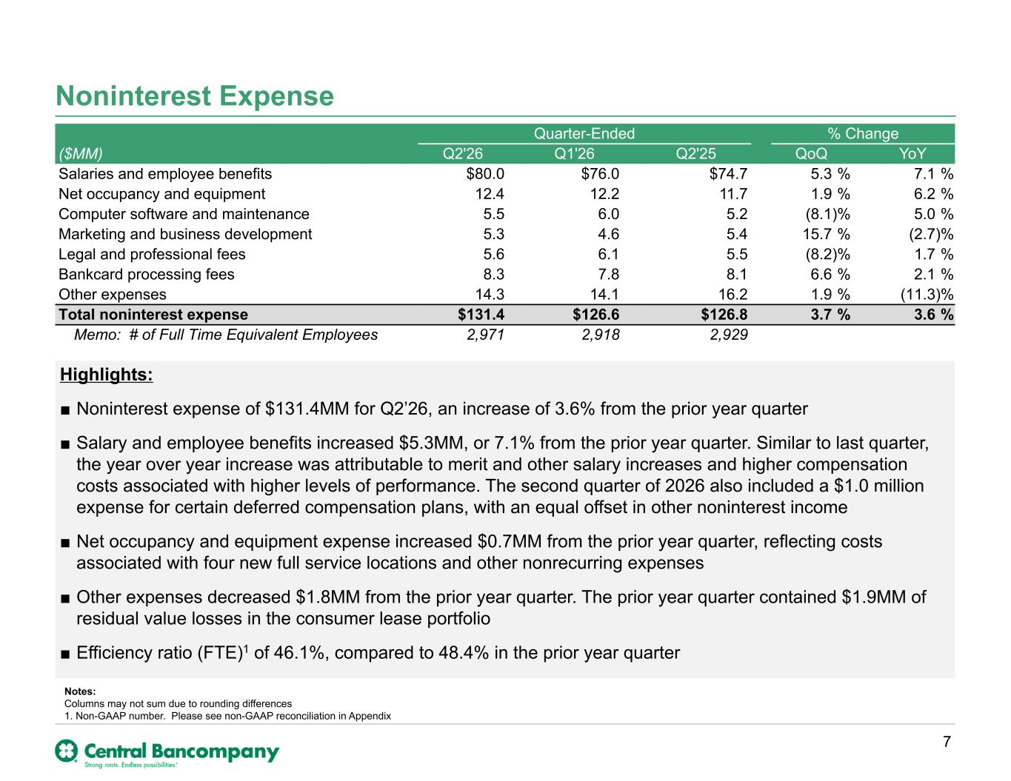
Highlights: ■ Noninterest expense of $131.4MM for Q2’26, an increase of 3.6% from the prior year quarter ■ Salary and employee benefits increased $5.3MM, or 7.1% from the prior year quarter. Similar to last quarter, the year over year increase was attributable to merit and other salary increases and higher compensation costs associated with higher levels of performance. The second quarter of 2026 also included a $1.0 million expense for certain deferred compensation plans, with an equal offset in other noninterest income ■ Net occupancy and equipment expense increased $0.7MM from the prior year quarter, reflecting costs associated with four new full service locations and other nonrecurring expenses ■ Other expenses decreased $1.8MM from the prior year quarter. The prior year quarter contained $1.9MM of residual value losses in the consumer lease portfolio ■ Efficiency ratio (FTE)1 of 46.1%, compared to 48.4% in the prior year quarter Noninterest Expense Quarter-Ended % Change ($MM) Q2'26 Q1'26 Q2'25 QoQ YoY Salaries and employee benefits $80.0 $76.0 $74.7 5.3 % 7.1 % Net occupancy and equipment 12.4 12.2 11.7 1.9 % 6.2 % Computer software and maintenance 5.5 6.0 5.2 (8.1) % 5.0 % Marketing and business development 5.3 4.6 5.4 15.7 % (2.7) % Legal and professional fees 5.6 6.1 5.5 (8.2) % 1.7 % Bankcard processing fees 8.3 7.8 8.1 6.6 % 2.1 % Other expenses 14.3 14.1 16.2 1.9 % (11.3) % Total noninterest expense $131.4 $126.6 $126.8 3.7 % 3.6 % Memo: # of Full Time Equivalent Employees 2,971 2,918 2,929 7 Notes: Columns may not sum due to rounding differences 1. Non-GAAP number. Please see non-GAAP reconciliation in Appendix

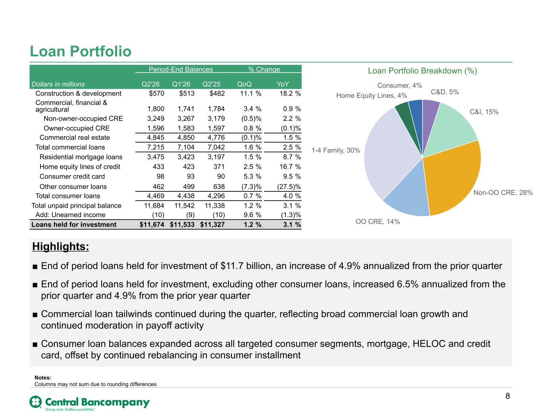
Highlights: ■ End of period loans held for investment of $11.7 billion, an increase of 4.9% annualized from the prior quarter ■ End of period loans held for investment, excluding other consumer loans, increased 6.5% annualized from the prior quarter and 4.9% from the prior year quarter ■ Commercial loan tailwinds continued during the quarter, reflecting broad commercial loan growth and continued moderation in payoff activity ■ Consumer loan balances expanded across all targeted consumer segments, mortgage, HELOC and credit card, offset by continued rebalancing in consumer installment Loan Portfolio Loan Portfolio Breakdown (%) C&D, 5% C&I, 15% Non-OO CRE, 28% OO CRE, 14% 1-4 Family, 30% Home Equity Lines, 4% Consumer, 4% Period-End Balances % Change Dollars in millions Q2'26 Q1'26 Q2'25 QoQ YoY Construction & development $570 $513 $482 11.1 % 18.2 % Commercial, financial & agricultural 1,800 1,741 1,784 3.4 % 0.9 % Non-owner-occupied CRE 3,249 3,267 3,179 (0.5) % 2.2 % Owner-occupied CRE 1,596 1,583 1,597 0.8 % (0.1) % Commercial real estate 4,845 4,850 4,776 (0.1) % 1.5 % Total commercial loans 7,215 7,104 7,042 1.6 % 2.5 % Residential mortgage loans 3,475 3,423 3,197 1.5 % 8.7 % Home equity lines of credit 433 423 371 2.5 % 16.7 % Consumer credit card 98 93 90 5.3 % 9.5 % Other consumer loans 462 499 638 (7.3) % (27.5) % Total consumer loans 4,469 4,438 4,296 0.7 % 4.0 % Total unpaid principal balance 11,684 11,542 11,338 1.2 % 3.1 % Add: Unearned income (10) (9) (10) 9.6 % (1.3) % Loans held for investment $11,674 $11,533 $11,327 1.2 % 3.1 % 8 Notes: Columns may not sum due to rounding differences

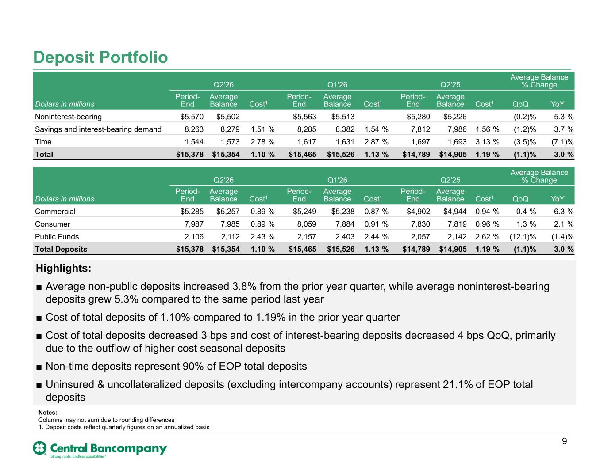
Deposit Portfolio 54% 36% 10% 9 Notes: Columns may not sum due to rounding differences 1. Deposit costs reflect quarterly figures on an annualized basis Q2'26 Q1'26 Q2'25 Average Balance % Change Dollars in millions Period- End Average Balance Cost1 Period- End Average Balance Cost1 Period- End Average Balance Cost1 QoQ YoY Noninterest-bearing $5,570 $5,502 $5,563 $5,513 $5,280 $5,226 (0.2) % 5.3 % Savings and interest-bearing demand 8,263 8,279 1.51 % 8,285 8,382 1.54 % 7,812 7,986 1.56 % (1.2) % 3.7 % Time 1,544 1,573 2.78 % 1,617 1,631 2.87 % 1,697 1,693 3.13 % (3.5) % (7.1) % Total $15,378 $15,354 1.10 % $15,465 $15,526 1.13 % $14,789 $14,905 1.19 % (1.1) % 3.0 % Q2'26 Q1'26 Q2'25 Average Balance % Change Dollars in millions Period- End Average Balance Cost1 Period- End Average Balance Cost1 Period- End Average Balance Cost1 QoQ YoY Commercial $5,285 $5,257 0.89 % $5,249 $5,238 0.87 % $4,902 $4,944 0.94 % 0.4 % 6.3 % Consumer 7,987 7,985 0.89 % 8,059 7,884 0.91 % 7,830 7,819 0.96 % 1.3 % 2.1 % Public Funds 2,106 2,112 2.43 % 2,157 2,403 2.44 % 2,057 2,142 2.62 % (12.1) % (1.4) % Total Deposits $15,378 $15,354 1.10 % $15,465 $15,526 1.13 % $14,789 $14,905 1.19 % (1.1) % 3.0 % Highlights: ■ Average non-public deposits increased 3.8% from the prior year quarter, while average noninterest-bearing deposits grew 5.3% compared to the same period last year ■ Cost of total deposits of 1.10% compared to 1.19% in the prior year quarter ■ Cost of total deposits decreased 3 bps and cost of interest-bearing deposits decreased 4 bps QoQ, primarily due to the outflow of higher cost seasonal deposits ■ Non-time deposits represent 90% of EOP total deposits ■ Uninsured & uncollateralized deposits (excluding intercompany accounts) represent 21.1% of EOP total deposits

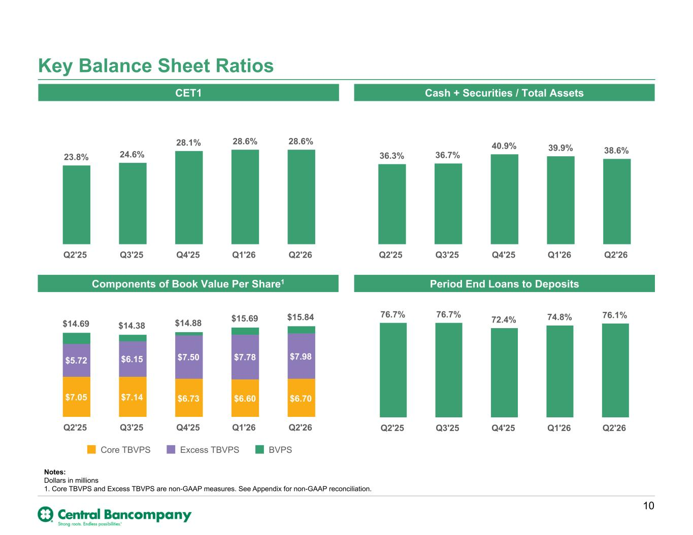
Key Balance Sheet Ratios CET1 Cash + Securities / Total Assets 23.8% 24.6% 28.1% 28.6% 28.6% Q2'25 Q3'25 Q4'25 Q1'26 Q2'26 36.3% 36.7% 40.9% 39.9% 38.6% Q2'25 Q3'25 Q4'25 Q1'26 Q2'26 Components of Book Value Per Share1 Period End Loans to Deposits 76.7% 76.7% 72.4% 74.8% 76.1% Q2'25 Q3'25 Q4'25 Q1'26 Q2'26 10 Notes: Dollars in millions 1. Core TBVPS and Excess TBVPS are non-GAAP measures. See Appendix for non-GAAP reconciliation. $14.69 $14.38 $14.88 $15.69 $15.84 $7.05 $7.14 $6.73 $6.60 $6.70 $5.72 $6.15 $7.50 $7.78 $7.98 Core TBVPS Excess TBVPS BVPS Q2'25 Q3'25 Q4'25 Q1'26 Q2'26

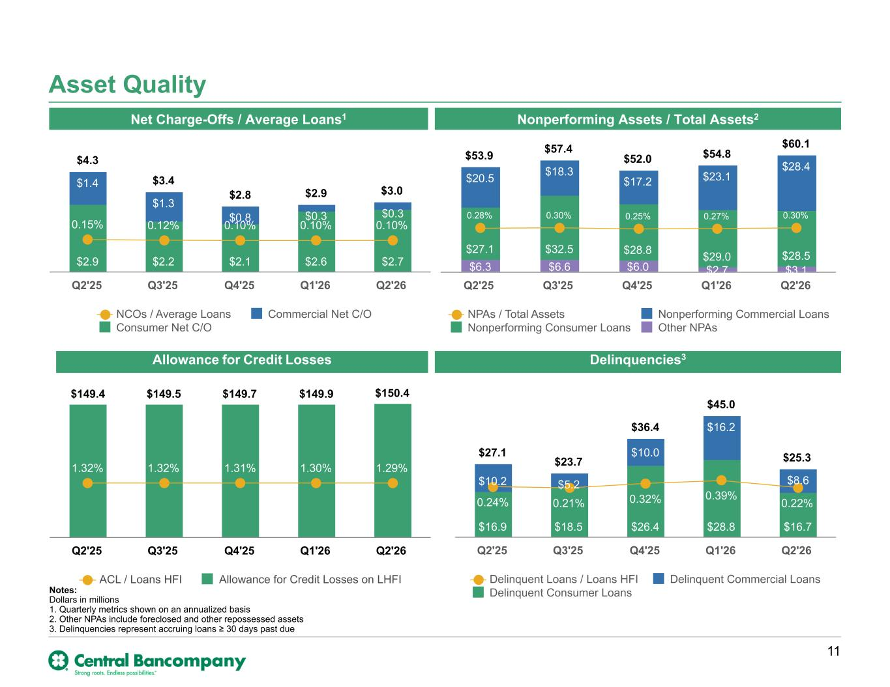
Asset Quality Allowance for Credit Losses Nonperforming Assets / Total Assets2Net Charge-Offs / Average Loans1 Delinquencies3 Notes: Dollars in millions 1. Quarterly metrics shown on an annualized basis 2. Other NPAs include foreclosed and other repossessed assets 3. Delinquencies represent accruing loans ≥ 30 days past due $149.4 $149.5 $149.7 $149.9 $150.4 1.32% 1.32% 1.31% 1.30% 1.29% ACL / Loans HFI Allowance for Credit Losses on LHFI Q2'25 Q3'25 Q4'25 Q1'26 Q2'26 11 $53.9 $57.4 $52.0 $54.8 $60.1 $6.3 $6.6 $6.0 $2.7 $3.1 $27.1 $32.5 $28.8 $29.0 $28.5 $20.5 $18.3 $17.2 $23.1 $28.4 0.28% 0.30% 0.25% 0.27% 0.30% NPAs / Total Assets Nonperforming Commercial Loans Nonperforming Consumer Loans Other NPAs Q2'25 Q3'25 Q4'25 Q1'26 Q2'26 $4.3 $3.4 $2.8 $2.9 $3.0 $2.9 $2.2 $2.1 $2.6 $2.7 $1.4 $1.3 $0.8 $0.3 $0.3 0.15% 0.12% 0.10% 0.10% 0.10% NCOs / Average Loans Commercial Net C/O Consumer Net C/O Q2'25 Q3'25 Q4'25 Q1'26 Q2'26 $27.1 $23.7 $36.4 $45.0 $25.3 $16.9 $18.5 $26.4 $28.8 $16.7 $10.2 $5.2 $10.0 $16.2 $8.6 0.24% 0.21% 0.32% 0.39% 0.22% Delinquent Loans / Loans HFI Delinquent Commercial Loans Delinquent Consumer Loans Q2'25 Q3'25 Q4'25 Q1'26 Q2'26

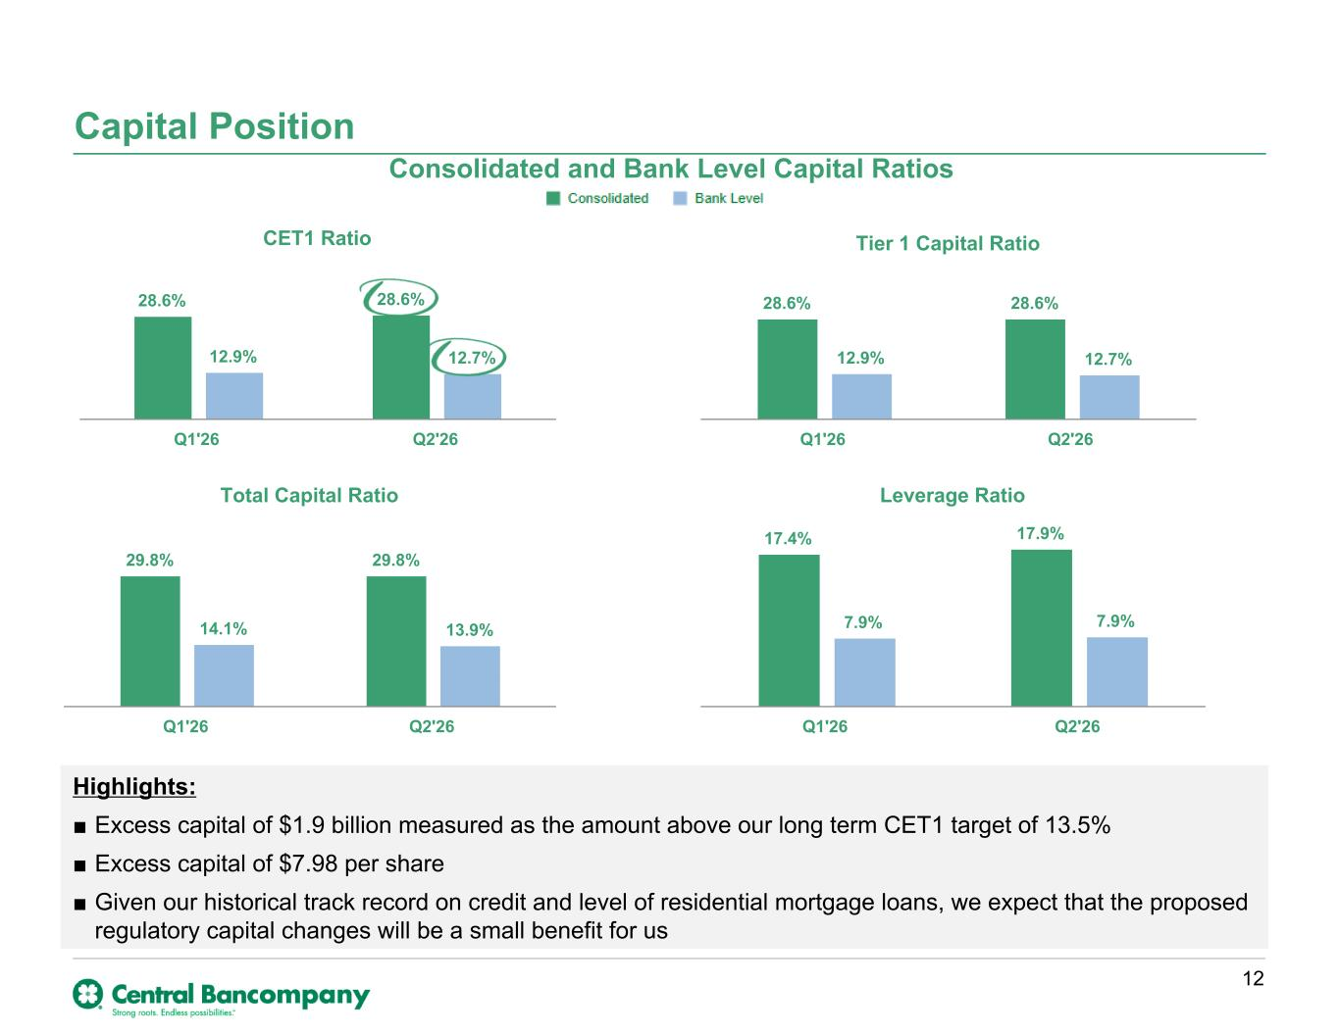
Consolidated and Bank Level Capital Ratios Capital Position CET1 Ratio 28.6% 28.6% 12.9% 12.7% Q1'26 Q2'26 Tier 1 Capital Ratio 28.6% 28.6% 12.9% 12.7% Q1'26 Q2'26 Total Capital Ratio 29.8% 29.8% 14.1% 13.9% Q1'26 Q2'26 Leverage Ratio 17.4% 17.9% 7.9% 7.9% Q1'26 Q2'26 Highlights: ■ Excess capital of $1.9 billion measured as the amount above our long term CET1 target of 13.5% ■ Excess capital of $7.98 per share ■ Given our historical track record on credit and level of residential mortgage loans, we expect that the proposed regulatory capital changes will be a small benefit for us 12

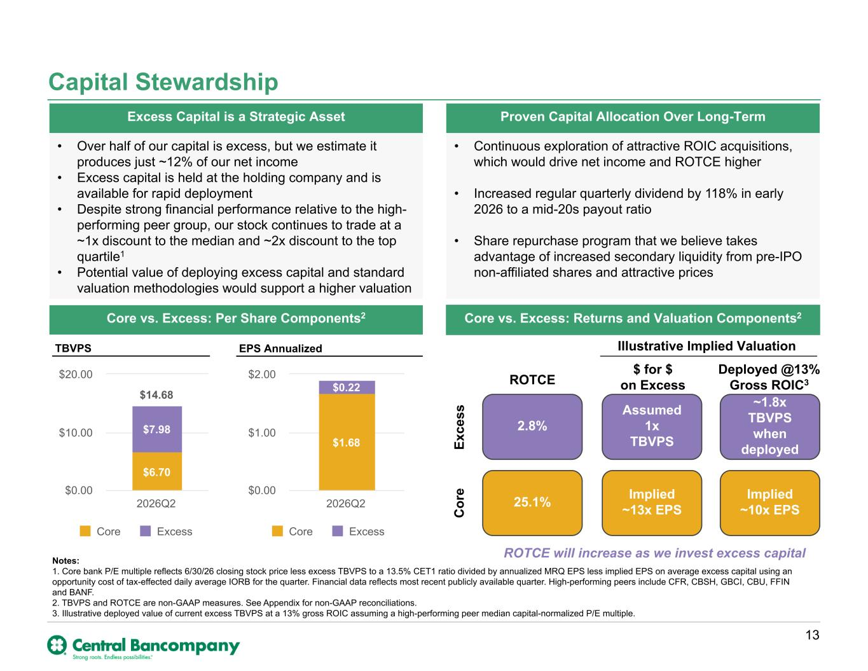
Deployed @13% Gross ROIC3 ROTCE will increase as we invest excess capital $ for $ on Excess Illustrative Implied Valuation Capital Stewardship 13 Excess Capital is a Strategic Asset Proven Capital Allocation Over Long-Term Core vs. Excess: Per Share Components2 Core vs. Excess: Returns and Valuation Components2 Notes: 1. Core bank P/E multiple reflects 6/30/26 closing stock price less excess TBVPS to a 13.5% CET1 ratio divided by annualized MRQ EPS less implied EPS on average excess capital using an opportunity cost of tax-effected daily average IORB for the quarter. Financial data reflects most recent publicly available quarter. High-performing peers include CFR, CBSH, GBCI, CBU, FFIN and BANF. 2. TBVPS and ROTCE are non-GAAP measures. See Appendix for non-GAAP reconciliations. 3. Illustrative deployed value of current excess TBVPS at a 13% gross ROIC assuming a high-performing peer median capital-normalized P/E multiple. $14.68 $6.70 $7.98 Core Excess 2026Q2 $0.00 $10.00 $20.00 $1.68 $0.22 Core Excess 2026Q2 $0.00 $1.00 $2.00 TBVPS EPS Annualized 2.8% Assumed 1x TBVPS 25.1% Implied ~13x EPS ROTCE Ex ce ss ~1.8x TBVPS when deployed C or e • Continuous exploration of attractive ROIC acquisitions, which would drive net income and ROTCE higher • Increased regular quarterly dividend by 118% in early 2026 to a mid-20s payout ratio • Share repurchase program that we believe takes advantage of increased secondary liquidity from pre-IPO non-affiliated shares and attractive prices Implied ~10x EPS • Over half of our capital is excess, but we estimate it produces just ~12% of our net income • Excess capital is held at the holding company and is available for rapid deployment • Despite strong financial performance relative to the high- performing peer group, our stock continues to trade at a ~1x discount to the median and ~2x discount to the top quartile1 • Potential value of deploying excess capital and standard valuation methodologies would support a higher valuation

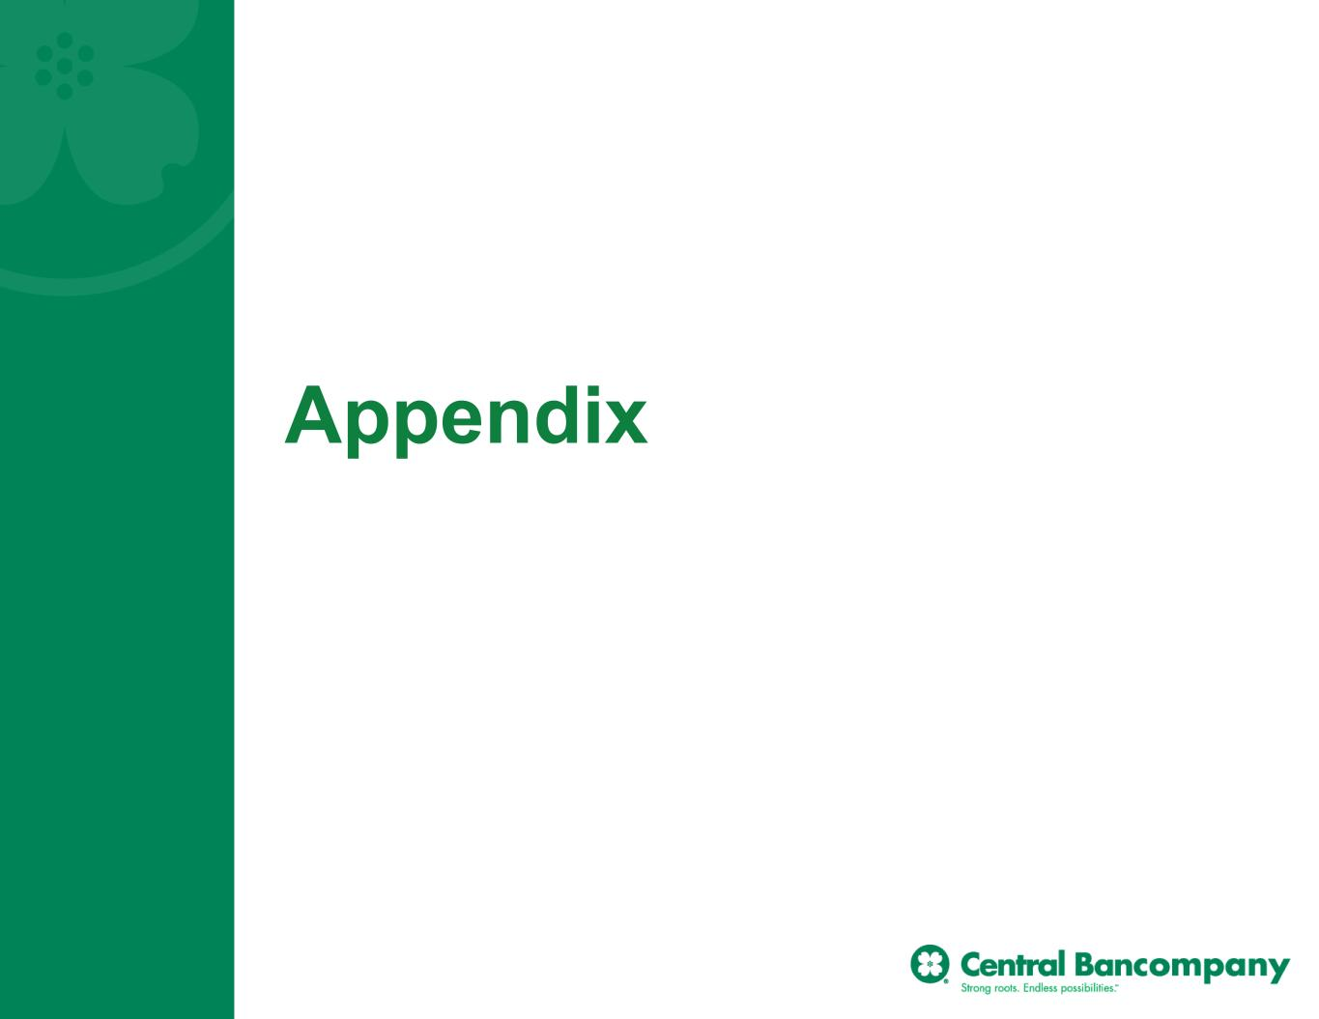
Appendix

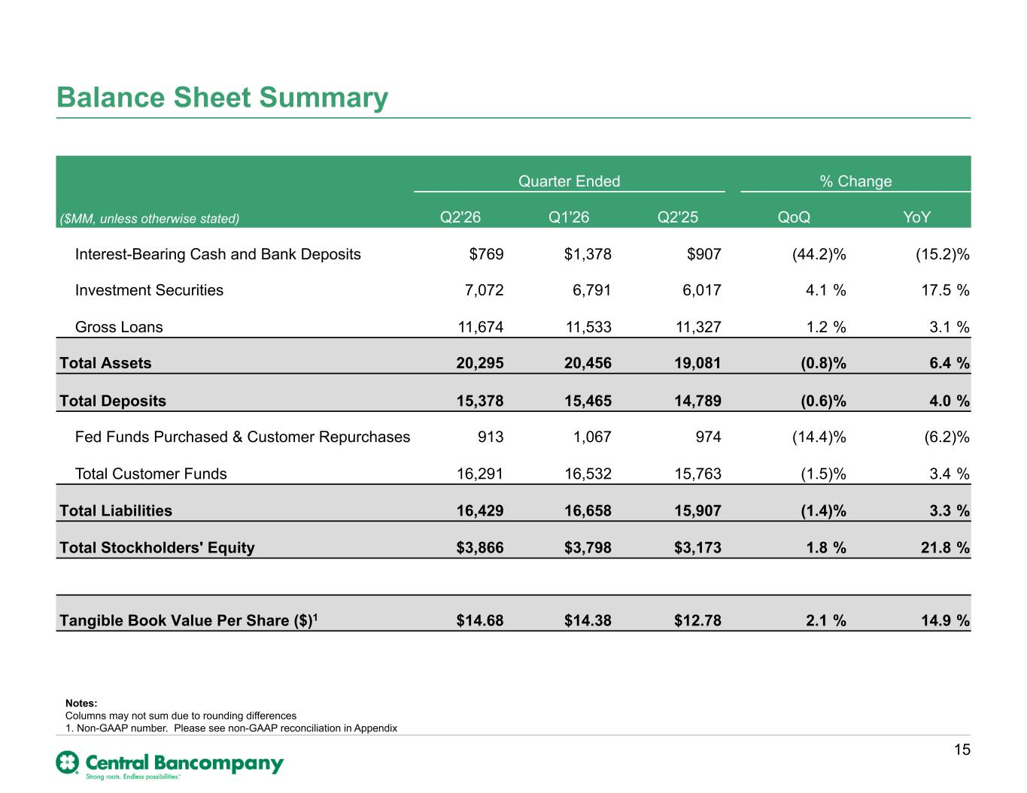
Balance Sheet Summary Quarter Ended % Change ($MM, unless otherwise stated) Q2'26 Q1'26 Q2'25 QoQ YoY Interest-Bearing Cash and Bank Deposits $769 $1,378 $907 (44.2) % (15.2) % Investment Securities 7,072 6,791 6,017 4.1 % 17.5 % Gross Loans 11,674 11,533 11,327 1.2 % 3.1 % Total Assets 20,295 20,456 19,081 (0.8) % 6.4 % Total Deposits 15,378 15,465 14,789 (0.6) % 4.0 % Fed Funds Purchased & Customer Repurchases 913 1,067 974 (14.4) % (6.2) % Total Customer Funds 16,291 16,532 15,763 (1.5) % 3.4 % Total Liabilities 16,429 16,658 15,907 (1.4) % 3.3 % Total Stockholders' Equity $3,866 $3,798 $3,173 1.8 % 21.8 % Tangible Book Value Per Share ($)1 $14.68 $14.38 $12.78 2.1 % 14.9 % 15 Notes: Columns may not sum due to rounding differences 1. Non-GAAP number. Please see non-GAAP reconciliation in Appendix

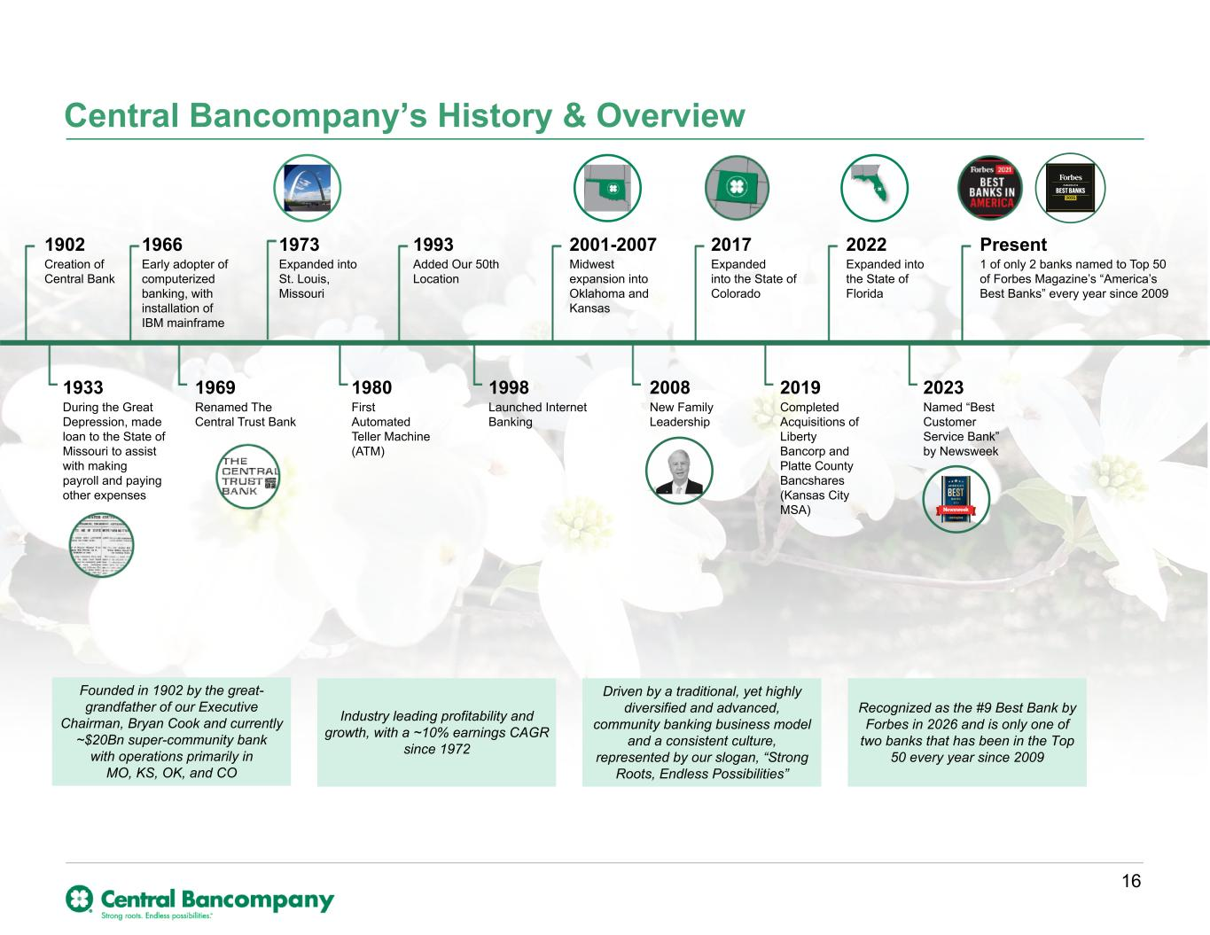
Central Bancompany’s History & Overview 1902 Creation of Central Bank 1973 Expanded into St. Louis, Missouri 1993 Added Our 50th Location 2001-2007 Midwest expansion into Oklahoma and Kansas 2022 Expanded into the State of Florida 1980 First Automated Teller Machine (ATM) 1998 Launched Internet Banking 2008 New Family Leadership 2019 Completed Acquisitions of Liberty Bancorp and Platte County Bancshares (Kansas City MSA) 2023 Named “Best Customer Service Bank” by Newsweek 1969 Renamed The Central Trust Bank 2017 Expanded into the State of Colorado Present 1 of only 2 banks named to Top 50 of Forbes Magazine’s “America’s Best Banks” every year since 2009 1966 Early adopter of computerized banking, with installation of IBM mainframe 1933 During the Great Depression, made loan to the State of Missouri to assist with making payroll and paying other expenses Founded in 1902 by the great- grandfather of our Executive Chairman, Bryan Cook and currently ~$20Bn super-community bank with operations primarily in MO, KS, OK, and CO Industry leading profitability and growth, with a ~10% earnings CAGR since 1972 Driven by a traditional, yet highly diversified and advanced, community banking business model and a consistent culture, represented by our slogan, “Strong Roots, Endless Possibilities” Recognized as the #9 Best Bank by Forbes in 2026 and is only one of two banks that has been in the Top 50 every year since 2009 16

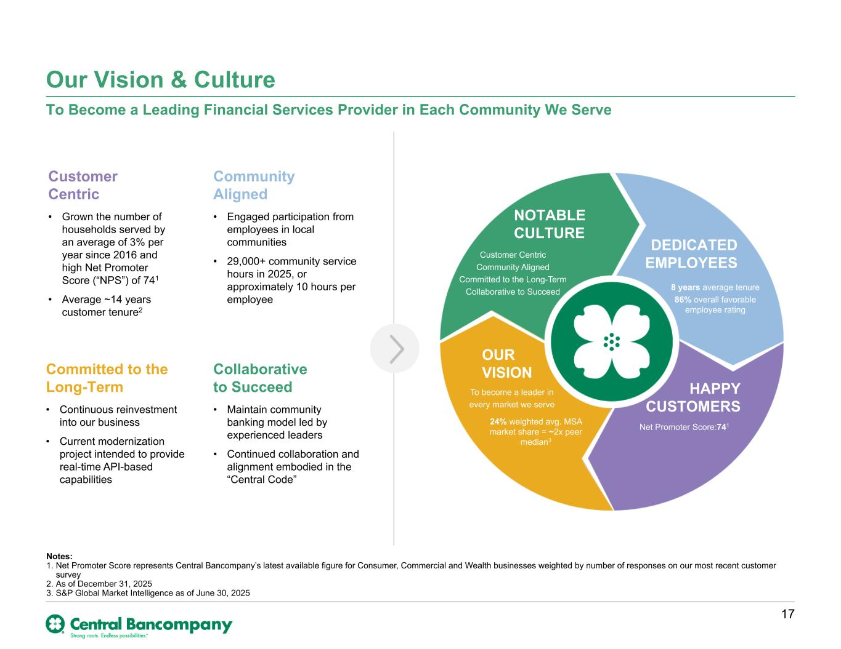
Our Vision & Culture To Become a Leading Financial Services Provider in Each Community We Serve Notes: 1. Net Promoter Score represents Central Bancompany’s latest available figure for Consumer, Commercial and Wealth businesses weighted by number of responses on our most recent customer survey 2. As of December 31, 2025 3. S&P Global Market Intelligence as of June 30, 2025 NOTABLE CULTURE DEDICATED EMPLOYEES HAPPY CUSTOMERS OUR VISION To become a leader in every market we serve Customer Centric Community Aligned Committed to the Long-Term Collaborative to Succeed 8 years average tenure 86% overall favorable employee rating Net Promoter Score:741 Collaborative to Succeed • Maintain community banking model led by experienced leaders • Continued collaboration and alignment embodied in the “Central Code” Community Aligned • Engaged participation from employees in local communities • 29,000+ community service hours in 2025, or approximately 10 hours per employee Committed to the Long-Term • Continuous reinvestment into our business • Current modernization project intended to provide real-time API-based capabilities Customer Centric • Grown the number of households served by an average of 3% per year since 2016 and high Net Promoter Score (“NPS”) of 741 • Average ~14 years customer tenure2 24% weighted avg. MSA market share = ~2x peer median3 17

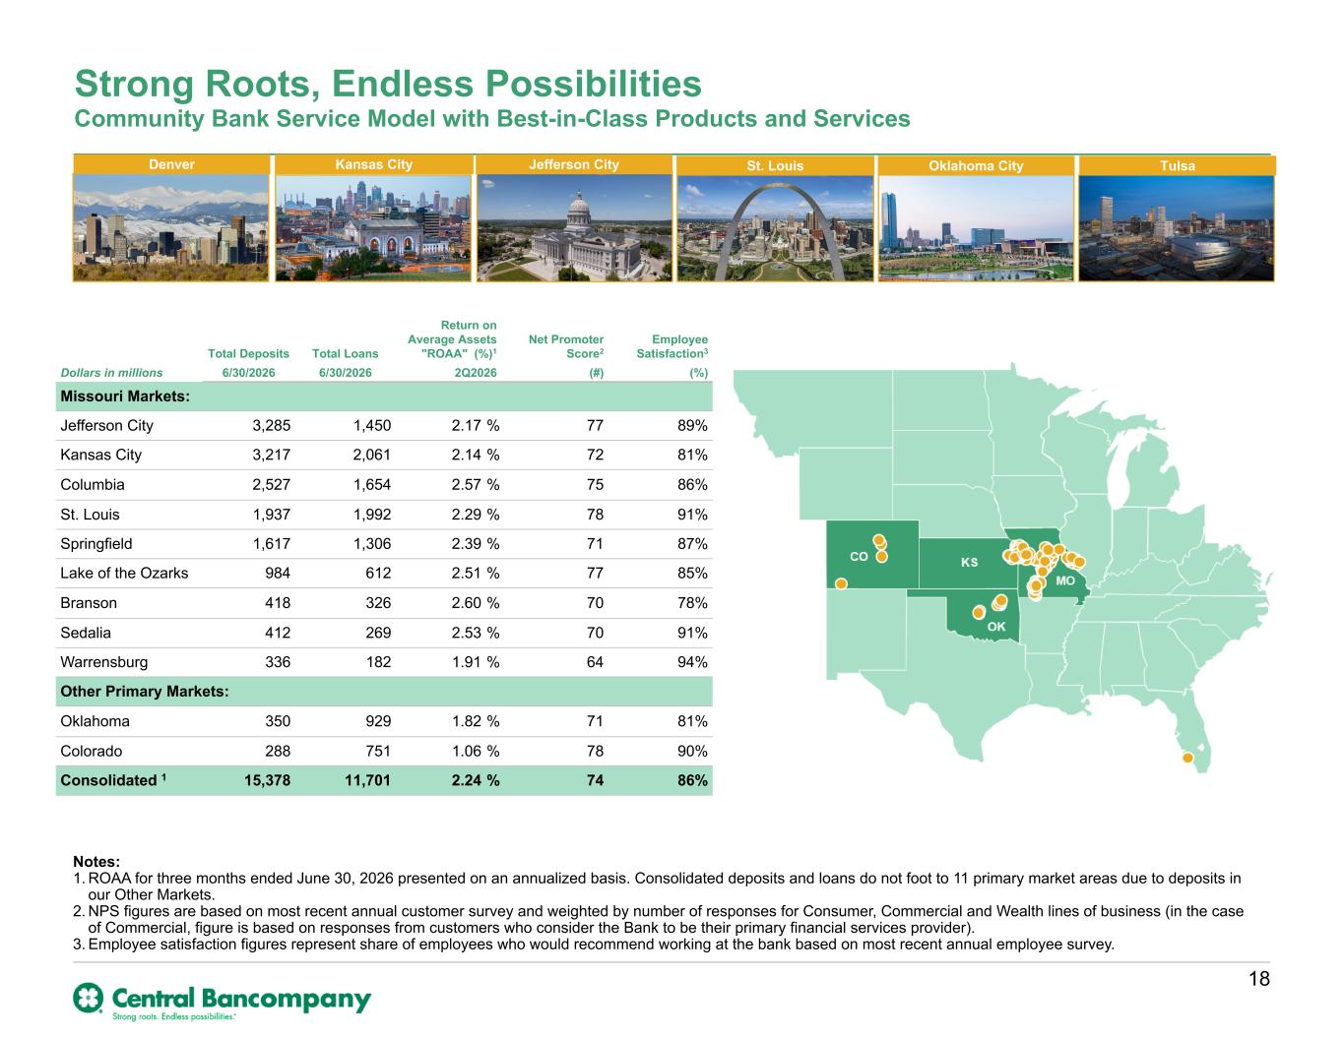
Community Bank Service Model with Best-in-Class Products and Services Strong Roots, Endless Possibilities Notes: 1. ROAA for three months ended June 30, 2026 presented on an annualized basis. Consolidated deposits and loans do not foot to 11 primary market areas due to deposits in our Other Markets. 2. NPS figures are based on most recent annual customer survey and weighted by number of responses for Consumer, Commercial and Wealth lines of business (in the case of Commercial, figure is based on responses from customers who consider the Bank to be their primary financial services provider). 3. Employee satisfaction figures represent share of employees who would recommend working at the bank based on most recent annual employee survey. FL Jefferson CityKansas CityDenver TulsaOklahoma CitySt. Louis Total Deposits Total Loans Return on Average Assets "ROAA" (%)1 Net Promoter Score2 Employee Satisfaction3 Dollars in millions 6/30/2026 6/30/2026 2Q2026 (#) (%) Missouri Markets: Jefferson City 3,285 1,450 2.17 % 77 89% Kansas City 3,217 2,061 2.14 % 72 81% Columbia 2,527 1,654 2.57 % 75 86% St. Louis 1,937 1,992 2.29 % 78 91% Springfield 1,617 1,306 2.39 % 71 87% Lake of the Ozarks 984 612 2.51 % 77 85% Branson 418 326 2.60 % 70 78% Sedalia 412 269 2.53 % 70 91% Warrensburg 336 182 1.91 % 64 94% Other Primary Markets: Oklahoma 350 929 1.82 % 71 81% Colorado 288 751 1.06 % 78 90% Consolidated 1 15,378 11,701 2.24 % 74 86% 18

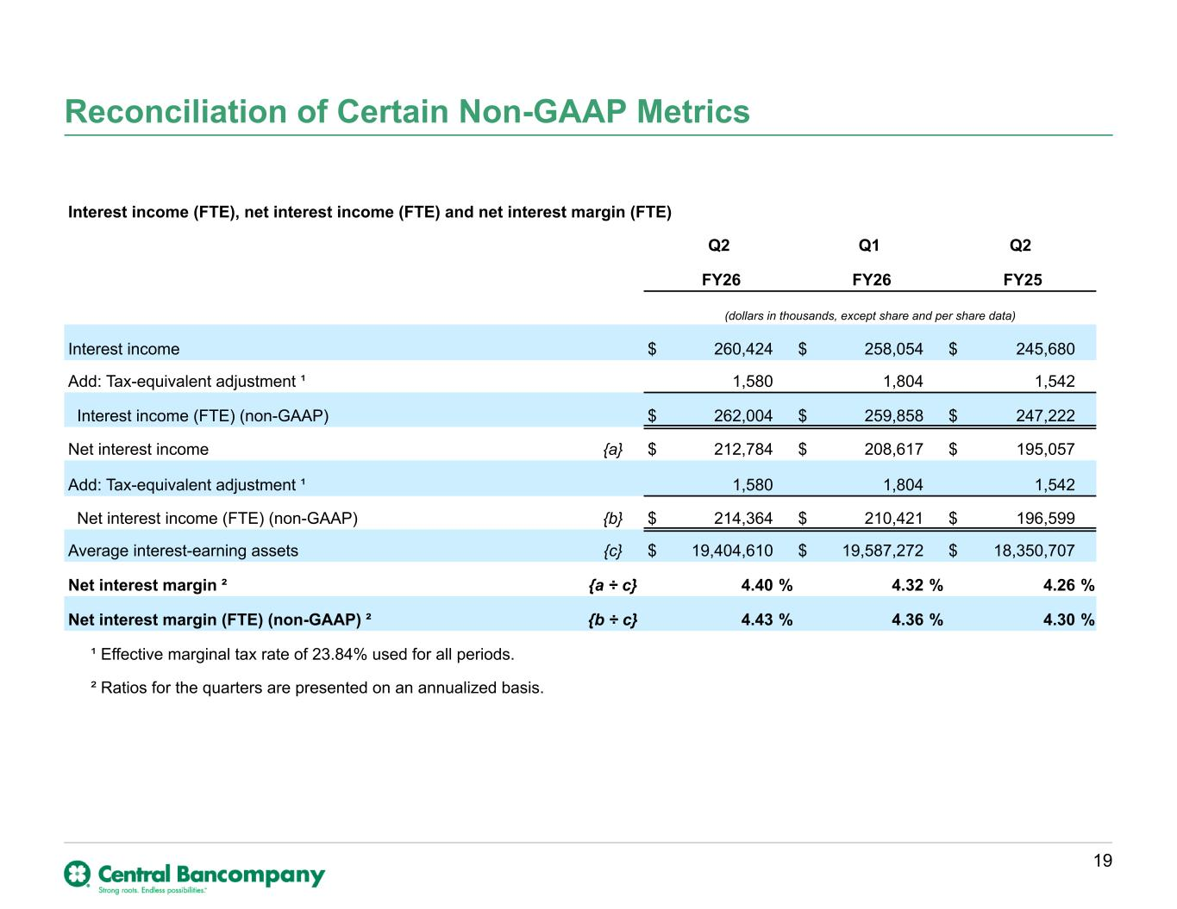
Reconciliation of Certain Non-GAAP Metrics 19 Interest income (FTE), net interest income (FTE) and net interest margin (FTE) Q2 Q1 Q2 FY26 FY26 FY25 (dollars in thousands, except share and per share data) Interest income $ 260,424 $ 258,054 $ 245,680 Add: Tax-equivalent adjustment ¹ 1,580 1,804 1,542 Interest income (FTE) (non-GAAP) $ 262,004 $ 259,858 $ 247,222 Net interest income {a} $ 212,784 $ 208,617 $ 195,057 Add: Tax-equivalent adjustment ¹ 1,580 1,804 1,542 Net interest income (FTE) (non-GAAP) {b} $ 214,364 $ 210,421 $ 196,599 Average interest-earning assets {c} $ 19,404,610 $ 19,587,272 $ 18,350,707 Net interest margin ² {a ÷ c} 4.40 % 4.32 % 4.26 % Net interest margin (FTE) (non-GAAP) ² {b ÷ c} 4.43 % 4.36 % 4.30 % ¹ Effective marginal tax rate of 23.84% used for all periods. ² Ratios for the quarters are presented on an annualized basis.

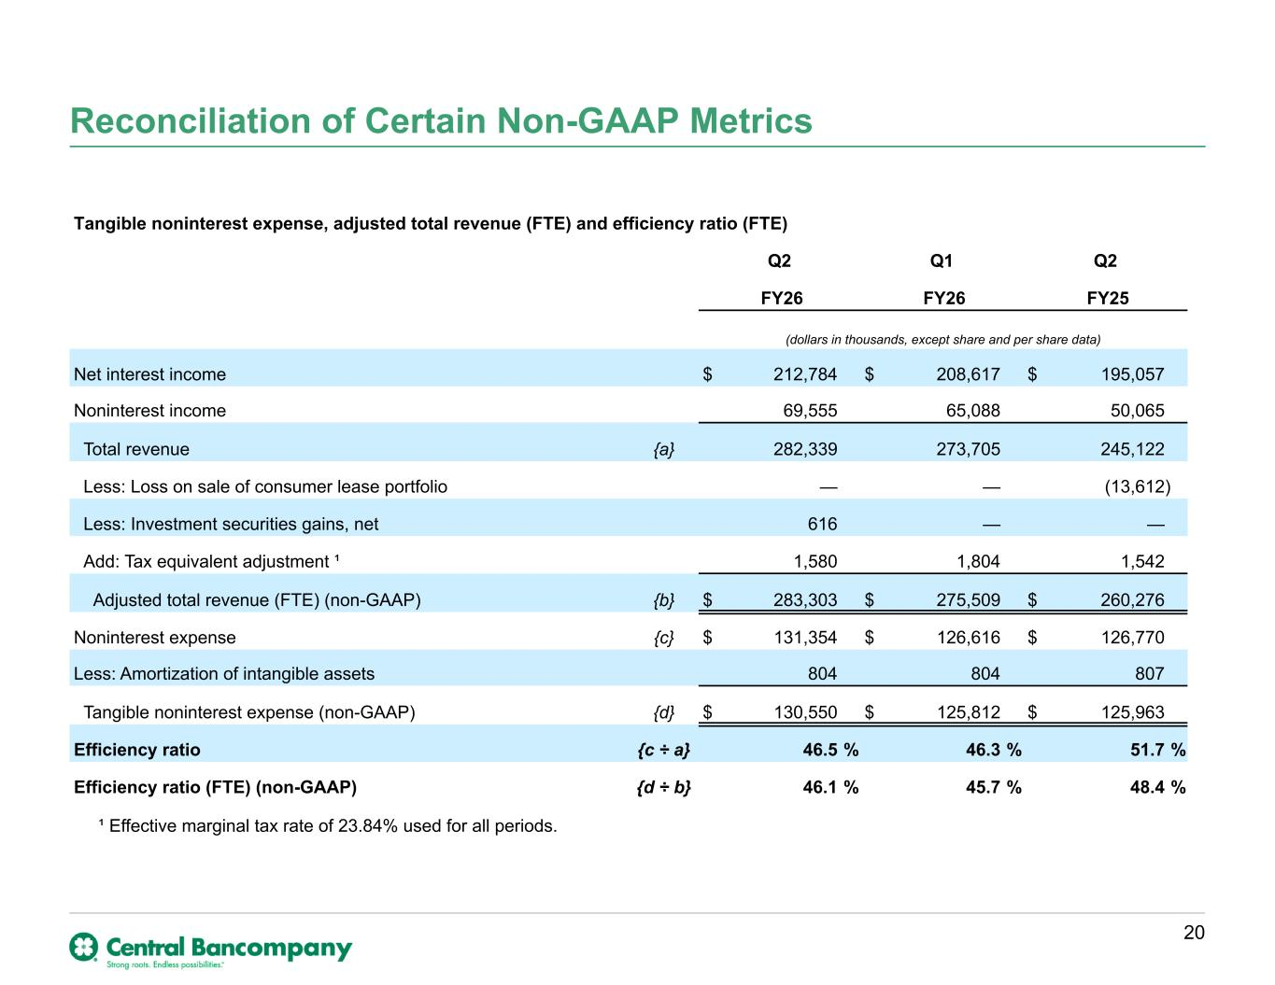
Reconciliation of Certain Non-GAAP Metrics 20 Tangible noninterest expense, adjusted total revenue (FTE) and efficiency ratio (FTE) Q2 Q1 Q2 FY26 FY26 FY25 (dollars in thousands, except share and per share data) Net interest income $ 212,784 $ 208,617 $ 195,057 Noninterest income 69,555 65,088 50,065 Total revenue {a} 282,339 273,705 245,122 Less: Loss on sale of consumer lease portfolio — — (13,612) Less: Investment securities gains, net 616 — — Add: Tax equivalent adjustment ¹ 1,580 1,804 1,542 Adjusted total revenue (FTE) (non-GAAP) {b} $ 283,303 $ 275,509 $ 260,276 Noninterest expense {c} $ 131,354 $ 126,616 $ 126,770 Less: Amortization of intangible assets 804 804 807 Tangible noninterest expense (non-GAAP) {d} $ 130,550 $ 125,812 $ 125,963 Efficiency ratio {c ÷ a} 46.5 % 46.3 % 51.7 % Efficiency ratio (FTE) (non-GAAP) {d ÷ b} 46.1 % 45.7 % 48.4 % ¹ Effective marginal tax rate of 23.84% used for all periods.

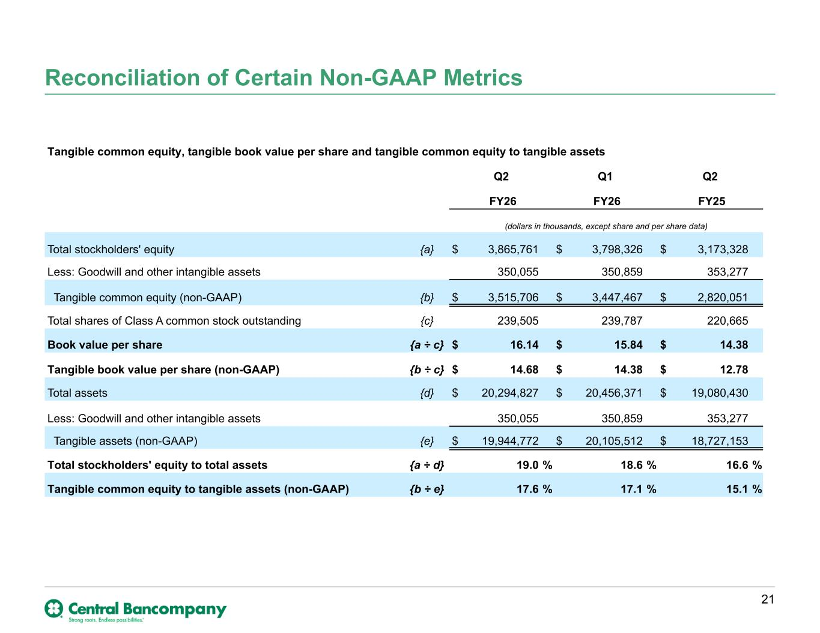
Reconciliation of Certain Non-GAAP Metrics 21 Tangible common equity, tangible book value per share and tangible common equity to tangible assets Q2 Q1 Q2 FY26 FY26 FY25 (dollars in thousands, except share and per share data) Total stockholders' equity {a} $ 3,865,761 $ 3,798,326 $ 3,173,328 Less: Goodwill and other intangible assets 350,055 350,859 353,277 Tangible common equity (non-GAAP) {b} $ 3,515,706 $ 3,447,467 $ 2,820,051 Total shares of Class A common stock outstanding {c} 239,505 239,787 220,665 Book value per share {a ÷ c} $ 16.14 $ 15.84 $ 14.38 Tangible book value per share (non-GAAP) {b ÷ c} $ 14.68 $ 14.38 $ 12.78 Total assets {d} $ 20,294,827 $ 20,456,371 $ 19,080,430 Less: Goodwill and other intangible assets 350,055 350,859 353,277 Tangible assets (non-GAAP) {e} $ 19,944,772 $ 20,105,512 $ 18,727,153 Total stockholders' equity to total assets {a ÷ d} 19.0 % 18.6 % 16.6 % Tangible common equity to tangible assets (non-GAAP) {b ÷ e} 17.6 % 17.1 % 15.1 %

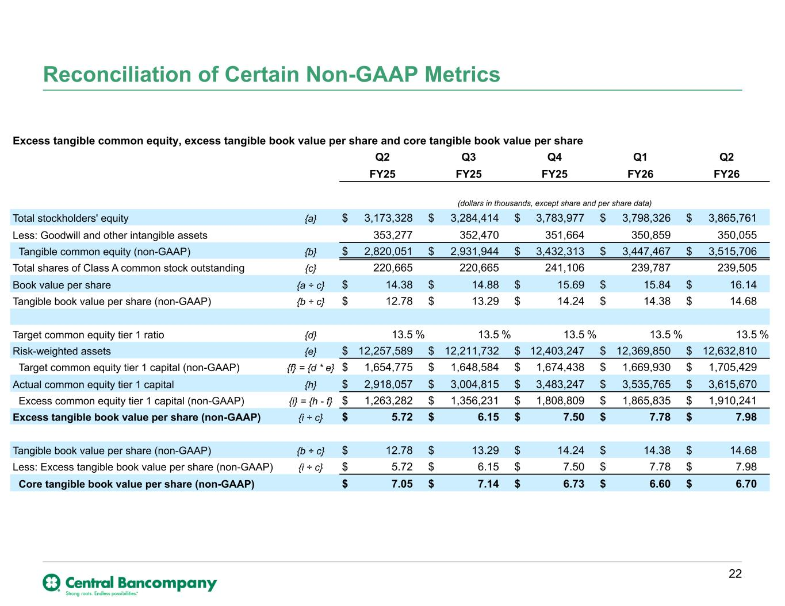
Reconciliation of Certain Non-GAAP Metrics 22 Excess tangible common equity, excess tangible book value per share and core tangible book value per share Q2 Q3 Q4 Q1 Q2 FY25 FY25 FY25 FY26 FY26 (dollars in thousands, except share and per share data) Total stockholders' equity {a} $ 3,173,328 $ 3,284,414 $ 3,783,977 $ 3,798,326 $ 3,865,761 Less: Goodwill and other intangible assets 353,277 352,470 351,664 350,859 350,055 Tangible common equity (non-GAAP) {b} $ 2,820,051 $ 2,931,944 $ 3,432,313 $ 3,447,467 $ 3,515,706 Total shares of Class A common stock outstanding {c} 220,665 220,665 241,106 239,787 239,505 Book value per share {a ÷ c} $ 14.38 $ 14.88 $ 15.69 $ 15.84 $ 16.14 Tangible book value per share (non-GAAP) {b ÷ c} $ 12.78 $ 13.29 $ 14.24 $ 14.38 $ 14.68 Target common equity tier 1 ratio {d} 13.5 % 13.5 % 13.5 % 13.5 % 13.5 % Risk-weighted assets {e} $ 12,257,589 $ 12,211,732 $ 12,403,247 $ 12,369,850 $ 12,632,810 Target common equity tier 1 capital (non-GAAP) {f} = {d * e} $ 1,654,775 $ 1,648,584 $ 1,674,438 $ 1,669,930 $ 1,705,429 Actual common equity tier 1 capital {h} $ 2,918,057 $ 3,004,815 $ 3,483,247 $ 3,535,765 $ 3,615,670 Excess common equity tier 1 capital (non-GAAP) {i} = {h - f} $ 1,263,282 $ 1,356,231 $ 1,808,809 $ 1,865,835 $ 1,910,241 Excess tangible book value per share (non-GAAP) {i ÷ c} $ 5.72 $ 6.15 $ 7.50 $ 7.78 $ 7.98 Tangible book value per share (non-GAAP) {b ÷ c} $ 12.78 $ 13.29 $ 14.24 $ 14.38 $ 14.68 Less: Excess tangible book value per share (non-GAAP) {i ÷ c} $ 5.72 $ 6.15 $ 7.50 $ 7.78 $ 7.98 Core tangible book value per share (non-GAAP) $ 7.05 $ 7.14 $ 6.73 $ 6.60 $ 6.70

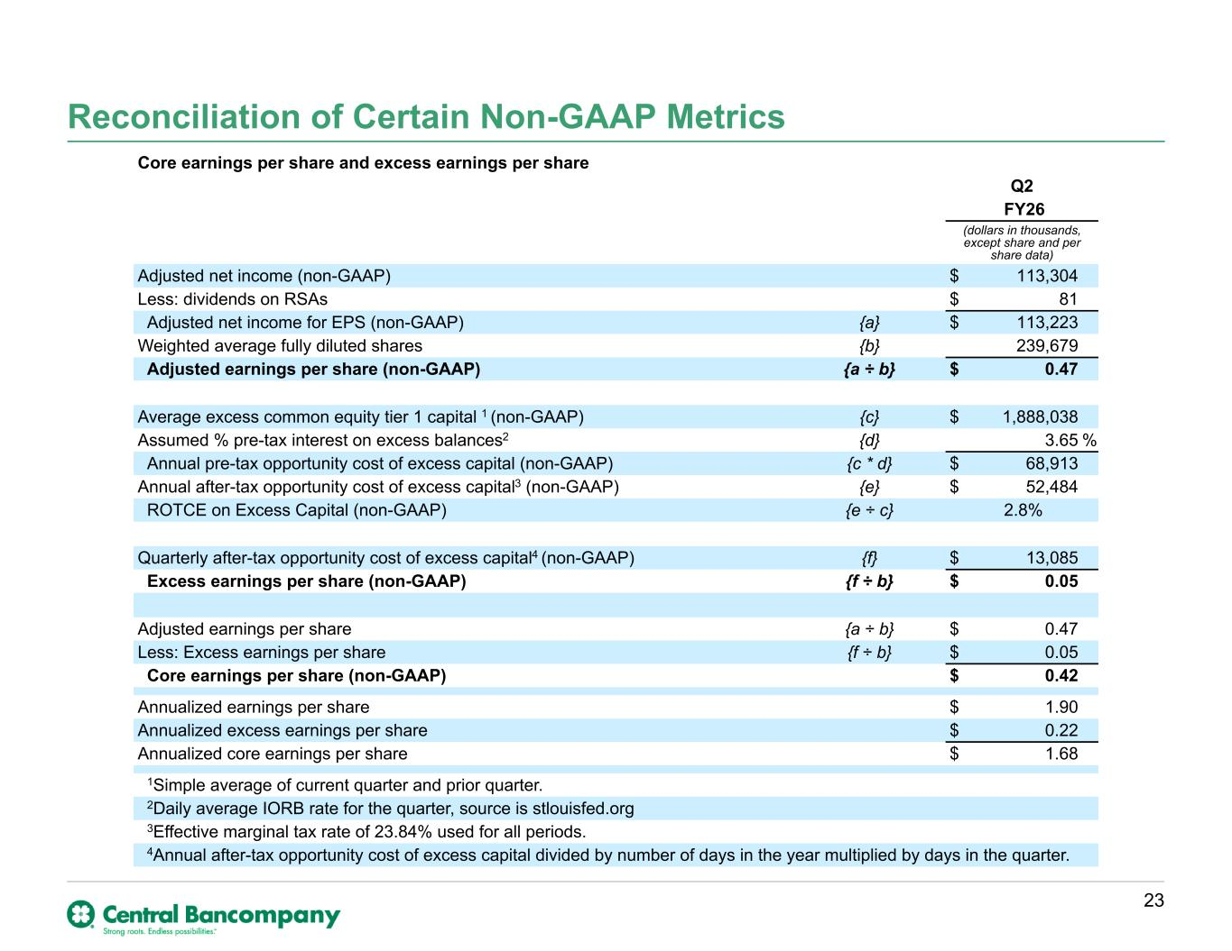
Reconciliation of Certain Non-GAAP Metrics 23 Core earnings per share and excess earnings per share Q2 FY26 (dollars in thousands, except share and per share data) Adjusted net income (non-GAAP) $ 113,304 Less: dividends on RSAs $ 81 Adjusted net income for EPS (non-GAAP) {a} $ 113,223 Weighted average fully diluted shares {b} 239,679 Adjusted earnings per share (non-GAAP) {a ÷ b} $ 0.47 Average excess common equity tier 1 capital 1 (non-GAAP) {c} $ 1,888,038 Assumed % pre-tax interest on excess balances2 {d} 3.65 % Annual pre-tax opportunity cost of excess capital (non-GAAP) {c * d} $ 68,913 Annual after-tax opportunity cost of excess capital3 (non-GAAP) {e} $ 52,484 ROTCE on Excess Capital (non-GAAP) {e ÷ c} 2.8% Quarterly after-tax opportunity cost of excess capital4 (non-GAAP) {f} $ 13,085 Excess earnings per share (non-GAAP) {f ÷ b} $ 0.05 Adjusted earnings per share {a ÷ b} $ 0.47 Less: Excess earnings per share {f ÷ b} $ 0.05 Core earnings per share (non-GAAP) $ 0.42 Annualized earnings per share $ 1.90 Annualized excess earnings per share $ 0.22 Annualized core earnings per share $ 1.68 1Simple average of current quarter and prior quarter. 2Daily average IORB rate for the quarter, source is stlouisfed.org 3Effective marginal tax rate of 23.84% used for all periods. 4Annual after-tax opportunity cost of excess capital divided by number of days in the year multiplied by days in the quarter.

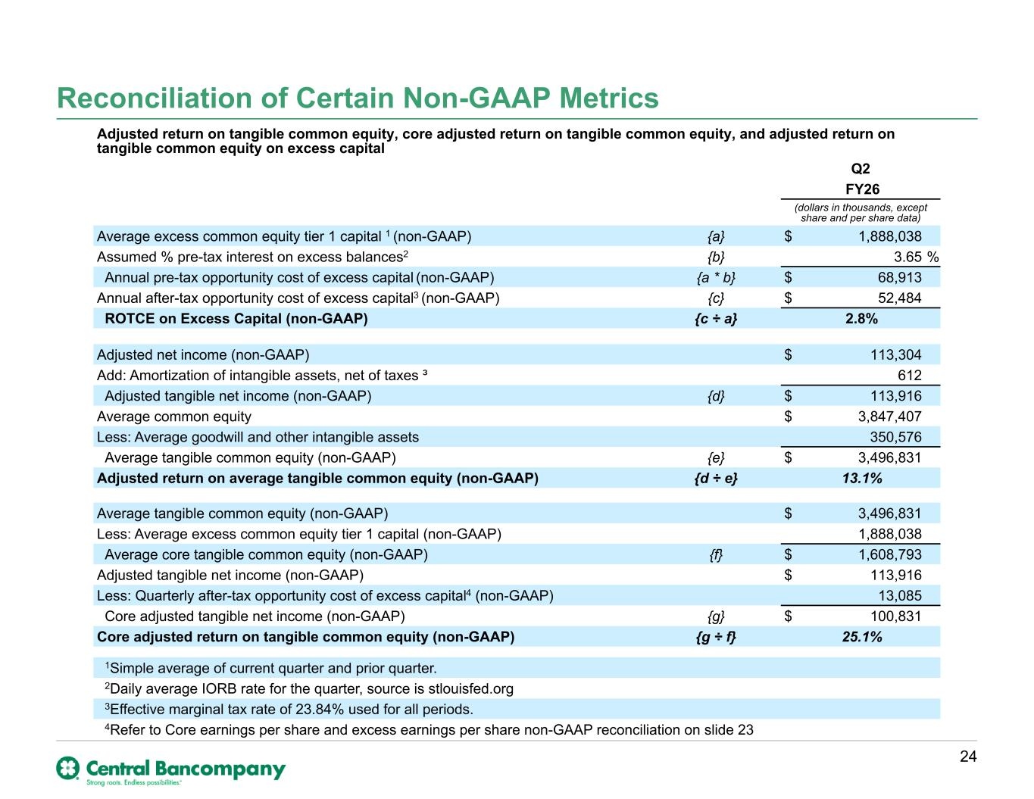
Reconciliation of Certain Non-GAAP Metrics 24 Adjusted return on tangible common equity, core adjusted return on tangible common equity, and adjusted return on tangible common equity on excess capital Q2 FY26 (dollars in thousands, except share and per share data) Average excess common equity tier 1 capital 1 (non-GAAP) {a} $ 1,888,038 Assumed % pre-tax interest on excess balances2 {b} 3.65 % Annual pre-tax opportunity cost of excess capital (non-GAAP) {a * b} $ 68,913 Annual after-tax opportunity cost of excess capital3 (non-GAAP) {c} $ 52,484 ROTCE on Excess Capital (non-GAAP) {c ÷ a} 2.8% Adjusted net income (non-GAAP) $ 113,304 Add: Amortization of intangible assets, net of taxes ³ 612 Adjusted tangible net income (non-GAAP) {d} $ 113,916 Average common equity $ 3,847,407 Less: Average goodwill and other intangible assets 350,576 Average tangible common equity (non-GAAP) {e} $ 3,496,831 Adjusted return on average tangible common equity (non-GAAP) {d ÷ e} 13.1% Average tangible common equity (non-GAAP) $ 3,496,831 Less: Average excess common equity tier 1 capital (non-GAAP) 1,888,038 Average core tangible common equity (non-GAAP) {f} $ 1,608,793 Adjusted tangible net income (non-GAAP) $ 113,916 Less: Quarterly after-tax opportunity cost of excess capital4 (non-GAAP) 13,085 Core adjusted tangible net income (non-GAAP) {g} $ 100,831 Core adjusted return on tangible common equity (non-GAAP) {g ÷ f} 25.1% 1Simple average of current quarter and prior quarter. 2Daily average IORB rate for the quarter, source is stlouisfed.org 3Effective marginal tax rate of 23.84% used for all periods. 4Refer to Core earnings per share and excess earnings per share non-GAAP reconciliation on slide 23

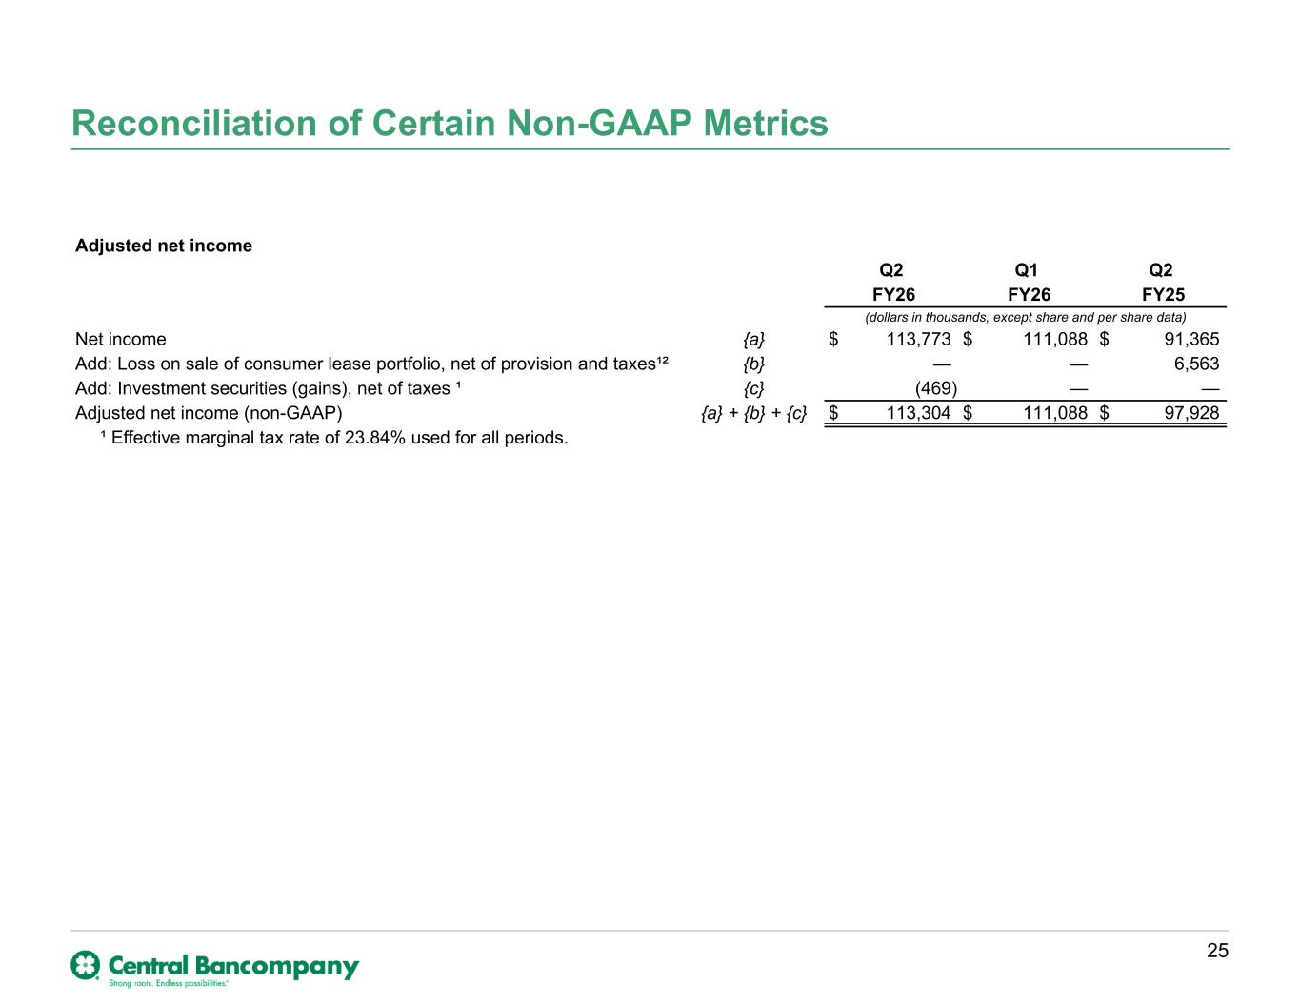
Reconciliation of Certain Non-GAAP Metrics 25 Adjusted net income Q2 Q1 Q2 FY26 FY26 FY25 (dollars in thousands, except share and per share data) Net income {a} $ 113,773 $ 111,088 $ 91,365 Add: Loss on sale of consumer lease portfolio, net of provision and taxes¹² {b} — — 6,563 Add: Investment securities (gains), net of taxes ¹ {c} (469) — — Adjusted net income (non-GAAP) {a} + {b} + {c} $ 113,304 $ 111,088 $ 97,928 ¹ Effective marginal tax rate of 23.84% used for all periods.

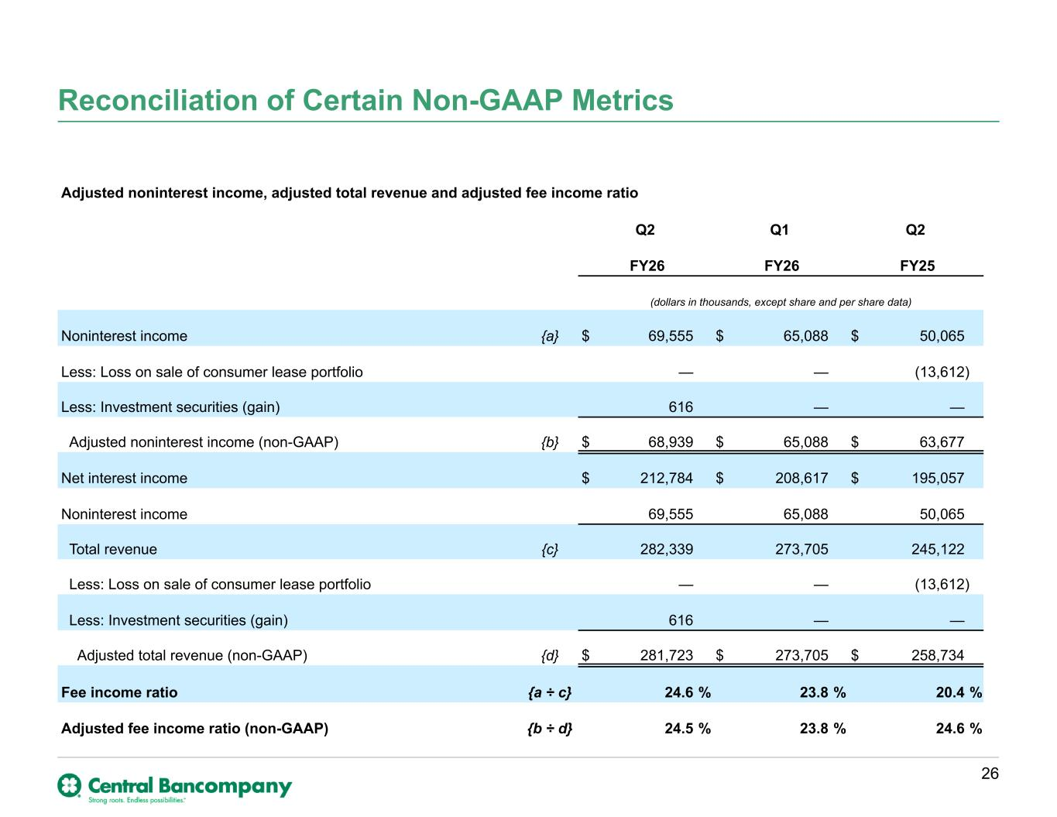
Reconciliation of Certain Non-GAAP Metrics 26 Adjusted noninterest income, adjusted total revenue and adjusted fee income ratio Q2 Q1 Q2 FY26 FY26 FY25 (dollars in thousands, except share and per share data) Noninterest income {a} $ 69,555 $ 65,088 $ 50,065 Less: Loss on sale of consumer lease portfolio — — (13,612) Less: Investment securities (gain) 616 — — Adjusted noninterest income (non-GAAP) {b} $ 68,939 $ 65,088 $ 63,677 Net interest income $ 212,784 $ 208,617 $ 195,057 Noninterest income 69,555 65,088 50,065 Total revenue {c} 282,339 273,705 245,122 Less: Loss on sale of consumer lease portfolio — — (13,612) Less: Investment securities (gain) 616 — — Adjusted total revenue (non-GAAP) {d} $ 281,723 $ 273,705 $ 258,734 Fee income ratio {a ÷ c} 24.6 % 23.8 % 20.4 % Adjusted fee income ratio (non-GAAP) {b ÷ d} 24.5 % 23.8 % 24.6 %

